PROSPECTUS

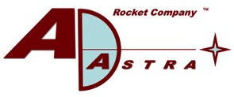

Ad Astra Rocket Company
Common Stock
Ad Astra Rocket Company (“Ad Astra”) is authorized by the Superintendencia General de Valores of Costa Rica (Sugeval) to effect this public offering. Authorization by Sugeval to effect this offering does not imply a qualification of this offering nor does it imply that Ad Astra is solvent.
Common Stock, par value $0.01 per share | Authorized Capital as of December 31, 2023
Total Authorized Capital | US$750,000
Outstanding Capital (Secondary Market) | US$210,221
Available Capital (Primary Market) | US$539,779

Representative Stock Broker Dealers

EMISIÓN DE OFERTA PÚBLICA: La SUGEVAL advierte que, por las características de esta emisión y de la empresa emisora, así como por los riesgos asociados a la actividad a que se dedica Ad Astra Rocket Company, éste es un producto de oferta pública, dirigido exclusivamente a inversionistas institucionales y sofisticados. Por lo tanto, de previo a tomar su decisión de inversión revise detalladamente el prospecto, la información financiera y sus proyecciones
This is a public offering of Ad Astra’s shares of common stock. Only institutional and sophisticated investors may purchase shares in this offering. Institutional investors include securities brokers and other financial intermediaries, international organizations, mutual funds, pension funds and trusts who act as mutual funds or pension funds. Sophisticated investors must have net assets equal to or more than US$1.0 million or be able to demonstrate that they have the ability to understand and assume the risks associated with this type of investment.

The Date of This Prospectus is April 12, 2024

Table of contents 2
Important Information for Investors 4
Special Note Regarding Forward-Looking Information 5
Civil Action for Damages 5
Chapter 1: Offering information and identification of the directors, managers and advisors involved in the public offering process 6
Offering Information 6
Lock up 7
Placement method 7
Shares reserved for issuance to stockholders or employees 7
Use of Proceeds 7
Funding sources 8
Issuance and placement 8
Form of shares 8
Payment Agent 8
Book Value of Capital Stock 9
Deadline of the registration Ad Astra’s stockholder records 9
Certain U.S. federal tax considerations for non-U.S. holders 9
Corporate Taxation 11
Dividend distributions 11
Sale, exchange, redemption or other disposition of Common Stock 11
Information reporting and backup withholding 12
Certain Costa Rican tax considerations 13
Capital Stock 13
Stock Split 13
Common Stock 14
Preferred Stock 14
Priority of Payments Upon Liquidation or Dissolution 18
Limitation on Directors’ Liability under Delaware Law 18
Notice to Investors and Transfer Restrictions 19
Differences between Delaware Corporate Law and Costa Rican Law 20
Directors, managers and advisers involved in the process of public offering 25
Chapter 2: Essential information 27
Risks related to purchasing shares of Common Stock 27
Risks related to Ad Astra and its business. 27
Risks related to the Offering 35
Risk Management 37
Analysis of financial indicators 38
Debt and Capitalization 41
Information of the Issuer 44
Chapter 3: Ad Astra’s History and Development 45
CHAPTER 4: Company Present Structure and Focus 48
NASA Relationship 48
Space Act Agreements 48
NASA Funded Contracts 48
Company Owned Intellectual Property 50
Congruency with United States Space Policy 51
CHAPTER 5: The VASIMR® Technology and its Advantages 52
The VASIMR® Engine 52
Variable Specific Impulse 52
VASIMR® at a power of 200 kW 54
Technology Readiness Level (TRL) 57
Present Status and Near-term Plans 57
Chronology of Technical Accomplishments 59
Major Technical and Business Goals 61
CHAPTER 6: VASIMR® ECONOMICS and Business Opportunities 62
The Market 62
Business Strategies and Technology Implementation Elements 62
Business concepts post initial space test 63
Competition 65
Company Strengths 65
Alliances, Collaborations and Partnerships 67
Collaboration with NAUTEL and Aethera, Ltd, Canada. 68
Solar array technology development 68
Other Potential Applications of Ad Astra’s Electric Propulsion Technology 68
CHAPTER 7: Costa Rica Operations and company diversification 71
Operations in Costa Rica 71
Plasma Research in Costa Rica 71
Company Diversificartion 72
Ad Astra’s Renewable Energy Journey 74
Green Hydrogen 75
Hydrogen – Biogas Power Generation 75
Hydrogen Storage Technology with Costa Rica’s RECOPE 76
First Hydrogen Fuel Cell Electric Bus 77
Latin America’s First Hydrogen Fuel Cell Electric Sedans 78
Latin America’s First H70 Fast Hydrogen Refueling Station 78
ProNova Energy, a Joint Venture with Mesoamérica 79
Chapter 8: Company Structure AND ORGANIZATON 80
Subsidiaries 80
Property, plant and equipment 81
Chapter 9: Operating results and financial forecasting and reporting (management view) 82
Results of Operations 82
Accounts Payable and Accrued Liabilities 83
Perceived Impact of Covid-19 on Ad Astra’s Operations 83
Projected Cash Expenditures 84
Chapter 10: Directors, management personnel and employees 85
The Management Team 86
Executive Compensation 88
Personnel 88
Chapter 11: Significant stockholders and transactions with related parties 89
Stock Ownership 89
Transactions with related parties 90
Chapter 12: Financial Information 91
Frequency of information to investors 91
Chapter 13: Additional information 92
Chapter 14: Annexes 93

Important Information for Investors
Restrictions: Nothing in this prospectus constitutes an offer of securities for sale in any jurisdiction where it is unlawful to do so. The securities offered hereby have not been, and will not be, registered under the U.S. Securities Act of 1933 or the securities laws of any state of the United States and the securities may not be offered or sold within the United States or to, or for the account or benefit of, U.S. persons (as defined in Regulation S under the U.S. Securities Act of 1933), except pursuant to an exemption from, or in a transaction not subject to, the registration requirements of the Securities Act of 1933 and applicable state or other securities laws. You acknowledge and agree that you will not engage in hedging transactions involving Ad Astra’s securities unless in compliance with the U.S. Securities Act of 1933.
Dear investor, it is your duty and right to understand the contents of this prospectus before making a decision to invest. This prospectus provides information on the offering and relevant information concerning Ad Astra and the risks associated with Ad Astra and the offering. The information provided in the prospectus is binding on Ad Astra, which means that Ad Astra is legally responsible for the information contained in this prospectus.
We urge you to review the material fact announcements issued by Ad Astra related to events that can affect Ad Astra’s performance as well as Ad Astra’s quarterly and annual financial statements.
The activities and performance of Ad Astra over time does not ensure its future solvency and liquidity. Any investment you make is solely at your own risk. The Superintendencia General de Valores (SUGEVAL) does not issue an opinion on the truthfulness, accuracy or adequacy of the information contained in this prospectus.
The SUGEVAL and those involved in the brokerage process assume no liability related to the financial condition of Ad Astra.
An investment in our stock is speculative, involves a high degree of risk, and should be considered only by sophisticated and institutional investors who can bear the economic risks of their investment for an indefinite period and who can afford to sustain a total loss of their investment. See “Risk Factors” in Chapter 2 of this prospectus for a description of the risk factors that management believes present the most substantial risks to an investor in this offering.
In making an investment decision, investors must rely on their own examination of the issuer and the terms of the offering, including the merits and risks involved. These securities have not been recommended or approved by Sugeval or any other federal or state securities commission or regulatory authority; furthermore, these authorities have not passed upon the accuracy or adequacy of this prospectus. Any representation to the contrary is a criminal offense.
In making your investment decision, you should rely only on the information contained in this prospectus, the material fact announcements and all other periodic information furnished to you in writing by an authorized officer of Ad Astra. This information is available to you on the SUGEVAL website at www.sugeval.fi.cr. We have not authorized anyone to provide you with any other information. If you receive any other information, you should not rely on it.
The information contained herein is presented as of the date of this prospectus. The delivery of this document at any later date should not create any implication that there has been no change in the information set forth herein or in the financial condition or prospects of Ad Astra.

Special Note Regarding Forward-Looking Information
This prospectus includes forward-looking statements. These statements relate to projections of revenue, income and capital expenditures and other forecasts of future operating and financial results and estimates of other amounts not yet determinable. These statements also relate to Ad Astra’s future prospects, development projects and business strategies. The statements contained in this prospectus that are not statements of historical fact may include forward-looking statements that involve a number of risks and uncertainties.
Some of these statements can be identified by the use of forward-looking terminology such as “believes,” “expects,” “estimates,” “intends,” “may,” “will,” “should,” or “anticipates,” or the negatives or other variations of these or similar words, or by discussion of strategies or risks and uncertainties. In addition, from time to time Ad Astra or its representatives have made or may make forward-looking statements orally or in writing. Furthermore, such forward-looking statements may be included in various filings that Ad Astra makes with governmental authorities or press releases or oral statements made by or with the approval of one of its authorized executive officers. The factors set forth under “Risk Factors” in this prospectus are among those that may cause actual results to differ materially from those projected in Ad Astra’s forward-looking statements.
All of Ad Astra’s forward-looking statements should be considered in light of such risk factors. Other factors and assumptions, not identified in this prospectus, also were involved in the derivation of the forward-looking statements, and the failure of such other factors and assumptions to occur or be realized may also cause actual results to differ materially from those projected. These forward-looking statements are only present expectations. Actual events or results may differ materially from those projected in the forward-looking statements.
All subsequent written and oral forward-looking statements attributable to Ad Astra or to persons acting on its behalf are expressly qualified in their entirety by the cautionary statements contained in this prospectus.

Civil Action for Damages
Ad Astra is incorporated in the State of Delaware and the vast majority of its assets and its principal operations are located in its offices located in Webster, Texas. In the event of a violation of the U.S. federal securities law by Ad Astra directly related to the offering contemplated by this prospectus, a purchaser of securities pursuant to this offering may have the right to bring a civil action for damages under the U.S. federal securities laws. Any such action may be brought in a federal court with appropriate jurisdiction located in Harris County, Texas. In the event that Ad Astra fails to comply with the applicable corporate laws of the State of Delaware, Ad Astra’s stockholders may also have the ability to enforce their rights under Delaware law in any proper Delaware Chancery Court.
In the event of a violation of the Costa Rican securities laws by Ad Astra directly related to the offering contemplated by this prospectus, a purchase of securities pursuant to this offering may have the right to bring a civil action for damages under the Costa Rican securities laws.

Chapter 1: Offering information and identification of the directors, managers and advisors involved in the public offering process

Offering Information
Set forth below is a summary of the material terms of the offering of common stock of Ad Astra offered by this prospectus. As of December 31, 2023, the total authorized amount of Ad Astra’s common stock was US$750,000, the capital amount issued and outstanding was US$210,221 at a par value of $0.01 per share, and the available capital was US$539,779.

The Issuer | Ad Astra Rocket Company, a Delaware corporation
Securities | Common Stock, par value $0.01 per share
ISIN Code | CRASTRAA0011
Nemotecnico | Acom$
Par Value | $0.01 per share
Total authorized capital at par value | US$750,000
Outstanding capital at par value | US$210,221
Available capital at par value | US$539,779
Authorized Shares | 75,000,000
Registered Capital | Primary Market (*) and Secondary Market
Price per Share | (*)
Minimum Investment for each Investor | US$25,000
Form of Shares | Book-entry at Interclear Central de Valores, S.A.
Placement mechanisms | Auction through the stock exchange  Placement through best effort agreements  Placement through underwriter agreements
* Price per share and number of shares offered will be defined by Ad Astra through a Material Fact Announcement within the period established by SUGEVAL before each placement of securities.

Lock up
Prior to March 28, 2012, Ad Astra’s shares of common stock were subject to a lock-up, which prevented the transfer or sale of the common stock. The lock-up expired on March 29, 2012.

Placement method
The offered shares will be placed in the primary market through one of the placement mechanisms described below.
- The issuer is able to select the placement method among direct placement, stock exchange auctions, or through underwriting agreements.
- All placements, except through underwriting agreement, will assure an equal access, treatment, issue and terms of allocation information to all investors without distinction.
- If the placement is made out of the Stock Exchange’s systems, the issuer will choose the allocation mechanism and conditions.
- If the placement is made through the Stock Exchange’s systems, the issuer will follow the mechanisms and rules of that entity and will make it accordingly to the equal access mentioned at literal (b).
- The issuer will make a Material Fact Announcement regarding the placement conditions (through or out of the Stock Exchange’s systems) at least two working days before the placement of securities to investors.
- If the placement is made either through the underwriting agreements method or through the best effort agreements method, the following information will be indicated: the name of the subscribers, the type of agreement, the amount to be subscribed, agreed price and compensations, the subscribers’ responsibilities. This announcement will be made one day after the agreement is signed.
Ad Astra is not conducting a public offering in the markets of any other countries simultaneously with this offering, and no portion of this offering is reserved for sale in other countries. In the future, Ad Astra may offer its shares of common stock for sale in other countries subject to compliance with applicable securities laws in each country. Ad Astra will issue a Material Fact Announcement within the period established by SUGEVAL to notify investors regarding offerings in other markets.

Shares reserved for issuance to stockholders or employees
Ad Astra has reserved shares of its authorized common stock for issuance to its directors, employees and consultants pursuant to Ad Astra’s 2016 Stock Incentive Plan.

Use of Proceeds
Ad Astra plans to use the proceeds from this offering to fund a portion of the costs for (1) the development and construction of an experimental prototype of the VASIMR® engine to be tested in a laboratory vacuum chamber at a power level of 100 to 200 kW; (2) the development and construction of two 100 - 200 kW VASIMR® engines and associated power infrastructure to be delivered and tested in Earth orbit; and (3) the design and construction of an electric power and propulsion test platform to support the testing of the VASIMR® engine in space. In addition, and as a secondary objective, Ad Astra plans to use some of the proceeds from this offering to support the organic growth of its green hydrogen business.

Funding sources
Ad Astra estimates that it will need a total of approximately US$100.0 million between 2024 and 2028 to fund the full cost of these items and to carry out its business plan. Please refer to the table entitled “Projected Cash Expenditures” under “Operating Results and Financial Forecasting and Reporting (management view)” for a summary of the intended uses of these funds. Ad Astra will incur fees and pay commissions to underwriters and others in connection with raising this capital, and thus the total amount of capital that may need to be raised is likely to be close to US$110.0 million.
In addition to the anticipated proceeds of this offering, Ad Astra will also pursue raising capital through offerings of capital stock in other markets and through credit facilities from banks. These capital-raising requirements could be offset by company revenue from direct US government contracts (such as NASA and DARPA), which may result from successful company proposals in response to announcements of opportunity for technology development issued by these agencies. There can be no assurance that Ad Astra will be successful in these efforts to raise additional capital.

Issuance and placement
Ad Astra will pay a fee of up to 2% of each placement of securities pursuant to this offering to the brokerage firm in the Costa Rican stock market that secures the transaction. In this offering, Ad Astra estimates that it incurred and will incur in the following additional expenses:

Expense | Estimated Amount
ISIN Code | $50
Registration and maintenance fees of the stock exchange | US$1,000 per year
Registration fees and maintenance for public offering in Sugeval | 0.1% of registered capital
Accounting and legal fees | $50,000

Form of shares
Some of the shares of capital stock that are currently issued, and outstanding, are represented by physical certificates. Shares issued in this offering are and will be represented by a book-entry at Interclear Central de Valores, S.A. and will not be physically delivered. The individual accounts are to be kept by the custodian in the name of each holder, and each holder will be required to pay the applicable fees of the custodian. The custodian is responsible for the safekeeping of and for all movements affecting securities, which may involve additional fees.

Payment Agent
Any distribution, dividends or other payments by Ad Astra to holders of the common stock will be distributed through Interclear Central de Valores, S.A. to the institutions of custody and then to the stockholders.

Book Value of Capital Stock
The book value of Ad Astra’s shares of capital stock, including all outstanding shares of common stock and all shares issuable upon conversion of outstanding shares of preferred stock, as of December 31, 2023 and 2022 is as follows:

 | 2023 | 2022
Stockholder’s Equity (Deficit) | (US$3,705,023) | (US$3,338,690)
Outstanding Shares of Common Stock | 21,021,963 | 21,021,963
Preferred Stock (as converted)¹ | 2,122,300 | 1,993,100
Total Shares | 23,144,263 | 23,015,063
Book Value Per Share | (US$0.16) | (US$0.14)
______________________
¹ Each outstanding share of Series A, and Series C Preferred stock is convertible into 3,000 shares of common stock. Each outstanding share of Series D and Series E Preferred stock is convertible into 100 shares of common stock.

Deadline of the registration Ad Astra’s stockholder records
Ad Astra will register ownership of the shares sold in this offering in its stockholder records within 10 business days after the offering has been closed.

Certain U.S. federal tax considerations for non-U.S. holders
The following summary is a description of certain United States federal income and estate tax considerations affecting Ad Astra and relating to the purchase, ownership and disposition of our Common Stock by Non-U.S. Holders. This summary is for general information only and does not purport to be a complete analysis of all the potential tax considerations relating thereto. This summary is based upon the provisions of the Internal Revenue Code of 1986, as amended (the “Code”), Treasury Regulations promulgated thereunder, administrative rulings and judicial decisions, all as of the date hereof. These authorities are subject to change, possibly retroactively, or to different interpretations that may result in United States federal income tax consequences different from those set forth below. We have not sought any rulings from the Internal Revenue Service (the “IRS”), with respect to the statements made and the conclusions reached in the following summary, and there can be no assurance that the IRS will agree with such statements and conclusions.
This summary does not address the effect of the United States federal gift tax laws, the tax considerations arising under the laws of any foreign, state or local jurisdiction, or any specific reporting requirements under Treasury Regulations. In addition, this discussion does not address tax considerations applicable to an investor’s particular circumstances or to investors that may be subject to special tax rules, including, without limitation:
- banks, insurance companies, or other financial institutions;
- holders subject to the alternative minimum tax;
- tax-exempt organizations;
- dealers in securities, currencies, or commodities;
- traders in securities that elect to use a mark-to-market method of accounting for their securities holdings;
- partnerships or other pass-through entities and holders of interests therein;
- expatriates and certain former residents of the United States;
- persons who hold Common Stock in connection with a hedging, integrated, conversion, “straddle,” or other risk reduction transaction; and
- persons deemed to sell the Common Stock under any constructive sale provision of the Code.
Holders subject to the special circumstances described above may be subject to tax rules that differ significantly from those summarized below.
Except as otherwise modified for United States federal estate tax purposes, a “Non-U.S. Holder” of our Common Stock is a beneficial owner of our Common Stock and is not, for United States federal income tax purposes:
- an individual who is a citizen or resident of the United States;
- a corporation or other entity taxable as a corporation for U.S. federal income tax purposes, created or organized in or under the laws of the United States, any state thereof or the District of Columbia;
- an estate, the income of which is subject to U.S. federal income taxation regardless of its source; or a trust if (1) the administration of the trust is subject to the primary supervision of a court within the United States and one or more United States persons have the authority to control all substantial decisions of the trust or (2) the trust has a valid election in effect under applicable Treasury Regulations to be treated as a United States person.
The treatment of a partner in an entity treated as a partnership for United States federal tax purposes that holds our Common Stock generally will depend on the status and tax situs of the partner and the activities of the partnership. Partners of partnerships considering the purchase of our Common Stock should consult their independent tax advisors.
HOLDERS ARE URGED TO CONSULT THEIR OWN TAX ADVISOR AS TO THE PARTICULAR TAX CONSEQUENCES OF PARTICIPATING IN THE OFFERING AND OF OWNING AND DISPOSING OF COMMON STOCK, INCLUDING THE APPLICATION OF THE FEDERAL GIFT TAX RULES, THE LAWS OF ANY STATE, LOCAL, FOREIGN OR OTHER TAXING JURISDICTION OR TAX TREATY, AND ANY CHANGES OR PROPOSED CHANGES IN APPLICABLE TAX LAWS OR INTERPRETATIONS THEREOF.
TO COMPLY WITH INTERNAL REVENUE SERVICE CIRCULAR 230, YOU ARE HEREBY NOTIFIED THAT: (A) ANY DISCUSSION OF U.S. FEDERAL TAX ISSUES CONTAINED OR REFERRED TO IN THIS OFFERING DOCUMENT IS NOT INTENDED OR WRITTEN TO BE USED, AND CANNOT BE USED BY YOU, FOR THE PURPOSES OF AVOIDING PENALTIES THAT MAY BE IMPOSED ON YOU UNDER THE CODE; (B) SUCH DISCUSSION IS BEING USED IN CONNECTION WITH THE PROMOTION OR MARKETING BY THE ISSUER OF THE TRANSACTIONS OR MATTERS ADDRESSED HEREIN; AND (C) YOU SHOULD SEEK ADVICE BASED ON YOUR PARTICULAR CIRCUMSTANCES FROM AN INDEPENDENT TAX ADVISOR.

Corporate Taxation
Ad Astra is a domestic corporation for U.S. federal income tax purposes and will be required to pay federal and state income tax on its income (currently at a maximum federal rate of 21% in 2023). Ad Astra will not be treated as a regulated investment company under the Internal Revenue Code. Ad Astra does not expect to be treated as a U.S. real property holding company (“USRPHC”) as it is not expected that Ad Astra will own U.S. real property in an amount that is significant enough to subject Ad Astra‘s foreign shareholders to the U.S. real property holding company rules.

Dividend distributions
In general, if distributions are made with respect to our Common Stock, such distributions will be treated as dividends to the extent of our current and accumulated earnings and profits as determined under the Code. Any portion of a distribution that exceeds our current and accumulated earnings and profits will first be applied in reduction of your tax basis in the Common Stock (determined on a share by share basis), and to the extent such portion exceeds your tax basis, the excess will be treated as gain from the disposition of the Common Stock, the tax treatment of which is discussed below under “—Sale, Exchange, Redemption, or Other Disposition of Common Stock.”
Any dividends for U.S. federal income tax purposes paid to a Non-U.S. Holder will be subject to U.S. federal withholding tax at a 30% rate subject to the two following exceptions:
- Dividends effectively connected with a trade or business of a Non-U.S. Holder and, if a tax treaty applies, attributable to a U.S. permanent establishment maintained by the Non-U.S. Holder within the United States generally will be exempt from withholding if the Non-U.S. Holder complies with applicable IRS certification requirements and instead such Non-U.S. Holder will be subject to U.S. federal income tax on a net income basis and must file U.S. tax returns. In the case of a Non-U.S. Holder that is a corporation, such effectively connected income also may be subject to the branch profits tax, which generally is imposed on a foreign corporation on the deemed repatriation from the United States of effectively connected earnings and profits at a 30% rate (or such lower rate as may be prescribed by an applicable tax treaty).
- A Non-U.S. Holder may be entitled to an exemption from or reduction in the rate of withholding tax under an applicable income tax treaty provided the Non-U.S. Holder satisfies applicable certification and other requirements. A Non-U.S. Holder that is eligible for a reduced rate of United States federal withholding tax under an income tax treaty may obtain a refund or credit of any excess amounts withheld by timely filing an appropriate claim for refund with the IRS.
A Non-U.S. Holder that is a foreign partnership, foreign partner in a partnership, or a foreign trust is urged to consult its own tax advisor regarding its status under these U.S. Treasury Regulations and the certification requirements applicable to it.

Sale, exchange, redemption or other disposition of Common Stock
Any gain realized by a Non-U.S. Holder upon the sale, exchange, redemption or other taxable disposition of shares of Common Stock generally will not be subject to U.S. federal income tax unless:
- the gain is effectively connected with the Non-U.S. Holder’s conduct of a trade or business in the United States or, if an income tax treaty applies, is attributable to a permanent establishment or fixed base maintained by the Non-U.S. Holder in the United States; in this case, the gain will be taxed on a net income basis at the rates and in the manner applicable to United States persons (as defined under the Code), and if the Non-U.S. Holder is a foreign corporation, the branch profits tax described above (see “—Dividend Distributions”) may also apply;
- the Non-U.S. Holder is an individual who is present in the United States for 183 days or more in the taxable year of that disposition, and certain other conditions are met; in this case, the gain, to the extent it exceeds certain losses, will generally be taxable at the rate of 30%; or
- we are or have been a (“USRPHC”) for United States federal income tax purposes.
A Non-U.S. Holder described in the first bullet point above will be subject to a flat 30% tax on any gain derived from the sale, exchange, redemption or other disposition of the Common Stock, which may be offset by U.S. source capital losses (even though such holder is not considered a resident of the United States). We do not believe that we are currently, and do not anticipate becoming a USRPHC.

Information reporting and backup withholding
Dividends paid to a Non-U.S. Holder generally will be subject to information reporting and may be subject to United States backup withholding, unless such Non-U.S. Holder provides a properly completed IRS Form W-8BEN certifying under penalties of perjury such Non-U.S. Holder is not a United States person or otherwise establishes an exemption. Copies of the information returns reporting such dividends (and the tax withheld with respect to such dividends) may also be made available to the tax authorities in the country in which you reside under the provisions of an applicable tax treaty.
Payment of the proceeds from the disposition of Common Stock effected by the U.S. office of a U.S. or foreign broker will be subject to information reporting requirements and backup withholding unless the Non-U.S. Holder disposing of the Common Stock provides an IRS Form W-8BEN certifying under penalties of perjury that such Non-U.S. Holder is not a United States person or otherwise establishes an exemption.
Payments of sales proceeds from the disposition of Common Stock by a foreign office of a broker to a Non-U.S. Holder outside the United States generally are not subject to U.S. backup withholding and information reporting requirements. However, unless the broker has documentary evidence in its records that the Non-U.S. Holder is not a United States person and certain other conditions are met, U.S. information reporting requirements will apply to a payment of sales proceeds, even if that payment is made outside the United States, if the broker is a “U.S. Related Person.” A “U.S. Related Person” is (i) a United States person (within the meaning of the Code); (ii) a foreign person that derives 50% or more of its gross income for certain period from activities that are effectively connected with the conduct of a trade or business in the United States; (iii) a controlled foreign corporation for U.S. federal income tax purposes; or (iv) a foreign partnership more than 50% of the capital or profits of which is owned by one or more United States persons which engages in a U.S. trade or business.
Any information reported to the IRS under the requirements described above may also be made available to the tax authorities in the country in which a Non-U.S. Holder is resident under the provisions of an applicable income tax treaty or other agreement. Backup withholding is not an additional tax but, rather, is a method of tax collection. Any withheld amounts generally may be credited against a Non-U.S. Holder’s U.S. federal income tax liability and that Non-U.S. Holder may be entitled to a refund provided that the required information is furnished to the IRS in a timely manner.
Investors are advised to consult their own tax advisors with respect to the application to their own circumstances of the above-described general federal income taxation rules and with respect to other federal, state, local or foreign tax consequences to them before making an investment in the Common Stock.

Certain Costa Rican tax considerations
Pursuant to Article I of the law on income tax, any capital gain realized upon a sale of Ad Astra's common stock would not be subject to taxes in Costa Rica as long as the capital received by Ad Astra for the purchase of the common stock was deployed outside of Costa Rica.
The income (dividends) from investing in shares in a company domiciled abroad, either acquired by a natural or a legal person, local or foreign, or a fund - and thus its participants - is not subject to taxes in Costa Rica, under the territoriality principle referred to in Article 1 of the law on income tax, because such income (dividends) will be generated abroad.
However, due to recent more aggressive collection policies from the Dirección General de Tributación, in some cases the profits derived from capital gains from the sale of investment securities invested outside the Costa Rican territory can be subject to income taxes to the extent that the funds are directly related to the country's economic structure, the origin of capital, or regular similar operations from the investor.
Investors are advised to consult their own tax advisors with respect to the application to their own circumstances of the above-described rules before making an investment in the Common Stock.

Capital Stock
Ad Astra’s Certificate of Incorporation, as amended in November 2020, authorizes the issuance of 75,000,000 shares of Common Stock and 100,000 shares of Preferred Stock. The Board of Directors has the authority to issue any such shares that are not currently outstanding at such prices and other terms as are approved by the Board. Ad Astra is not party to any agreements with any of its stockholders of any class that give any such stockholders economic rights related to its shares of capital stock that are not available to all holders of such class of capital stock.
On February 16, 2010, Ad Astra amended its Certificate of Incorporation to eliminate its Class A and Class B Common Stock, and to convert all outstanding shares of common stock into a single series of common stock.

Stock Split
During the year ended December 31, 2008, the Company declared a stock split by way of stock dividend of 3,000 shares of common stock for each outstanding share of Common Stock, such that each holder of one share of common stock exchanged such share for 3,000 shares of common stock. The conversion price for each outstanding share of Series A Preferred Stock was adjusted so that each share of Series A Preferred Stock shall be convertible into 3,000 shares of common stock. Appropriate adjustments were made for each outstanding option in order to prevent the dilution or enlargement of rights and benefits. As a result, 15,852,000 shares of common stock were issued in exchange for 5,284 shares of common stock outstanding previous to the stock split dividend. All share amounts in this prospectus reflect this stock split by way of stock dividend.

Common Stock
As of December 31, 2023, there were 21,021,963 shares of Common Stock issued and outstanding.
Holders of common stock are entitled to one vote for each share held and have no preemptive or similar right to subscribe for, or to purchase, any shares of common stock or other securities to be issued by Ad Astra in the future.
The Board of Directors has the power to manage Ad Astra’s business and affairs and may take all actions that are not reserved to the stockholders in the Bylaws, the Certificate of Incorporation or under Delaware law. In general, actions required to be approved by the board of Directors of Ad Astra require the affirmative vote of the majority of the Board of Directors for approval, including any amendment of the Bylaws.
Stockholders must be given notice of any meeting of the stockholders not less than ten days nor more than sixty days before the date of the meeting. Meetings of the stockholders may be held in any location specified by the Board of Directors. Annual meetings of the stockholders are expected to be held in Houston, Texas. The Board of Directors may authorize stockholders to participate in, and vote at, stockholders’ meetings by telephone, video conference or other means of remote communication.
Special meetings of the stockholders or of any class or series thereof entitled to vote may be called by the Board of Directors, the President or by the Chairman of the Board of Directors, or at the request in writing by stockholders of record owning at least fifty percent (50%) of the issued and outstanding shares of Ad Astra’s common stock.
Holders of shares of common stock have no exchange or conversion rights and shares of common stock are not subject to redemption. All outstanding shares of common stock are duly authorized, validly issued, fully paid and nonassessable. Subject to the prior rights of the holders of the preferred stock and the holders of any future class or series of capital stock having a preference in relation to the common stock as to distributions upon the dissolution, liquidation and winding-up of Ad Astra, holders of common stock are entitled to share ratably in all assets of Ad Astra which remain after payment in full of all debts and liabilities of Ad Astra. Subject to the prior rights of any future class or series of capital stock having a preference in relation to the common stock as to dividends, holders of common stock are entitled to receive such dividends, if any, as may be declared by Ad Astra's Board of Directors from time to time out of funds and other assets legally available therefor.

Preferred Stock
The Board of Directors is authorized, without action by the holders of common stock, to issue up to 100,000 shares of preferred stock, $0.01 par value, in one or more series, to establish the number of shares to be included in each such series and to fix the designations, preferences, relative, participating, optional and other special rights of the shares of each such series and the qualifications, limitations and restrictions thereof. Upon the voluntary or involuntary liquidation, dissolution of winding up of Ad Astra, holders of preferred stock will generally be entitled to receive specified distributions out of Ad Astra’s assets available for distribution to its stockholders prior to any distribution or payment to the holders of the Common Stock.
  - Series A Preferred Stock
As of December 31, 2023, there were 2,200 authorized shares of Series A Preferred Stock and 369 shares of Series A Preferred stock issued and outstanding. During 2008, 824 shares of Series A Preferred stock previously issued were converted into 2,472,000 shares of Common Stock.
Conversion. Each share of Series A Preferred is convertible, at the holder’s option, into that number of shares of Common Stock as is determined by dividing the initial purchase price paid for such share to Ad Astra by the conversion price in effect at the time of conversion. Currently, each share of Series A Preferred is convertible into 3,000 shares of Common Stock. The conversion price of each share of Series A Preferred is subject to adjustment upon the occurrence of certain events, including stock splits, dividends and combinations. Each share of Series A Preferred will automatically convert into Common Stock at the then effective conversion price upon the closing of an underwritten public offering of Ad Astra’s Common Stock pursuant to a registration statement under the U.S. Securities Act. In addition, each holder of Series A Preferred stock has the right to convert such shares into shares of Common Stock at any time at the then effective conversion price.
Dividends. Holders of Series A Preferred shall be entitled to receive dividends when and as declared by the Board of Directors. In the event that Ad Astra declares or pays any dividends upon the Common Stock other than dividends payable solely in shares of Common Stock, Ad Astra shall also declare and pay to the holders of the Series A Preferred at the same time the dividends which would have been declared and paid with respect to the Common Stock issuable upon conversion of the Series A Preferred, had such conversion occurred immediately prior to the record date for the Common Stock dividend.
Liquidation. Upon the voluntary or involuntary liquidation, dissolution of winding up of Ad Astra, holders of the Series A Preferred are entitled to receive out of Ad Astra’s assets available for distribution to its stockholders, prior to any distribution or payment to the holders of the Common Stock, an amount equal to the greater of (i) the initial purchase price per share of Series A Preferred, plus all declared and unpaid dividends thereon, and (ii) such amount that the holders of Series A Preferred would have received if the Series A Preferred had been converted into Common Stock immediately prior to such liquidation, dissolution or winding up.
Voting. The Series A Preferred will not vote generally with the Common Stock. However, Ad Astra will not, without the consent of the holders of at least 75% of the Series A Preferred, amend, alter, or repeal any provision of its certificate of incorporation or bylaws in a manner that is materially adverse to the powers, preferences or rights of the Series A Preferred. In addition, Ad Astra will not, without the consent of the holders of at least 75% of the Series A Preferred, create, issue or authorize the issuance of shares of any class or series of capital stock unless it ranks junior to, or on a parity with, the Series A Preferred with respect to the distribution of assets on the liquidation, dissolution or winding up of the company and the payment of dividends.
Optional Redemption by Ad Astra; Conversion Rights. The Series A Preferred is redeemable, in whole or in part, at the initial purchase price (subject to adjustments for stock dividends, splits or combinations) plus an annual return equal to the Prime Rate (as reported by Bloomberg L.P.) at the time of the redemption notice, anytime at the option of Ad Astra after the five-year anniversary of the issuance of the Series A Preferred.
Each holder of Series A Preferred will have the right, within 15 days after receiving Ad Astra’s notice of redemption, to convert the Series A Preferred to Common Stock at the then effective conversion price.
  - Series B Preferred Stock
All shares of Series B Preferred Stock were converted into shares of Common Stock in September 2010, and there are presently no authorized or outstanding shares of Series B Preferred Stock.
  - Series C Preferred Stock
As of December 31, 2023, there were 1,000 authorized shares of Series C Preferred Stock and 26 shares of Series C Preferred stock issued and outstanding.
The Series C Preferred ranks equally with the Series A Preferred as to the payment of dividends and with respect to the distribution of assets on the liquidation, dissolution or winding up of the company. The Series C Preferred has identical designations, powers, preferences and rights as the Series A Preferred except with respect to redemption and conversion rights. Ad Astra’s right to redeem the Series C Preferred and the rights of the holders of Series C Preferred to convert the Series C Preferred into Common Stock are described below.
Conversion. Each share of Series C Preferred has a liquidation preference equal to the original purchase price and does not pay a mandatory dividend. The Series C is convertible by the holder into Common Stock within 15 days of notice of redemption from the Company at a price determined by dividing the Series C original issue price by the Series C conversion price in effect at the time of conversion. The Series C conversion price is equal to the original issue price per share divided by 3,000. The Series C stock may become mandatorily convertible to common shares at a conversion rate of 3,000 shares of common stock for each Series C share held in the event of the Company closing the sale of its common stock to the public in an underwritten offering pursuant to an effective registration statement under the Securities Act of 1933, as amended.
Dividends. Holders of Series C Preferred shall be entitled to receive dividends when and as declared by the Board of Directors. In the event that Ad Astra declares or pays any dividends upon the Common Stock other than dividends payable solely in shares of Common Stock, Ad Astra shall also declare and pay to the holders of the Series C Preferred at the same time the dividends which would have been declared and paid with respect to the Common Stock issuable upon conversion of the Series C Preferred, had such conversion occurred immediately prior to the record date for the Common Stock dividend.
Liquidation. Upon the voluntary or involuntary liquidation, dissolution or winding up of Ad Astra, holders of the Series C Preferred are entitled to receive out of Ad Astra’s assets available for distribution to its stockholders, prior to any distribution or payment to the holders of the Common Stock, an amount equal to the greater of (i) the initial purchase price per share of Series C Preferred, plus all declared and unpaid dividends thereon, and (ii) such amount that the holders of Series C Preferred would have received if the Series A Preferred had been converted into Common Stock immediately prior to such liquidation, dissolution or winding up.
Voting. The Series C Preferred will not vote generally with the Common Stock. However, Ad Astra will not, without the consent of the holders of at least 75% of the Series C Preferred, amend, alter, or repeal any provision of its certificate of incorporation or bylaws in a manner that is materially adverse to the powers, preferences or rights of the Series C Preferred. In addition, Ad Astra will not, without the consent of the holders of at least 75% of the Series C Preferred, create, issue or authorize the issuance of shares of any class or series of capital stock unless it ranks junior to, or on a parity with, the Series C Preferred with respect to the distribution of assets on the liquidation, dissolution or winding up of the company and the payment of dividends.
Optional Redemption by Ad Astra. The Series C Preferred is redeemable, in whole or in part, at the initial purchase price (subject to adjustments for stock dividends, splits or combinations), plus any dividends declared but unpaid thereon anytime at the option of Ad Astra upon twenty days prior written notice.
  - Series D Preferred Stock
As of December 31, 2023, there were 4,000 authorized shares of Series D Preferred Stock and 3,736 shares of Series D Preferred stock issued and outstanding.
The Series D Preferred ranks equally with the Series A Preferred and Series C Preferred as to the payment of dividends and with respect to the distribution of assets on the liquidation, dissolution or winding up of the company. Each share of Series D Preferred has a liquidation preference equal to the original purchase price and does not pay a mandatory dividend.
Conversion. The Series D is convertible at any time at the option of the holder into Common Stock at a price determined by dividing the Series D original issue price by the Series D conversion price in effect at the time of conversion. The Series D conversion price is equal to the original issue price per share divided by 100. The Series D stock will become mandatorily convertible to Common Stock at a conversion rate of 100 shares of Common Stock for each Series D share held in the event of (1) the Company closing the sale of its Common Stock to the public in an underwritten offering pursuant to an effective registration statement under the Securities Act of 1933, as amended or (2) holders of at least a majority of the outstanding shares of Series D Preferred voting to convert all of the Series D Preferred into Common Stock.
Dividends. Holders of Series D Preferred shall be entitled to receive dividends when and as declared by the Board of Directors. In the event that Ad Astra declares or pays any dividends upon the Common Stock other than dividends payable solely in shares of Common Stock, Ad Astra shall also declare and pay to the holders of the Series D Preferred at the same time the dividends which would have been declared and paid with respect to the Common Stock issuable upon conversion of the Series D Preferred, had such conversion occurred immediately prior to the record date for the Common Stock dividend.
Liquidation. Upon the voluntary or involuntary liquidation, dissolution or winding up of Ad Astra, holders of the Series D Preferred are entitled to receive out of Ad Astra’s assets available for distribution to its stockholders, prior to any distribution or payment to the holders of the Common Stock, an amount equal to the greater of (i) the initial purchase price per share of Series D Preferred, plus all declared and unpaid dividends thereon, and (ii) such amount that the holders of Series D Preferred would have received if the Series D Preferred had been converted into Common Stock immediately prior to such liquidation, dissolution or winding up.
Voting. The Series D Preferred will not vote generally with the Common Stock. However, Ad Astra will not, without the consent of the holders of at least 75% of the Series D Preferred, amend, alter, or repeal any provision of its certificate of incorporation or bylaws in a manner that is materially adverse to the powers, preferences or rights of the Series D Preferred. In addition, Ad Astra will not, without the consent of the holders of at least 75% of the Series D Preferred, create, issue or authorize the issuance of shares of any class or series of capital stock unless it ranks junior to, or on a parity with, the Series D Preferred with respect to the distribution of assets on the liquidation, dissolution or winding up of the company and the payment of dividends.
  - Series E Preferred Stock
As of December 31, 2023, there were 10,000 authorized shares of Series E Preferred Stock and 5637 shares of Series E Preferred stock issued and outstanding.
The Series E Preferred ranks equally with the Series A Preferred, Series C and Series D Preferred as to the payment of dividends and with respect to the distribution of assets on the liquidation, dissolution or winding up of the company. Each share of Series E Preferred has a liquidation preference equal to the original purchase price and does not pay a mandatory dividend.
Conversion. The Series E is convertible at any time at the option of the holder into Common Stock at a price determined by dividing the Series E original issue price by the Series E conversion price in effect at the time of conversion. The Series E conversion price is equal to the original issue price per share divided by 100. The Series E stock will become mandatorily convertible to Common Stock at a conversion rate of 100 shares of Common Stock for each Series E share held in the event of (1) the Company closing the sale of its Common Stock to the public in an underwritten offering pursuant to an effective registration statement under the Securities Act of 1933, as amended or (2) holders of at least a majority of the outstanding shares of Series E Preferred voting to convert all of the Series E Preferred into Common Stock.
Dividends. Holders of Series E Preferred shall be entitled to receive dividends when and as declared by the Board of Directors. In the event that Ad Astra declares or pays any dividends upon the Common Stock other than dividends payable solely in shares of Common Stock, Ad Astra shall also declare and pay to the holders of the Series E Preferred at the same time the dividends which would have been declared and paid with respect to the Common Stock issuable upon conversion of the Series E Preferred, had such conversion occurred immediately prior to the record date for the Common Stock dividend.
Liquidation. Upon the voluntary or involuntary liquidation, dissolution or winding up of Ad Astra, holders of the Series E Preferred are entitled to receive out of Ad Astra’s assets available for distribution to its stockholders, prior to any distribution or payment to the holders of the Common Stock, an amount equal to the greater of (i) the initial purchase price per share of Series E Preferred, plus all declared and unpaid dividends thereon, and (ii) such amount that the holders of Series E Preferred would have received if the Series E Preferred had been converted into Common Stock immediately prior to such liquidation, dissolution or winding up.
Voting. The Series E Preferred will not vote generally with the Common Stock. However, Ad Astra will not, without the consent of the holders of at least 75% of the Series E Preferred, amend, alter, or repeal any provision of its certificate of incorporation or bylaws in a manner that is materially adverse to the powers, preferences or rights of the Series E Preferred. In addition, Ad Astra will not, without the consent of the holders of at least 75% of the Series E Preferred, create, issue or authorize the issuance of shares of any new class or series of capital stock unless it ranks junior to, or on a parity with, the Series E Preferred with respect to the distribution of assets on the liquidation, dissolution or winding up of the company and the payment of dividends.

Priority of Payments Upon Liquidation or Dissolution
Upon a liquidation or dissolution of Ad Astra, cash and other assets available for distribution would be distributed pursuant to applicable Delaware law, any preferences of Ad Astra’s capital stock and the priorities of secured creditors as follows:
- First, to all secured creditors of Ad Astra in an amount equal to the lesser of the amount of their claim or the value of the collateral securing the claim;
- Second, in respect of any valid claims that are properly and timely made against Ad Astra in connection with its dissolution;
- Third, to all holders of Preferred Stock on a proportional basis; and
- Fourth, to all holders of Common Stock on a proportional basis.

Limitation on Directors’ Liability under Delaware Law
The Delaware General Corporation Law authorizes corporations to limit or eliminate the personal liability of Directors to corporations and their stockholders for monetary damages for breach of Directors’ fiduciary duty of care. Generally, the duty of care requires that, when acting on behalf of Ad Astra, Directors must exercise an informed business judgment based on all material information reasonably available to them. Absent the limitations authorized by Delaware law, Directors could be accountable to corporations and their stockholders for monetary damages for conduct that does not satisfy their duty of care. Although Delaware law does not change Directors’ duty of care, it enables corporations to limit available relief to equitable remedies such as injunction or rescission. Ad Astra’s certificate of incorporation limits the liability of its Directors to the fullest extent permitted by Delaware law. Delaware law does not permit a corporation to limit the liability of a Director (1) for any breach of the Director’s duty of loyalty to the corporation or its stockholders; (2) for acts or omissions not in good faith or which involve intentional misconduct or a knowing violation of law; (3) for a willful or negligent violation of the provisions of Delaware law that prohibit the unlawful payment of dividends or unlawful stock purchases or redemptions; or (4) for any transaction from which the Director derived an improper personal benefit The inclusion of this provision in the certificate of incorporation may have the effect of reducing the likelihood of derivative litigation against Directors, and may discourage or deter stockholders or management from bringing a lawsuit against Directors for breach of their duty of care, even though such an action, if successful, might otherwise have benefited Ad Astra and its stockholders.

Notice to Investors and Transfer Restrictions
By purchasing Common Stock in this offering, an investor will be deemed to have acknowledged, represented to, warranted and agreed as follows:
1. The Common Stock offered hereby has not been, and will not be, registered under the Securities Act of 1933 or the securities laws of any state of the United States and the Common Stock may not be offered or sold within the United States or to, or for the account or benefit of, U.S. persons (as defined in Regulation S under the Securities Act of 1933), except pursuant to an exemption from, or in a transaction not subject to, the registration requirements of the Securities Act of 1933 and applicable state or other securities laws.
2. (a) If it is an individual, it is not a resident of the United States; (b) if it is a legal entity, it is not incorporated or organized under the laws of the United States; and (c) it is otherwise not a U.S. person (as defined in Regulation S under the Securities Act of 1933) and it is not acquiring the securities for the account or benefit of any U.S. person.
3. It will not offer, sell, pledge, or otherwise transfer any of the Common Stock except (A) to Ad Astra, (B) if within the United States in a transaction meeting the requirements of Rule 144A under the Securities Act of 1933 to a person that is a qualified institutional buyer (as defined in Rule 144A) or a purchaser that the investor and any person acting on the investor’s behalf reasonably believe is a qualified institutional buyer, in each case purchasing for the account of a qualified institutional buyer, or pursuant to another available exemption from the registration requirements of the Securities Act of 1933, (C) if outside the United States, in compliance with Rule 904 of Regulation S under the Securities Act of 1933, or (D) pursuant to an effective registration statement under the Securities Act of 1933 and, in each of cases (A) through (D), in compliance with applicable state securities laws and securities laws of any other applicable jurisdiction; and
4. It will not engage in hedging transactions with regard to such Common Stock unless in compliance with the Securities Act of 1933.
5. It will give to each person to whom it transfers the Common Stock notice of any restrictions on resale or other transfer of the Common Stock.
6. It understands that the shares of Common Stock will bear a legend substantially to the following effect:
THE SHARES OF COMMON STOCK EVIDENCED HEREBY HAVE NOT BEEN AND WILL NOT BE REGISTERED UNDER THE UNITED STATES SECURITIES ACT OF 1933, AS AMENDED (THE “SECURITIES ACT”), AND SUCH COMMON STOCK MAY NOT BE OFFERED, SOLD, PLEDGED OR OTHERWISE TRANSFERRED AT ANY TIME WITHIN A ONE-YEAR DISTRIBUTION COMPLIANCE PERIOD EXCEPT (1) TO AD ASTRA ROCKET COMPANY, (2) IN A TRANSACTION MEETING THE REQUIREMENTS OF RULE 144A UNDER THE SECURITIES ACT (“RULE 144A”) TO A PERSON THAT IS (A) A QUALIFIED INSTITUTIONAL BUYER (AS DEFINED IN RULE 144A) OR A PURCHASER THAT THE SELLER AND ANY PERSON ACTING ON THE SELLER’S BEHALF REASONABLY BELIEVE IS A QUALIFIED INSTITUTIONAL BUYER, IN EACH CASE PURCHASING FOR THE ACCOUNT OF A QUALIFIED INSTITUTIONAL BUYER AND (B) AWARE THAT THE OFFER, SALE, PLEDGE OR OTHER TRANSFER IS BEING MADE IN RELIANCE ON RULE 144A, (3) IN AN OFFSHORE TRANSACTION MEETING THE REQUIREMENTS OF REGULATION S UNDER THE SECURITIES ACT, (4) PURSUANT TO AN EFFECTIVE REGISTRATION STATEMENT UNDER THE SECURITIES ACT, OR (5) PURSUANT TO AN EXEMPTION FROM REGISTRATION UNDER THE SECURITIES ACT (IF AVAILABLE), IN EACH CASE IN ACCORDANCE WITH ANY APPLICABLE SECURITIES LAWS OF THE STATES OF THE UNITED STATES AND OTHER JURISDICTIONS. EACH HOLDER AND BENEFICIAL OWNER, BY ITS ACCEPTANCE OF THIS CERTIFICATE OR ANY INTEREST IN THE SHARES OF COMMON STOCK EVIDENCED HEREBY, REPRESENTS THAT IT UNDERSTANDS AND AGREES TO THE FOREGOING AND FOLLOWING RESTRICTIONS.
EACH HOLDER AND BENEFICIAL OWNER OF THIS CERTIFICATE AGREES NOT TO ENGAGE IN HEDGING TRANSACTIONS WITH REGARD TO SUCH COMMON STOCK UNLESS IN COMPLIANCE WITH THE SECURITIES ACT.
THIS CERTIFICATE AND ANY RELATED DOCUMENTATION MAY BE AMENDED OR SUPPLEMENTED FROM TIME TO TIME TO MODIFY THE RESTRICTIONS ON RESALES AND OTHER TRANSFERS OF THIS CERTIFICATE TO REFLECT ANY CHANGE IN APPLICABLE LAW OR REGULATION (OR THE INTERPRETATION THEREOF) OR IN PRACTICES RELATING TO THE SALE OR TRANSFER OF RESTRICTED SECURITIES GENERALLY. THE HOLDER OF THIS CERTIFICATE SHALL BE DEEMED BY THE ACCEPTANCE OF THIS CERTIFICATE TO HAVE AGREED TO ANY SUCH AMENDMENT OR SUPPLEMENT.
Each brokerage firm that enters into an investment contract in accordance with the rules of the Costa Rican Bolsa Nacional de Valores to conduct trades in Ad Astra’s common stock on behalf of an investor will be required to make representations in such contract that it will comply with the foregoing terms and conditions.
7. Ad Astra and others will rely upon the truth and accuracy of the foregoing acknowledgments, representations and agreements, and agree that if any of the acknowledgments, representations or warranties deemed to have been made by it by its purchase of the Common Stock are no longer accurate, it shall promptly notify Ad Astra. If it is acquiring any Common Stock as a representative or agent for one or more investor accounts, it represents that it has full power to make the foregoing acknowledgments, representations and agreements on behalf of each such account.

Differences between Delaware Corporate Law and Costa Rican Law
The table below shows the material differences between Delaware corporate law and Costa Rican law.

THEME | COSTA RICA | DELAWARE
Shareholder’s meeting | 1- Governing body of the corporation. The powers that the law, the certificate of incorporation or the bylaws do not attribute to the Board of Directors or the officers of the corporation must be approved by the shareholders.  2- Elects the Board of Directors  3- Shareholder meetings can be:  a) General: for all shareholders.  b) Special: for shareholders with particular rights.  The general shareholders meeting may be ordinary or extraordinary. In the extraordinary meetings the following topics are covered: changing the social pact, authorizing shares or other securities that are not provided in the social pact and other items according to the social pact or the law. If none of these items are covered, the meeting is considered ordinary.  4- The assembly can be called in the way or within the period of time defined by the social pact or with a fifteen day notice, as defined in the Code of Commerce.  5- Through a power of attorney given by a shareholder, another person can be granted the right to vote shares held by the shareholder.  6- There is a first and a second call, which must be separated by at least one hour. For it to be a quorum in the first call of regular meetings, there must be present at least fifty percent (50%) of the shares that are entitled to vote and decisions are valid only if approved by a majority of the shares present. In extraordinary meetings, at least seventy-five percent (75%) of the shares must be present for a quorum and decisions are valid only if approved by a majority of the shares present. In the second call, there is no requirement to establish a quorum and decisions are valid if approved by a majority of the shares present.  7- The minutes of the shareholder’s meeting are signed by the president and the secretary of the corporation.  8- Twenty five percent (25%) of the voting shares can request a shareholder’s meeting and in certain cases, individual shareholders can request a shareholders meeting. | 1- Shareholder approval is required only for the following actions: Amendment to the certificate of incorporation (Section 242), merger of the corporation (Section 263), sale of all or substantially all of the assets of the corporation (Section 271) and liquidation of the corporation (Section 275). All other material decisions of the corporation can be approved by the Board of Directors.  2- Elects the Board of Directors  3- Shareholder meetings can be:  a) Annual: shareholders elect the Board of Directors and vote on any other matters presented. This is similar to an ordinary assembly under the Costa Rican legislation.  b) Special: shareholders will only act upon matters included in the notice of the special meeting.  4- The shareholders meeting may be called upon no less than 10 days and no more than 60 days’ notice. If the notice is sent by mail, it shall be deemed to be given when deposited in the United States mail, postage prepaid, directed to the stockholder at his address for notices as it appears in the corporation’s records. Notice shall also be effective if given by a form of electronic transmission consented to by the stockholder (Bylaws, Section 2.5).  5- To establish a quorum, a majority of the voting shares must be present in person or by proxy at the meeting (Section 216). A proxy is used for the same purpose as a power of attorney or special power under Costa Rican law (Section 212).  6- At any meeting of the stockholders at which a quorum is present, a majority of the voting shares, present in person or by proxy, may adjourn the meeting by announcement at the meeting of the time and place (or means of remote communication) of the adjourned meeting. If an adjournment is for more than thirty days, or if after the adjournment a new record date is fixed, a notice of the adjourned meeting shall be given to each stockholder of record entitled to vote at the meeting (Bylaws Section 2.6).  7- There is no first or second call.  8- The Directors are often present at shareholder’s meetings, but Delaware law does not require their presence.  9- Holders of at least fifty percent (50%) of the voting shares can call a special meeting of shareholders.  10- The minutes of the shareholder’s meeting are signed by the Secretary of the corporation.  11- Shareholders can participate in a meeting via teleconference (Section 211).  12- Any action that may be taken at an annual or special meeting of the stockholders may be taken without a meeting, without prior notice and without a vote, if written consent, setting forth the action, is signed by the holders of outstanding stock having not less than the minimum number of votes that would be necessary to authorize or take such action at a meeting at which all shares entitled to vote were present and voted (Bylaws Section 2.13).
Board of Directors | 1- Board of Directors is elected by the shareholders' meeting and cumulative voting is used for election (number of votes times the number of positions to choose)  2- The actions of the Board are registered in the Public Register  3- A majority of the Board must be present to establish a quorum.  4- There is a fiscal.  5- The president has all the powers granted by law. | 1- Board of Directors is elected annually by the shareholders. The Director nominees are generally proposed by the incumbent Board of Directors and Directors are elected by a plurality of the votes.  2- Actions of the Board are not registered in a Public Register; they are recorded in the corporation’s minute book.  3- A majority of the Board must be present to establish a quorum.  4- Approves the bylaws and certificate of incorporation. The certificate of incorporation and any amendments thereto must also be approved by the stockholders.  5- There is no fiscal.
Legal Representatives and Powers of Attorney | 1- Actions of the company are carried out by the company’s legal representatives. The legal representatives may be granted powers of attorney by the company’s Board of Directors or by the stockholders at the annual meeting. The Board of Directors has authorized Dr. Franklin Chang Diaz to take all necessary actions in connection with this offering. The company will issue a Material Fact Announcement if the Board changes the grant of authority to Dr. Chang Diaz. | 1- Actions of the company are carried out by the company’s officers. Officers must obtain approval and authorization by the Board of Directors of all material matters.
Stock Dividends | 1- The company holds an annual stockholders meeting to approve the company’s annual financial statements and declare dividends if the company has surplus stockholder’s equity or net profits in the current year. The company may only declare a stock dividend if the company has surplus stockholder’s equity or net profits in the current year. (Article 155 of Costa Rican Commerce Code) | 1- The company may declare a stock split by way of stock dividend, regardless of whether the company has surplus or net profits. The company will transfer sufficient paid in capital from additional paid in capital to its capital account. The Board of Directors can approve the stock dividend without approval of the company’s stockholders.
Cash Dividends | 1- The company holds an annual stockholders’ meeting to approve the company’s annual financial statements and declare dividends if the company has surplus stockholder’s equity or net profits in the current year. The company may only declare a cash dividend if the company has net profits in the current year or accumulated profits from past periods. (Article 155 of Costa Rican Commerce Code) | 1- The Directors of the company may declare and pay dividends on the shares of capital stock either (1) out of the company’s surplus or (2) if there is no surplus, out of the company’s net profits for the fiscal year in which the dividend is declared or the preceding fiscal year. The Board of Directors can approve the cash dividend without approval of the company’s stockholders (Section 170).
Identification number | 1- In Costa Rica, each company is assigned an identification number. | 1- Delaware does not assign each company an identification number. The company is identified by its name and the state in which it is organized.
Register | 1- All the changes to the social pact and empowerments are registered in the public records. | 1- The certificate of incorporation is filed in Delaware and it includes: name, address, an agent (like the resident agent) in Delaware, the corporation’s purpose, the authorized capital stock, the characteristics of the stock and the rights of the preferred stock. It also regulates the rights to receive dividends, can limit the liability of Directors and officers. The certificate of incorporation can only be amended with the approval of the Board and the shareholders.  2- A certificate of designations is filed in Delaware establishing the characteristics of each series of preferred stock.  3- To change the authorized capital stock, the certificate of incorporation must be amended.  4- The company’s Bylaws are maintained with the company’s records and are not filed in Delaware.
Securities Exchange Act of 1934. Section 12(g) |  | The corporation will be required to register under the Securities Exchange Act of 1934 if it has assets of over $10 million and its common stock is held by either (1) at least 2,000 persons or (2) at least 500 persons who are not accredited investors.  If the corporation registered under the Securities Exchange Act, it would be required to file Annual Reports, Quarterly Reports and Current Reports with the U.S. Securities and Exchange Commission, which will be publicly available to all stockholders.  Registration under the Securities Exchange Act is a separate and distinct process from listing of the common stock with a U.S.-based stock exchange. There is no guarantee that the corporation would list its common stock with a U.S.-based stock exchange.

Directors, managers and advisers involved in the process of public offering
This prospectus is prepared and updated annually primarily by Ad Astra’s CEO and Chairman, Dr. Franklin Chang Díaz with the support of Ad Astra’s Controller, Ms. Enriqueta Martínez and Ad Astra’s legal advisors from Akin Gump Strauss Hauer and Feld, LLC in Houston. The firm, Ham Langston and Brezina is respondible for the annual audit of the company, which is presented as part of this prospectus.
Listed below are the people who have been materially involved in the process of registration and approval of this offering:
Name | Position | Participation
Franklin Chang Díaz | CEO and Chairman, Ad Astra Rocket Company | Issuer
Enriqueta Martínez | Controller, Ad Astra Rocket Company | Issuer
M. Isabel Sanchez Mora | Director of Business Strategy and Investment | Issuer
David Borda | Independent Auditor, Ham, Langston & Brezina, L.L.P. | Auditor

Ham, Langston & Brezina, L.L.P. (HL&B) is an independent certified public accounting firm based in Houston, Texas. HL&B is represented by the independent accounting firm of Arroyo Hernandez & Asociados S.A. based in San Jose, Costa Rica. HL&B provides auditing and assurance services to clients in various industries, including the aerospace industry. In addition to Ad Astra, HL&B currently provides and has provided assurance services to several firms engaged in the aerospace industry. These firms provide a range of services in the aerospace industry, including the provision of technical and support services to NASA and other U.S. government agencies.

Chapter 2: Essential information

Risks related to purchasing shares of Common Stock
Risk factors define situations, circumstances or events that may arise in the company and may reduce or limit the performance or liquidity of the securities being offered to the public and result in losses to the investor.
The following risk factors provide guidance to enable the investor to assess the impact these circumstances could have on the investment and, according to the CEO and Chairman of the company, Dr. Franklin Chang-Díaz, the risks disclosed are the most important among the risks that investors need to know in order to make an investment decision.
An investment in our Common Stock involves a high degree of risk. In addition to the other information contained in this prospectus, you should carefully consider the following risk factors before deciding to invest in Ad Astra’s Common Stock. This prospectus contains certain forward-looking statements that involve risks and uncertainties. Ad Astra’s actual results could differ materially from those anticipated in these forward-looking statements as a result of certain factors, including those set forth in the following risk factors and elsewhere in this prospectus. If any of the following risks actually occurs, it is likely that Ad Astra’s business, financial condition and operating results would be harmed. As a result, the value of Ad Astra’s common stock could decline, and you could lose part or all of your investment.

Risks related to Ad Astra and its business.
  - There is no assurance that Ad Astra will be capable of generating significant revenue or producing positive cash flows.
Ad Astra commenced operations as a private sector company in mid-2005 and has generated revenue, through contracts and general engineering services. However, Ad Astra can provide no assurances that it will continue to do so in the future. While Ad Astra may in the future generate revenue and cash flow through the operation and development of the business plan described in this prospectus, there is no assurance that Ad Astra will be capable of producing positive cash flow on a consistent basis or that any such funds will be available for future product development.
  - There can be no assurance that Ad Astra will be capable of raising the additional funding that it needs to carry out its business plan.
Ad Astra’s ability to timely develop and commercialize the technologies described in this memorandum depends upon its ability to obtain significant additional financing through government contracts, capital markets or other means. Ad Astra estimates that it will need to raise at least an additional US$110.0 million over the next three to four years to carry out its business plan. There is no assurance that Ad Astra will be successful in obtaining additional financing as and when needed. Failure to obtain additional financing on a timely basis may cause Ad Astra to postpone its development plans or reduce or terminate some or all of its operations.
Any equity financing may cause significant dilution to existing stockholders. Any debt financing likely will include financial and other covenants that will restrict Ad Astra’s flexibility. At a minimum, Ad Astra expects that these covenants would include restrictions on its ability to pay dividends on its Common Stock.
  - Ad Astra’s auditors have expressed doubt regarding Ad Astra’s ability to continue as a going concern if it is unable to raise additional capital.
As they have in previous years since 2010, Ad Astra’s auditors have expressed doubt in their audit report dated March 10, 2023 regarding Ad Astra’s ability to continue as a going concern. As detailed in this prospectus, Ad Astra will be required to raise additional capital through additional government contracts, capital markets or other means in order to continue its operations.
  - There can be no assurance of the successful or timely development of Ad Astra’s technologies.
While laboratory experiments have demonstrated the solid physics foundations on which the VASIMR® technology is based, the VASIMR® engine has only been operated in a laboratory and has not been tested in space. The first flight test of the VASIMR® rocket is planned to start in 2028. There can be no assurance that these tests will be successful or that they will occur on schedule. The company will incur significant capital costs prior to the initial testing of the VASIMR® in space. If the VASIMR® engine does not function in accordance with the company’s plans, the company may not be able to generate revenue at sufficient levels to maintain its operations and may be required to make material changes to its business plan.
Additionally, the final cost of development cannot be determined until these tests are successful and complete. Ad Astra’s success will depend on its ability to timely complete its projects within estimated cost parameters and ultimately deploy its products in a cost-effective manner.
  - Ad Astra’s shareholders are unlikely to receive dividends prior to the commercial deployment of the VASIMR® engine in space.
Ad Astra has not paid dividends since its inception and does not anticipate issuing them prior to the commercial deployment of the VASIMR® engine in space. There can be no guarantee or assurance that dividends will ever be paid. In fact, Ad Astra’s goal is to reinvest earnings in an effort to complete development and commercial deployment of its technologies and products, and to generate sales and long-term profitability and value. In addition, future debt securities or bank lines of credit may significantly impact Ad Astra’s ability to pay dividends to its shareholders.
  - The marketplace for Ad Astra’s technology and products is uncertain.
There can be no assurance that there will be a demand for Ad Astra’s technology, products and services or that Ad Astra will be successful in obtaining a sufficient market share to sustain its business or to achieve profitable operations. A significant portion of Ad Astra’s business plan is based on the assumption that substantial revenues will be generated in connection with the commercialization of the VASIMR® engine. Because this technology has not yet been successfully tested in space, predicting the ultimate size of the market is speculative. Lack of significant market acceptance of Ad Astra’s products and services, delays in such acceptance, or failure of markets to develop could negatively affect Ad Astra’s business, financial condition, and results of operations. Many of the factors that affect Ad Astra, and its business, are dictated by the marketplace and are beyond Ad Astra’s control.
Ad Astra’s growth and future financial performance depend in part upon Ad Astra’s ability to anticipate technological advances and customer requirements, including NASA’s post-shuttle needs and worldwide orbital operational requirements. There can be no assurance that Ad Astra will be able to achieve the technological advances that may be necessary for it to remain competitive. Ad Astra’s failure to anticipate or respond adequately to changes in technology and worldwide requirements, or delays in additional product development or introduction, could have a material adverse effect on its business and financial performance.
  - Ad Astra expects to be substantially dependent on U.S. or foreign governmental agencies and private companies as customers, but it does not have any firm commitments from any such customers for its products or services.
Ad Astra follows a philosophy of “technology push” vs “demand pull.” Therefore, Ad Astra's business plan calls for it to develop its products and services without any firm commitments from NASA or other potential governmental or private sector customers worldwide. Ad Astra will invest substantial resources developing products and services prior to receiving any orders from NASA or other such customers and cannot provide any assurances that such products or services will be used. If these potential customers do not purchase the products and services Ad Astra is developing, its ability to generate revenue will be adversely affected.
Assuming Ad Astra is successful in entering into contracts with these customers its financial performance will be substantially dependent on the revenue generated from these contracts. For contracts involving the U.S. government, funds will be dependent on annual Congressional appropriations. If a contract extends over many years, failure to receive sufficient funds from Congress or a withdrawal by Congress of prior appropriations could result in contract termination “for convenience.”
  - Some of Ad Astra’s competitors have much greater financial resources than Ad Astra.
Ad Astra competes in markets that are new, intensely competitive and rapidly changing. Ad Astra expects to experience increasing competition from established groups, many of which will have significantly greater financial, marketing and other resources. Ad Astra’s competitors may be able to respond more quickly to new or emerging technologies and changes in customer requirements than Ad Astra can. On the other hand, the VASIMR® engine technology is unique and Ad Astra’s competitors, although more established, would face a difficult challenge in attempting to develop alternate propulsion systems that can match or surpass the VASIMR® engine without infringing on patent rights.
Several electric propulsion technologies are currently being developed by NASA and other organizations both, domestic and international. Some of these technologies, such as the ion engine and the Hall thruster, although less capable, are more established than the VASIMR® engine. Although these technologies are potential competitors, NASA has included the VASIMR® engine in its Next Space Technologies for Exploration Partnerships (NextSTEP) technology development portfolio. However, NASA may not be interested in using the VASIMR® engine if other electric propulsion technologies are developed more quickly than, or are less expensive than, the VASIMR® engine. Ad Astra believes that these competing technologies, although arguably more developed, provide less capability and consume a greater amount of more expensive propellant than the VASIMR® system. NASA has demonstrated its interest in VASIMR® on multiple occasions through funded contracts, official letters and signed agreements, as discussed in detail further in this Memorandum.

  - Ad Astra’s success depends on its ability to retain key personnel.
Ad Astra’s success is dependent upon the efforts of certain key members of its management and engineering and physics teams, including its founder and chief executive officer, Dr. Franklin Chang Díaz. Dr. Chang Díaz and other key members of Ad Astra’s engineering and physics teams will be instrumental in implementing Ad Astra’s business plan. The loss of any of these persons could have a material adverse effect on Ad Astra. Ad Astra’s future success is likely to depend substantially on its continued ability to attract and retain highly qualified personnel. The competition for such personnel is intense, and Ad Astra’s inability to attract and retain such personnel could have a material adverse effect on Ad Astra.
  - Compliance with government regulations could be costly and failure to comply could limit Ad Astra’s ability to develop and commercialize its products.
Ad Astra’s business activities are regulated by various agencies and departments of the U.S. federal government and, in certain circumstances, the governments of other countries. Several government agencies, including NASA and the U.S. Air Force, maintain Export Control Offices to ensure that any disclosure of scientific and technical information complies with the Export Administration Regulations and the International Traffic in Arms Regulations ("ITAR"). Exports of Ad Astra’s products, services and technical information require either Technical Assistance Agreements or licenses from the U.S. Department of State depending on the level of technology being transferred. This includes regulations restricting the ability of U.S. based companies to complete offshore launches or to export certain equipment and technical data to any country outside the United States. The export of information with respect to ground-based sensors, detectors, high-speed computers, and national security and missile technology items are controlled by the Department of Commerce. The government is very strict with respect to compliance and has served notice that failure to comply with the ITAR or the Commerce Department regulations may subject guilty parties to fines of up to $1 million and up to 10 years imprisonment per violation. Failure to comply with any of these regulations could cause significant delays in Ad Astra’s efforts to develop and commercialize its products. Ad Astra has filed export license applications on selected VASIMR® technology components, including exports to the United Kingdom (superconducting magnets), Costa Rica (helicon plasma source) and Canada (solid state RF amplifiers.)
In addition to the standard local, state and national government regulations that all businesses must adhere to, the space industry has specific regulations. Command and telemetry frequency assignments for space missions are regulated internationally by the International Telecommunications Union ("ITU"). In the United States, the Federal Communications Commission ("FCC") and the National Telecommunications Information Agency ("NTIA") regulate command and telemetry frequency assignments. All launch vehicles that are launched from a launch site in the United States must pass certain launch range safety regulations that are administered by the U.S. Air Force. In addition, all commercial space launches from the United States require a license from the Department of Transportation. For international approvals, the FCC and NTIA obtain these approvals from the ITU. These regulations have been in place for a number of years to cover the large number of non-government commercial space missions that have been launched and put into orbit in the last 15 to 20 years. Some of Ad Astra’s commercial space missions could be subject to these regulations.
Ad Astra is required to obtain permits, licenses, and other authorizations under federal, state, local and foreign statutes, laws or regulations or other governmental restrictions relating to the environment or to emissions, discharges or releases of pollutants, contaminants, petroleum or petroleum products, chemicals or industrial, toxic or hazardous substances or wastes into the environment including, without limitation, ambient air, surface water, ground water, or land, or otherwise relating to the manufacture, processing, distribution, use, treatment, storage, disposal, transport or handling of pollutants, contaminants, petroleum or petroleum products, chemicals or industrial, toxic or hazardous substances or wastes or the clean-up or other remediation thereof.
Also, if Ad Astra enters into projects with the Department of Defense, Ad Astra may need to obtain special clearances. Classified programs generally will require Ad Astra to comply with various executive orders, federal laws and regulations and customer security requirements that may include specialized facilities and restrictions on how Ad Astra develops, stores, protects and shares information. Laboratories, manufacturing and assembly areas, meeting spaces, office areas, storage areas, computers systems and networks and telecommunications systems may require modification or replacement in order to comply with customer requirements. Classified programs may require Ad Astra’s employees to obtain government clearances and restrict its ability to have key employees work on these programs until these clearances are received from the appropriate United States government agencies. In order to staff these programs Ad Astra may need to recruit personnel with the appropriate professional training, experience and security clearances. There is no assurance that Ad Astra can locate and recruit these individuals in a timely and cost-effective manner. Ad Astra may be required to modify existing facilities and to develop new facilities and capabilities that will only be utilized by these classified programs. Ad Astra may be required to install computer networks, communications systems and monitoring systems that are dedicated to these classified programs. Some or all of these requirements may entail substantial additional expense. It is uncertain whether Ad Astra will be able to recover any of the costs of these systems from its customers. The failure of Ad Astra to comply with any of the foregoing executive orders, federal laws and regulations and customer requirements could have serious adverse effects. Also, Ad Astra’s ability to successfully market and sell into the Department of Defense markets may be severely hampered if Ad Astra is unable to meet classified program requirements. There is no assurance that Ad Astra will be able to successfully pass the criteria required in order to win a classified program.
Ad Astra’s failure to comply with any of the above-mentioned regulations could have serious adverse effects on its business.
  - Ad Astra’s ability to protect its intellectual property is essential to the growth and development of Ad Astra’s products and services.
Ad Astra relies, in part, on patents, trade secrets and know-how to develop and maintain its competitive position and technological advantage. Ad Astra has a plan to protect its intellectual property through a combination of license agreements, patents, trademarks, service marks, copyrights, trade secrets and other methods of restricting disclosure and transferring title. There is no guarantee that any patent, trademark or other applications will be granted. Ad Astra has and intends to continue entering into confidentiality agreements with its employees, consultants and vendors; entering into license agreements with third parties; and generally seeking to control access to and distribution of its intellectual property.
Currently, Ad Astra’s technology and intellectual property is largely based on closely guarded industrial secrets and a patent issued under the United States patent laws and owned solely by the company . While Ad Astra’s technology is covered by such a patent and at this time Ad Astra does not have actual knowledge of any infringement claims against these inventions, these patents afford Ad Astra a limited protection which may not be sufficient to adequately protect its interests. For example, Ad Astra’s competitors may independently develop similar technologies, duplicate technology developed by Ad Astra in a manner that does not infringe Ad Astra’s patent, licensed patents or challenge the patents of Ad Astra’s licensor. Furthermore, none of the patents licensed to Ad Astra have been protected under the patent laws of any other country other than the United States.
  - In developing the VASIMR® engine for in-space propulsion, Ad Astra will depend heavily on its relationships with its partners and subcontractors.
Ad Astra expects to depend significantly on other companies for the development and manufacture of key components for the VASIMR® engine. In addition, Ad Astra may partner with other companies to provide future product and service offerings to NASA and other customers. There is a risk that Ad Astra may have disputes with its current or future subcontractors, including disputes regarding the ownership of the intellectual property underlying the deliverables produced under the contract, the quality and timeliness of work performed by the subcontractor, customer concerns about the subcontractor, Ad Astra’s failure to extend existing task orders or issue new task orders under a subcontract or its hiring of personnel of a subcontractor. A failure by one or more of Ad Astra’s subcontractors to satisfactorily provide on a timely basis the agreed-upon products or perform the agreed-upon services may materially and adversely impact Ad Astra’s ability to develop and manufacture the VASIMR® engine on schedule and within budget.
  - Ad Astra may be subject to liabilities in connection with its operations and its ability to obtain only limited insurance may not cover all risks.
Ad Astra has the obligation to indemnify NASA from any liabilities, claims or damages arising out of the use of the technology licensed from NASA or the sale, use or disposition of any products incorporating the licensed technology. Ad Astra may find it difficult to ensure certain risks involved in its operations. Insurance market conditions or factors outside of Ad Astra’s control at the time the insurance is purchased could cause premiums to be significantly higher than current estimates. Additionally, the U.S. Department of State has published regulations that could significantly affect the ability of brokers and underwriters to place insurance for certain space missions. These factors could cause other terms to be significantly less favorable than those currently available, may result in limits on amounts of coverage that Ad Astra can obtain, or may prevent Ad Astra from obtaining insurance at all. Furthermore, there is no assurance that proceeds from insurance that Ad Astra is able to purchase will be sufficient to cover losses.
  - Ad Astra's business could be adversely affected by terrorist attacks.
Ad Astra’s business partially depends on activities regulated by various agencies and departments of the U.S. government and other companies that rely on the government. In the recent past, in response to terrorists' activities and threats aimed at the United States, transportation, mail, financial, and other services have been slowed or stopped altogether. Further delays or stoppages in transportation, mail, financial, or other services could have a material adverse effect on Ad Astra’s business, results of operations, and financial condition. Furthermore, Ad Astra may experience a small increase in operating costs, such as costs for transportation, insurance, and security as a result of these activities and potential activities. The U.S. economy in general has been adversely affected by terrorist activities and threats, and any economic downturn could adversely impact Ad Astra’s results of operations, impair its ability to raise capital, or otherwise adversely affect Ad Astra’s ability to grow its business.

  - Ad Astra's business could be adversely affected by natural disasters.
Ad Astra, as every corporation, may be affected by natural disasters such as earthquakes, flooding, and hurricanes, among others. In case of a natural disaster that affects the company directly, it would have a material adverse effect on Ad Astra’s ability to generate revenue.
  - Ad Astra's business could be negatively affected by situations that are out of its control.
Ad Astra may be negatively affected by situations that are out of its control such as global health pandemics, political unrest, armed regional and international hostilities, international responses to these hostilities, social protests, disabling of facilities due to blockages or other emergencies in the area, extended disruptions of electricity and other public utilities, service outages at third-party internet providers, or the threat of potential for these events, both locally and internationally. These events could disrupt communications and travel, also represent significant risks to our employees, and increase the difficulty of obtaining and retaining highly skilled and qualified personnel, cause sudden significant changes in the economy, and therefore adversely affect Ad Astra, its providers, and its customer’s ability to operate, and for that reason, the investor’s investment.
  - Ad Astra’s shareholders may experience dilution as a result of new issuances of capital stock, conversion of outstanding preferred stock into common stock or if stock options granted under Ad Astra’s stock incentive plan are exercised.
Ad Astra has issued multiple series of preferred stock, and each share of Series A and Series C preferred stock is convertible into 3,000 shares of common stock and each share of Series D and E preferred stock is convertible into 100 shares of common stock. Ad Astra’s Board of Directors has adopted a stock incentive plan and reserved 2,000,000 shares of Ad Astra’s common stock for issuance to its employees, consultants, officers and directors under the plan. Shares of common stock issued under the plan and any future plan adopted by Ad Astra, new issuances of common stock and conversion of preferred stock into common stock will have a dilutive effect, which could be substantial, on Ad Astra’s outstanding shares of common stock.
  - If Ad Astra chooses to become a U.S. Government contractor, Ad Astra would be subject to a number of rules and regulations the violation of which could result in Ad Astra being barred from future government contracts.
Ad Astra will be required to comply with and will be affected by laws and regulations relating to the award, administration and performance of U.S. Government contracts. These laws and regulations, among other things:
 | • |  | require certification and disclosure of all cost or pricing data in connection with certain contract negotiations;
 | • |  | impose acquisition regulations that define allowable and unallowable costs and otherwise govern Ad Astra’s right to reimbursement under certain cost-based U.S. Government contracts; and
 | • |  | restrict the use and dissemination of information classified for national security purposes and the exportation of certain products and technical data.
A violation of specific laws and regulations could result in the imposition of fines and penalties, the termination of contracts or debarment from future bidding on U.S. Government contracts. In some instances, these laws and regulations impose terms or rights that are more favorable to the government than those typically available to commercial parties in negotiated transactions. For example, the U.S. Government is likely to be able to terminate any contracts with Ad Astra for convenience, as well as for default based on performance. In addition, U.S. Government contracts generally contain provisions that allow the U.S. Government to unilaterally suspend Ad Astra from receiving new contracts pending resolution of alleged violations of certain federal laws or regulations, reduce the value of existing contracts, issue modifications to a contract and control and potentially prohibit the export of Ad Astra’s services and associated materials. Because some of Ad Astra’s revenues are expected to be derived from contracts supporting NASA, material modifications to its existing contracts or a prohibition against bidding on future U.S. Government contracts would have a material adverse effect on Ad Astra’s ability to generate revenue.
  - If Ad Astra chooses to become a government contractor, its business could be adversely affected by a negative audit by the U.S. Government.
U.S. Government agencies, including NASA, routinely audit and investigate government contractors. These agencies review a contractor’s performance under its contracts, cost structure and compliance with applicable laws, regulations and standards. The U.S. Government also may review the adequacy of, and a contractor’s compliance with, its internal control systems and policies, including the contractor’s purchasing, property, estimating, compensation and management information systems. Any costs found to be improperly allocated to a specific contract will not be reimbursed, while such costs already reimbursed must be refunded. If an audit uncovers improper or illegal activities, Ad Astra may be subject to civil and criminal penalties and administrative sanctions, including termination of contracts, forfeiture of profits, suspension of payments, fines, and suspension or prohibition from doing business with the U.S. Government. In addition, Ad Astra could suffer serious harm to its reputation, affecting Ad Astra’s non-governmental business if allegations of impropriety were made against Ad Astra.
  - Ad Astra may be subject to legal and administrative contingencies that may result in financial loss due to the imposition of fines and penalties, lawsuits, litigation, the termination of contracts, and harm to its reputation.
Disputes are an ongoing risk for any organization and may be due to failure in meeting terms of a contract, failure to include risk mitigating clauses in a contract, failure to comply with laws related to the business such as bylaws or internal policies, employee misconduct, accidents and other liability, failure to reference mistakes or misunderstandings of law or negligence in following proceedings, rules or requirements with tax authorities, stock market regulators, and other government authorities. Disputes may lead to uncertainty of the consequences of an agency's action, which could also result in litigation. All of these may result in penalties imposed by authorities or a judiciary process, and may harm the company’s finances and reputation, and consequently the shareholders’ investment.
  - Changes in legislation and regulation may adversely affect the operations and cause financial losses
Legislative and regulatory rule changes may significantly increase the cost of being a public company, demand more human resources, and increase the cost of the operations locally and internationally. Ad Astra may not be well equipped to respond to such changes and some of its more established competitors may adopt such changes more quickly. These changes could have a material adverse impact on Ad Astra’s financial condition and resultant operations, and thereby to the shareholder’s investment.
  - Changes in tax rates and tax proceedings could have a material negative impact on Ad Astra’s operational and financial results.
Ad Astra is subject to direct and indirect taxes in different jurisdictions. The company calculates, files, and pays taxes in each tax jurisdiction according to its interpretation of applicable tax laws. Tax accounting often involves complex matters and judgment is required in determining and complying with all the applicable tax laws and provisions for taxes and other tax liabilities. There can be no assurance that a taxing authority will not have a different interpretation of the law and assess the company with additional taxes.
Furthermore, tax rates, interpretation and enforcement changes may be unpredictable, and any of these occurrences could have a material adverse effect on Ad Astra’s operational results, its financial condition, and the shareholder’s investment.
  - Ad Astra is a company incorporated in the United States of America and it may be difficult for an investor outside of the United States to enforce judgments against the company or its Directors and Executive Officers.
Ad Astra is a U.S. company; as a result, the rights of holders of its common shares are governed by U.S. law and its certificate of incorporation and bylaws. The rights of shareholders under U.S. law may differ from the rights of shareholders of companies incorporated in other jurisdictions. A number of Ad Astra’s Directors and key employees referred to in this prospectus are not residents of Costa Rica, and a portion of its assets are located inside the United States. As a result, it may be difficult for investors to enforce judgments obtained in Costa Rican courts against the company.
  - Ad Astra's business could be adversely affected by damage to its reputation.
Ad Astra, as every other corporation, may be affected by rumors, negative comments or misleading communications in published articles, social or other mass media. In addition, the company may be affected by poor administrative management, unethical behavior of the entity's officials or representatives, negative customer opinions or breaches of government contracts, money laundering or legal situations that can affect the image of the company. In this case the investment in the company stock and therefore the investor can be negatively affected.

Risks related to the Offering
  - Our Common Stock has a limited trading market, and we cannot assure you that will be able to sell Common Stock in the market.
Our Common Stock is eligible for trading on the Costa Rican Bolsa Nacional de Valores (BNV); however, this market is small and it may be difficult for you to sell your shares of Common Stock through the BNV in a timely manner. If you purchase shares of Common Stock in this offering, you will pay a price that was not established in a competitive market. Ad Astra has determined the price of the shares of Common Stock to be sold in this offering based on the successful accomplishment of its technical milestones and risk reduction, actual price paid by its prior investors and perceived demand by prospective sophisticated and institutional investors. Because the technology and its applications are so new, Ad Astra cannot determine the price of the shares based on traditional valuation criteria. The price bears no relationship to earnings, book value or other valuation criteria. The market may not agree with or accept the prior valuation of our Common Stock, in which case you may not be able to sell your shares at or above the purchase price.
  - The price of our Common Stock may be volatile and may be affected by market conditions beyond our control.
The trading price of our Common Stock on the BNV or otherwise is likely to fluctuate in the future because of the volatility of the stock market in general and a variety of other factors, many of which are beyond our control, including:
- Developments or setbacks in the space industry;
- Announcements made by NASA or the European Space Agency;
- Changes in the market outlook for the industries in which we operate;
- Departure of our key personnel; and
- Future sales of our Common Stock.
The price volatility of our Common Stock may be greater if the public float and trading volume of shares of our Common Stock is low.
  - The financial projections prepared in connection with this offering may prove not to be accurate.
The financial projections furnished to investors in connection with the offering contemplated by this prospectus are not derived from current or historical results of operations. In addition, the revenue projections are not based on firm contracts that ensure future streams of revenue. Projections of revenue and income in future years by nature are speculative and therefore may be unreliable. The financial projections, and the market valuation derived therefrom, were furnished to investors solely to satisfy the requirements of the Sugeval in connection with the public offering of our Common Stock. It is not common for U.S. companies without historical results or firm contracts to present financial projections to investors due to the inherent risks of such projections and their speculative nature. Investors should not place undue reliance on the financial projections or the related market valuation and should understand that an investment in Ad Astra’s Common Stock involves a high degree of risk. Ad Astra has been advised by its legal counsel that material misrepresentations in a prospectus can serve as the basis for liability of the company under U.S. securities laws.
  - If we fail to comply with the SUGEVAL’s or the BNV’s rules and regulations, our Common Stock may cease to be listed for trading.
As a condition to maintaining the listing of our Common Stock on the BNV, we will be required to comply with the disclosure requirements and other rules and regulations of Sugeval and the BNV. One such regulation establishes limits on the maximum amount of liabilities that Ad Astra can have outstanding relative to its equity capital. Ad Astra’s ability to satisfy this requirement is substantially dependent on its ability to raise new equity capital over the next three to four years. If we fail to provide the required information to our investors or otherwise are unable to comply with the requirements of Sugeval or the BNV, our Common Stock is likely to be delisted and will cease trading on the BNV. Absent a trading market for our Common Stock, it will be difficult for you to sell your shares in an efficient manner.
  - If the offering contemplated by this Prospectus does not comply with Regulation S, U.S. persons who invest may have the right to rescind their investment.
The offering of our Common Stock pursuant to this Prospectus is being structured to comply with Regulation S under the U.S. Securities Act of 1933. Each investor who purchases shares of Ccommon Stock pursuant to this Prospectus is making certain representations to Ad Astra set forth under “Notice to Investors and Transfer Restrictions” necessary to ensure compliance with Regulation S. If Ad Astra fails to properly structure the offering to ensure compliance with Regulation S or other applicable exemptions, a U.S. person who purchased shares may have the right to rescind their purchase of shares of our Common Stock and demand the return of their investment. In addition, this investor can seek monetary damages and other sanctions against Ad Astra in the U.S. Securities and Exchange Commission.
  - Our Board of Directors may decide to list our Common Stock on a stock exchange in the United States or another country.
Our Board of Directors may decide to terminate the listing of our Common Stock on the BNV and instead list the Common Stock for trading on a stock exchange in the United States, Europe or another country. The Board may make this decision based on a variety of factors including the perception that listing on a different stock exchange would facilitate the raising of additional capital. If our Common Stock ceases to be listed on the BNV and is listed instead on a new stock exchange, you will be required to retain a broker to facilitate your ability to sell your shares of Common Stock on the new exchange.

Risk Management
  - Ad Astra's business could be negatively affected by situations that are out of its control.
Ad Astra generally does not have insurance for losses and interruptions caused by the situations out of its control. Eventually, as company operations grow, Ad Astra may obtain insurance coverage.
  - Ad Astra may be subject to legal and administrative contingencies that may result in financial loss due to the imposition of fines and penalties, lawsuits, litigation, the termination of contracts, and harm to its reputation.
Ad Astra will use transparent communication to reduce or eliminate the negative risk associated with disputes and litigation. To aid in this endeavor, Ad Astra ensures high-quality technical contracts and maintains accurate records of its agreements
  - Changes in legislation and regulation may adversely affect operations and cause financial losses
If legislative and regulatory rule changes significantly increase the cost of being a public company, Ad Astra may not be well equipped to respond to such changes and will be required to review the situation with the shareholders to identify the most viable alternatives.
  - Changes in tax rates and tax proceedings could have a material negative impact on Ad Astra’s operational and financial results.
Ad Astra operates its businesses under the most transparent and ethical standards; therefore, its decisions and actions are made following its best understanding of the law. Based on the circumstances, Ad Astra may seek advice from an independent tax advisor to approach and review a taxing authority’s interpretation of the law applied to the company or any other change applied.
  - Ad Astra is a company incorporated in the United States of America and it may be difficult for an investor outside of the United States to enforce judgments against the company or its directors and executive officers.
In the event of a violation of the U.S. federal securities law by Ad Astra directly related to the offering contemplated by this prospectus, a purchaser of securities pursuant to this offering may have the right to bring a civil action for damages under the U.S. federal securities laws. Any such action may be brought in a federal court with appropriate jurisdiction located in Harris County, Texas. In the event that Ad Astra fails to comply with the applicable corporate laws of the State of Delaware, Ad Astra’s stockholders may also have the ability to enforce their rights under Delaware law in any proper Delaware Chancery Court.
In the event of a violation of the Costa Rican securities laws by Ad Astra directly related to the offering contemplated by this prospectus, a purchase of securities pursuant to this offering may have the right to bring a civil action for damages under the Costa Rican securities laws.
  - Ad Astra's business could be adversely affected by damage to its reputation.
Ad Astra has established corporate governance policies focused on the transparency of its operations, hiring and investment processes. Some of the policies include restricting data to only key employees, as well as the use of software which can help in data protection and with cybersecurity. There is an Audit Committee of the Board of Directors to help with and oversee financial management and internal control.In cases of misinterpretation of our core business, technology, resources, funding, etc., Ad Astra will directly contact the source and carefully select third parties to work to resolve the situation if necessary.
Ad Astra has an official channel of communication to the stock market through the use of material announcements and it could also influence public opinion through press releases or oral statements made by or with the approval of one of its authorized executive officers.

Analysis of financial indicators
Although the company has not yet reached the point of profitability, from 2009 to the present, it has generated revenue, stemming mainly from its activities in energy and space.
The information below is based on Ad Astra’s audited financial statements as of and for the years ended December 31, 2020, 2021, 2022 and unaudited 2023.
  - Liquidity indicator
The liquidity indicator is calculated by taking the current assets excluding the inventories and dividing by the current liabilities.
Liquidity indicator = (Current assets – inventories) / Current liabilities
 | 2020 | 2021 | 2022 | 2023
Current assets USD$ | 143,847 | 228,435 | 360,626 | 77,596
Inventories USD$ | - | - | - | -
Current liabilities USD$ | 3,222,947 | 2,784,178 | 4,423,941 | 4,457,438
Liquidity indicator (Times) | 0.04 | 0.08 | 0.08 | 0.02
  - Rates of return
Return on Assets (ROA): is calculated by dividing net income by average total assets

ROA = Net Income / Average total assets

 | 2020 | 2021 | 2022 | 2023
Net income (loss) USD$ | (1,858,953) | (1,149,845) | (2,884,919) | (706,384)
Average total assets USD$ | 1,676,811 | 2,101,326 | 2,573,177 | 2,305,145
ROA (%) | N/A | N/A | N/A | N/A
ROA measures how profitable a company is relative to its total assets. Ad Astra has had net losses during the years listed, for this reason, the ROA cannot be calculated for those years
Net margin: is calculated by dividing the net income by total income

Net margin = Net income / Total income

 | 2020 | 2021 | 2022 | 2023
Net income (loss) USD$ | (1,858,953) | (1,149,845) | (2,884,919) | (706,384)
Total income USD$ | 1,007,895 | 1,990,506 | 497,037 | 963,143
Net margin (%) | N/A | N/A | N/A | N/A
The net margin shows how much of each dollar earned by the company is translated into profits. Ad Astra’s net margin cannot be calculated for the years listed because the company incurred net losses in those years.
Return on Equity (ROE): is calculated by dividing the net income by the average equity

ROE = Net income / Average equity

 | 2020 | 2021 | 2022 | 2023
Net income (loss) USD$ | (1,858,953) | (1,149,845) | (2,884,919) | (706,384)
Average equity USD$ | (3,013,573) | (2,530,099) | (2,575,367) | (3,521,857)
Return on Equity (ROE) (%) | N/A | N/A | N/A | N/A
ROE is the amount of net income returned as a percentage of shareholders equity. The equity in 2019, 2020, 2021, 2022, and 2023 was negative and the company has had net losses, for these reasons the ROE is not meangingful.

Earnings per share (EPS): The EPS is calculated by taking the net income excluding the dividend on preferred stock and dividing by the average outstanding shares.

EPS = (net income – dividend on preferred stock) / Average number of shares outstanding)

 | 2020 | 2021 | 2022 | 2023
Net income (loss) USD$ | (1,858,953) | (1,149,845) | (2,884,919) | (706,384)
Dividend on preferred stock USD$ | - | - | - | -
Average outstanding shares | 21,024,687 | 22,768,613 | 22,985,313 | 23,079,663
Earnings per share USD$ | N/A | N/A | N/A | N/A
The EPS is the portion of a company's profit allocated to each outstanding share of common stock and convertible preferred stock. Each share of Ad Astra's Series A and C preferred stock is convertible into 3,000 shares of common stock, and each share of Ad Astra’s Series D and Series E preferred stock is convertible into 100 shares of common stock. EPS for Ad Astra is not meaningful for the three years listed because the company has negative income for those periods.
In December 2008, the Board of Directors approved a stock split by way of dividend of 3,000 shares of common stock for each outstanding share of common stock. As a result of the stock split, each outstanding share of common stock was converted into 3,000 shares of common stock.
Interest coverage: is calculated by taking the net income adding the financial expenses and dividing by the financial expenses.
Interest coverage = (Net income + Financial Expenses) / Financial Expenses
 | 2020 | 2021 | 2022 | 2023
Net income (loss) USD$ | (1,858,953) | (1,149,845) | (2,884,919) | (706,384)
Financial expenses USD$ | 91,480 | 90,186 | 78,377 | 133,288
Interest coverage (Times) | N/A | N/A | N/A | N/A
Interest coverage measures the ability of the company’s profit to cover its financial burden. This indicator could not be calculated for the three years listed because the company has negative income for those years.
Fixed Asset Turnover: is calculated by taking the total income and dividing by the average fixed assets.
Fixed Asset Turnover = Total Income / Average Fixed Assets
 | 2020 | 2021 | 2022 | 2023
Total income USD$ | 1,007,895 | 1,990,506 | 497,037 | 963,143
Average fixed assets USD$ | 1,453,312 | 1,431,581 | 1,436,476 | 1,435,215
Fixed asset turnover (Times) | 0.69 | 1.39 | 0.35 | 0.67
This ratio measures the company’s ability to generate net sales from fixed-asset investments.
Accounts Receivable Turnover: is calculated by taking the total income and dividing by the average accounts receivable.
Accounts Receivable Turnover = Total Income / Average Accounts Receivable
 | 2020 | 2021 | 2022 | 2023
Total income USD$ | 1,007,895 | 1,990,506 | 497,037 | 963,143
Average accounts receivable USD$ | 38,001 | 72,670 | 58,234 | 8,907
Accounts receivable turnover (Times) | 26.52 | 27.39 | 8.54 | 108.14
This indicator measures the company's effectiveness in extending credit as well as collecting debts.
Accounts Payable Turnover: is calculated by taking the total income and dividing by the average accounts payable.
Accounts Payable Turnover = Total Income / Average Accounts Payable
 | 2020 | 2021 | 2022 | 2023
Total income USD$ | 1,007,895 | 1,990,506 | 497,037 | 963,143
Average accounts payable USD$ | 964,141 | 906,334 | 1,044,912 | 1,079,575
Accounts payable turnover (Times) | 1.05 | 2.20 | 0.48 | 0.89
This indicator is a short-term liquidity measure used to quantify the rate at which a company pays its suppliers.
Delinquencies in Accounts Receivable Ratio: is calculated by taking the past due accounts receivable and dividing by the total number of current accounts receivable.
Delinquencies in Accounts Receivable Ratio = Past Due Accts Rec / Current Accts Rec
 | 2020 | 2021 | 2022 | 2023
Past due accounts receivable USD$ | N/A | N/A | N/A | N/A
Total number of current accts rec USD$ | 45,339 | 100,000 | 16,468 | 1,345
Delinquencies in accts rec ratio (%) | N/A | N/A | N/A | N/A
This indicator is a measure used to quantify the amount of accounts receivable overdue compared to the total number of current accounts receivable. There are no overdue accounts receivable, and therefore the ratio is not meaningful.

Debt and Capitalization
Total Liabilities
As per the Organic Law of the Banco Central de Costa Rica, Article 116, a company in a non-financial sector requesting registration in the SUGEVAL cannot exceed a total liability level of four times its total equity. The ratio is calculated as total liabilities over equity (excluding retained earnings).
Total Liability Level = Total Liabilities / (Equity – Retained Earnings)
 | 2020 | 2021 | 2022 | 2023
Total liabilities | 4,887,410 | 4,375,438 | 5,921,650 | 5,732,353
Total equity | (3,248,153) | (1,812,044) | (3,338,690) | (3,705,023)
Retained earnings | - | - | - | -
Level of debt (times) | N/A | N/A | N/A | N/A
Because the company has accumulated losses for the audited periods analyzed, it is unnecessary to deduct the amount of such losses from equity to calculate this ratio.
Level of Debt Plus Contingent Liabilities: is defined as the total liabilities plus contingent liabilities divided by the total equity.
Level of Debt Plus Contingent Liabilities = (Total Liabilities + Contingent Liabilities) / Total Equity
 | 2020 | 2021 | 2022 | 2023
Total liabilities (USD$) | 4,887,410 | 4,375,438 | 5,921,650 | 5,732,353
Contingent Liabilities (USD$) | 150,000 | 150,000 | 150,000 | 150,000
Total equity (USD$) | (3,248,153) | (1,812,044) | (3,338,690) | (3,705,023)
Level of debt (Times) | N/A | N/A | N/A | N/A
From time to time, the Company may be involved in various claims and legal actions arising in the ordinary course of business. Management, along with the assistance of legal counsel, will determine the ultimate disposition and potential impact of these matters on the Company's financial condition, liquidity or results from operations. As of December 31, 2023, the Company is involved in a regulatory tax matter with the taxing authorities in Costa Rica. The taxing authorities have claimed the Company owed taxes and penalties related to ancillary income earned. As a result of this claim, the Company recorded a current liability of $150,000 to cover the potential assessment of back taxes, penalties and legal representation for the matter.
Capitalization
 | Shares | Par Value | Additional Paid-in Capital | Total Capitalized
Fiscal Year 2019
Common Stock Issued for Cash
Preferred Stock Issued for Cash | 1,814 | 18 | 1,450,782 | 1,450,800
Fiscal Year 2020
Common Stock Issued for Cash | - | - | - | -
Preferred Stock Issued for Cash | 1,624 | 11 | 1,299,189 | 1,299,200
Fiscal Year 2021
Common Stock Issued for Cash | - | - | - | -
Preferred Stock Issued for Cash | 2,626 | 27 | 2,100,773 | 2,100,800
Fiscal Year 2022
Common Stock Issued for Cash | - | - | - | -
Preferred Stock Issued for Cash | 595 | 5 | 475,995 | 476,000
Fiscal Year 2023
Common Stock Issued for Cash | - | - | - | -
Preferred Stock Issued for Cash | 1292 | 13 | 1,033,587 | 1,033,600

 | December 31, 2023
Common stock
Outstanding Shares of Common Stock | 21,021,963
Par value (2) | $0.01
Outstanding Capital (Common Stock) | $210,221
Percentage of common stockholders non-US citizens | 21.23%
Total Common Shares Authorized | 75,000,000
Total Authorized Capital (Common Stock) | $750,000
Preferred stock
Outstanding Shares of Series A Preferred Stock | 369
Outstanding Shares of Series C Preferred Stock | 26
Outstanding Shares of Series D Preferred Stock | 3,736
Outstanding Shares of Series E Preferred Stock | 4,345
Par value | $0.01
Outstanding Capital (Series A Preferred Stock) | $4.00
Outstanding Capital (Series C Preferred Stock) | $1.00
Outstanding Capital (Series D Preferred Stock) | $ 37.00
Outstanding Capital (Series E Preferred Stock) | $56.00
Percentage of preferred stockholders non-US citizens | 21%
(1) Ad Astra has no shares of Treasury Stock.

The following table sets forth the capitalization of Ad Astra as of December 31, 2020, 2021, 2022, and 2023.
Assets | December 31, 2020 | December 31, 2021 | December 31, 2022 | December 31, 2023
Cash and Cash Equivalents | $89,034 | $104,759 | 329,228 | 66,881
Other Assets | $1,550,223 | $2,458,635 | 2,253,732 | 1,960,449
Total Assets | $1,639,257 | $2,563,394 | 2,582,960 | 2,027,330
Liabilities
Convertible Debentures
Accounts Payable and Accrued Liabilities | $2,198,444 | $1,042,468 | 1,475,781 | 1,262,244
Other Liabilities | $2,280,966 | $2,924,970 | 4,037,869 | 4,062,109
Line of Credit – Related Party | $408,000 | $408,000 | 408,000 | 408,000
Stockholders’ Equity
Par Value of Stock | 210,273 | 210,300 | 210,305 | 210,318
Additional Paid In Capital | 38,091,570 | 4,0677,497 | 42,035,765 | 42,375,803
Retained Deficit | (41,549,996) | (42,699,841) | (45,584,760) | (46,285,885)
Total Liabilities and Stockholders’ Equity | $1,639,257 | $2,563,394 | $2,582,960 | $2,032,589

Information of the Issuer
Name and jurisdiction | Ad Astra Rocket Company, a Delaware corporation
Date established | January 14, 2005
Legal address | 141 W. Bay Area Blvd., Webster, Texas 77598
Telephone number | 001 (281) 526-0500 / (506) 2666-9272
P.O. Box | N/A
Email | aarcinfo@adastrarocket.com
Web site | www.adastrarocket.com
Representative of a foreign firm | No

Chapter 3: Ad Astra’s History and Development
In 1973 as a graduate student at the Massachusetts Institute of Technology (MIT), Franklin Chang Díaz began studying the behavior of superhot gases, called plasmas, being studied as part of the quest for controlled thermonuclear fusion: the process that powers the sun and the stars as a source of power on Earth.
One aspect of his research involved the controlling and ducting of million-degree plasmas, in magnetic structures called magnetic mirrors and later in more complex geometries called magnetic divertors, important components in a power producing fusion reactor.
Magnetic mirrors and divertors are open structures and can be thought of as open “magnetic bottles” capable of holding plasma, keeping it away from material structures. Extreme plasma temperatures are then possible and the open structure of these systems provides a natural “outlet” through which plasma can escape to produce rocket thrust.
These ideas, later published in a paper entitled “A Supersonic Gas Target for a Bundle Divertor Plasma”, Nuclear Fusion, 22, (8) (1982), led to his concept for a plasma rocket, which he initially called the “Hybrid Plume Plasma Rocket.”
Research in the new concept, funded in part by NASA began in the early 1980s at the MIT Plasma Fusion Center in Cambridge Massachusetts. Dr. Chang Díaz, already an astronaut in training, enlisted the aid of Dr. T. F. Yang, an MIT plasma physicist working on fusion reactor engineering. Together they built the first experiment and tested the key theories of the rocket. The first NASA patent was granted in 1989.
The “specific impulse” (abbreviated I_{sp}) is a key attribute of any rocket. It is a measure of the speed of the exhaust flowing out of the magnetic bottle and, more importantly, of the rocket’s fuel efficiency. For a vehicle with a finite amount of power available (as it is normally the case in a spacecraft with an onboard power source), controlling the I_{sp} is analogous to the gears in a car. A high gear produces speed but at the expense of torque and vice versa. In a car, gears are essential in managing the finite engine power for climbing and for speed. The same analogy applies to rockets in flight as they “climb” the gravitational hill of the Earth and “accelerate” in the “flat highway” of interplanetary space.
Unfortunately, the I_{sp} of conventional chemical rockets cannot be changed in flight. They are like autos with a single (low) gear.
An important paper entitled “Rapid Mars Transits with Exhaust-Modulated Plasma Propulsion” (NASA TP-3539, 1995,) published by Dr. Chang Díaz’s team at NASA, described these concepts in the context of a mission to the planet Mars.
The experimental program continued at MIT through the early 1990s but ultimately relocated to the NASA Johnson Space Center in Houston where the Advanced Space Propulsion Laboratory (ASPL) was created to house the research.
Over the next decade at NASA, the ASPL assembled a much larger research team involving collaborators from other NASA centers, the national laboratories at Los Alamos and Oak Ridge and a host of universities and research centers both in the USA and abroad.
Important refinements were introduced to the rocket concept, including the use of the “helicon” plasma source, which replaced the initial plasma gun originally envisioned and made the rocket completely “electrodeless”, an extremely desirable feature to assure reliability and long life. A new patent was granted in 2002.
Major breakthroughs were obtained in the knowledge of the controlling physics and engineering of the device. Two of them were especially important: first, full and efficient plasma production was demonstrated in the helicon plasma source operating at high power, and second the acceleration of the plasma ions in the second stage of the rocket, which had been only theoretically predicted, was experimentally verified.
Continued technical success induced Dr. Chang Díaz and his team to consider a faster development through a private initiative. In January of 2005, while still a NASA employee, Dr. Chang Díaz hired Mr. Robert Singer, a corporate attorney to act as his fiduciary and incorporate a new company under the name of Ad Astra Technologies, Inc. (which eventually became Ad Astra Rocket Company.) Mr. Singer incorporated the new company on January 14, 2005, listing himself as its president and sole owner. Following this action, in February of 2005 Dr. Chang Díaz proposed the privatization of the Advanced Space Propulsion Laboratory (ASPL) by the newly formed company to NASA management, who were intrigued by the novel idea.
Negotiations between Ad Astra, represented by Mr. Singer, and NASA led to the signing in June of 2005 of a Space Act Agreement between the two parties. The agreement transferred the VASIMR® “know-how” exclusively to Ad Astra and loaned the experimental equipment and laboratory facility to the new company in exchange for the potential of the government to use the technology in the future.
Following the signature of the Space Act Agreement, the ASPL officially ceased to be a NASA facility and became part of the private company. Actual handover of the facility from NASA however did not occur until July 1, 2005.
On July 8, 2005, Dr. Chang Díaz retired from NASA. Seven days later on July 15 the company had its formative meeting. Mr. Singer transferred ownership of the company to Dr. Chang Díaz who named six individuals to the founding Board of Directors: Mr. Robert Singer who also became secretary of the corporation, Dr. Jared Squire, Dr. Tim Glover, Mr. Edelmiro Muñiz and Mr. George W. S. Abbey. Dr. Chang Díaz was named Chairman and CEO.
On February 6, 2006, a royalty-bearing exclusive license to the NASA VASIMR® patents was granted to Ad Astra by the U.S. government. Following this transition, the company operated at a much faster pace exclusively on private investment capital. Major improvements to the original NASA technology were realized.
As part of his original plan to establish part of the company’s operation in Costa Rica, Dr. Chang Díaz initiated the formation of a wholly owned Ad Astra subsidiary in Guanacaste, Costa Rica. The 700 square meter research facility in Costa Rica was inaugurated on July 15, 2006 to support the Houston operation. In addition to its initial mission to support the Houston operation, this installation has diversified the company's business into renewable energy and hydrogen technology for energy storage for stationary applications and fuel cell electric vehicles.
Ad Astra filed a new provisional patent in early 2007. The provisional patent encompasses major advances in several technical areas that are key to realizing the practicality and operational efficiency of the technology. On August 26, 2010, the U.S. Patent and Trademark Office published Ad Astra’s patent application # 20100213851-A1 entitled “Plasma Source” where major refinements to the original VASIMR® patent are introduced. On November 26, 2013, the United States Patent and Trademark Office (USPTO) issued U.S. Patent No – 8593064 B2, entitled “Plasma Source Improved with an RF Coupling System,” to Ad Astra Rocket Company of Webster, TX, USA. The new company-owned intellectual property (IP) encompasses a wide range of improvements to the plasma technology embodied in the VASIMR® engine as well as in numerous related applications of the invention in energy, materials processing and waste remediation, among others. The term of the patent is 22.9 years from the official date of its issuance.
In May 2007, the U.S. State Department granted an export license to Ad Astra, allowing the export of the first stage of the VASIMR® system to this facility for reliability and life cycle testing. The Costa Rica subsidiary is also coordinating a number of earthbound technologies such as “green” hydrogen energy storage and fuel cell electric transportation.
Since 2007, Ad Astra has continued with the maturation of the VASIMR® engine technology to the present, approaching a Technology Readiness Level (TRL) of 6. Present efforts, funded under the NASA NextSTEP contract, have moved the TRL to level 5 with increasingly longer duration firings of the VASIMR® VX-200SSTM engine at power levels approaching 100kW.

CHAPTER 4: Company Present Structure and Focus
As a high technology R&D Delaware Corporation since 2005, Ad Astra Rocket Company is presently domiciled in Webster, Texas, about 3 miles from NASA’s Johnson Space Center. The company’s main focus remains the maturation and commercialization of the Variable Specific Impulse Magnetoplasma Rocket (VASIMR®) engine, an advanced, high-power electric propulsion system originated at NASA with potential to support a growing government and commercial worldwide in-space transportation market.
The company’s main objective remains to bring the VASIMR® engine to full operational deployment in space, beginning with a full test of the VASIMR® system in low Earth orbit. Given sufficient funding, this goal is planned for the second half of 2028. Beyond this test, the company envisions operating the engine in a number of commercial applications in Earth orbit, including drag compensation of orbiting space stations and satellite refueling, delivery, repositioning, end-of-life disposal and general servicing. In addition, the VASIMR® is also envisioned to provide primary propulsion for robotic cargo and logistics supply missions in the Earth-Moon environment, including the Earth-Moon and Earth-Sun Lagrange points where strategic supply depots are being considered by NASA and other space agencies. The VASIMR® is also expected to provide primary propulsion for space tugs with ready access to space resources, including asteroids and comets and to support robotic and human missions to Mars and beyond.

NASA Relationship
Ad Astra’s founder, Dr. Franklin Chang Díaz, has a long-standing (>40 years) relationship with NASA as a NASA astronaut and scientist. In the mid-1980s, Dr. Chang Díaz led a NASA-funded VASIMR® development activity at the Massachusetts Institute of Technology. The project was transferred to NASA’s Lyndon B. Johnson Space Center in Houston in 1993 where Dr. Chang Díaz became the founding Director of the Advanced Space Propulsion Laboratory (ASPL). Following his retirement from NASA in 2005, Dr. Chang Díaz continued the development of the VASIMR® engine in his capacity as Chairman of the Board and Chief Executive Officer of Ad Astra Rocket Company.

Space Act Agreements
Since its founding in 2005, Ad Astra has continued to strengthen the relationship and signed a number of agreements with NASA. These agreements span the 19-year life of the company and include the privatization agreement signed in 2005 and other support and collaboration agreements with NASA’s Johnson Space Center.

NASA Funded Contracts
NASA funding of the VASIMR engine has grown over the years. In 2013 a small technology development contract was issued to Ad Astra Rocket Company through the Johnson Space Center JETS engineering services support contractor JACOBS Engineering. The NASA task order provided $181,000 to initiate the design, purchase the required materials for the ceramic components of the VASIMR rocket core. Some of the funding was also allocated to complete the design of a new matching circuit for the engine’s RF subsystem. All tasks were completed successfully.
In November of 2014 a second NASA task order for $855,000 was issued to Ad Astra to demonstrate the manufacturing of the proprietary all ceramic rocket core. This 6-month project was also successfully completed in February of 2015, on budget and ahead of schedule.
On December 12, 2014 Ad Astra submitted a 3-year $10.6M proposal to the NASA NextSTEP Broad Agency Announcement, issued by NASA in November of 2014 to demonstrate high power electric propulsion technologies at a technology readiness level (TRL) of 5.
On March 30, 2015 NASA officially accepted Ad Astra’s proposal. Under this work, valued at approximately $10 million over three years, the partnership advanced the VASIMR® engine to approach a technology readiness level (TRL) 5 – a step closer to spaceflight – with a demonstration of the VX-200-SS™ laboratory prototype, a fully integrated system capable of operating at high power continuously for a minimum of 100 hours.
On August 7, 2015, after contract negotiations were completed, Ad Astra received the Authority to Proceed (ATP) on the NextSTEP contract. All contract deliverables for the first two years were completed by Ad Astra on budget and on schedule and all invoices were accepted by NASA and paid in full.
In August of 2017 Ad Astra received NASA approval to proceed with year-three activities. These activities involved the completion of several key milestones, including the demonstration of thermal steady state operation of the VX-200SSTM VASIMR® engine prototype at 100 kW; followed by the demonstration of 100 hr of continuous operation at 100 kW on that device.
In June of 2019, NASA extended the NextSTEP contract to June 30, 2020 to give Ad Astra extra time to incorporate new modifications to the rocket based on test data obtained in 2019. These modifications were incorporated in the test article. By the end of 2019, Ad Astra had met 52 of the 55 contract milestones.
In early 2020, Ad Astra successfully met one of the three remaining NextSTEP milestones, the successful test in vacuum of the new radio frequency (RF) power processing unit (PPU) built for Ad Astra by Aethera Technologies Ltd.
In 2020, the Covid-19 global pandemic created a major slowdown of the global economy as companies were forced to adopt stay-at-home protocols to arrest the spread of the virus. Ad Astra was forced to adopt these measures at both its Costa Rica and Texas facilities. Given these extraordinary conditions, NASA granted a no-cost extension on the completion of the remaining NextSTEP milestones until December 31, 2020.
On December 31, 2020, Ad Astra submitted its final report and briefing to NASA for activities in 2020.
On January 14, 2021, NASA officially accepted the accomplishment of one of the two remaining milestones in the contract, the demonstration of thermal steady state, and granted Ad Astra until June 30, 2021 to complete the final milestone, the 100-hour test.
On July 16, 2021, two weeks after the end of the NextSTEP Contract, Ad Astra successfully completed a steady state endurance test of the VX-200SSTM VASIMR® engine prototype, firing the engine for 88 continuous hours at 80kw. The test began at 12:50 pm (CST) on Monday July 12 and ended Friday, July 16 at 4:55 am (CST).
The firing stopped only 12 hours shy of its intended duration of 100 hours due to a spurious temperature sensor located in the test support equipment and not on the engine. The engine prototype performed normally throughout the test and all indications were that, were it not for this faulty sensor, it would have met and exceeded the 100-hour goal. Ad Astra believes the 88-hour test provides objective and sufficient evidence that the VASIMR® engine has met the intent of the high-power endurance goal set by NASA.
NASA was briefed and recognized this post-facto achievement and paid the remaining contractual invoices due. Ad Astra continued to move the technology forward to its next maturation phase.
On July 25, 2022, NASA approved phase 1 of a proposal entitled “Improved Thermo-mechanical Design of the VASIMR® RF Coupler,” submitted to test a new thermal management concept for the rocket core assemblies. The 6-month project supported the design and test of an initial heat transfer assembly and the refurbishment of Ad Astra’s small vacuum chamber to conductt the test. A successful phase 1 was completed on January 25, 2023. A phase 2 proposal for the manufacturing and integration, on the VX-200SSTM prototype, has been submitted to NASA and the Company awaits NASA’s decision.
On May 19, 2023, NASA approved Phase 2 of the project “Improved Thermo-mechanical Design of the VASIMR® RF Coupler” The 18-month project is manufacturing a full-sale 2nd stage RF coupler assembly based on the results obtained in Phase 1. The new RF coupler assembly will be tested in late 2024 in the VX-200SSTM prototype.
On August 3, 2023, NASA approved Phase 1 of the project entitled “Improved design of the VASIMR® RF Transmission Line” This 6-month project was successfully completed on February 2, 2024. A Phase 2 proposal was submitted on February 2, 2024 and awaits a NASA decision.
Working at the subsystem level, these contracts are designed to continue to systematically advance the VASIMR® technology readiness.

Company Owned Intellectual Property
The VASIMR® engine, formerly known as the Hybrid Plume Plasma Rocket, was conceived by Dr. Franklin Chang Díaz in 1979 as a high-power electric rocket with envisioned performance far beyond the conventional chemical rockets of today. Two U.S. patents were granted to Dr. Chang Díaz in the mid 1980s on the basic concept (U.S. Patent 4,815,279 Hybrid Plume Plasma Rocket and U.S. Patent 4,893,470, Method of Hybrid Plume Propulsion.) Starting in 1999, the experiment was reconfigured to match the geometry of a proposed flight demonstration with excellent results. Record high-density plasma discharges with hydrogen and deuterium were obtained and are now routine. A new US patent (6,334,302 B1, Variable Specific Impulse Magnetoplasma Rocket Engine) on the modified version of the engine under development today was also granted to Dr. Chang Díaz in 2002.
Ad Astra has developed additional intellectual property, outside the original NASA patents, and on November 26, 2013, the United States Patent and Trademark Office (USPTO) issued U.S. Patent No – 8593064 B2, entitled “Plasma Source Improved with an RF Coupling System,” to Ad Astra Rocket Company of Webster, TX, USA. The new company-owned intellectual property (IP) encompasses a wide range of improvements to the plasma technology embodied in the VASIMR® engine as well as in numerous related applications of the invention in energy, materials processing and waste remediation, among others. The term of the patent is 22.9 years from the official date of its issuance.
Key refinements in the design include a specially shaped helicon antenna that works in concert with the local magnetic field to create an electromagnetic lens focusing the radiofrequency (RF) power at the center of the rocket core. This increases the plasma density and is largely responsible for the high plasma production efficiency of the device. The high efficiency antenna also allows operation at a lower RF frequency than that of a conventional helicon and enables the use of more efficient solid-state technology for the RF power source, a synergistic benefit that makes the engine more compact and lightweight.
Other important features in the new patent include the use of high surface conductivity conductors in the antenna strap and a number of thermal management design options with RF compatible materials to handle the waste heat in the rocket core. In the course of development of the VX-200 test article, Ad Astra has generated unique know-how in plasma control algorithms, RF wave absorption and impedance matching techniques, materials properties, and others, that are kept within the company in the form of trade secrets. Beyond the realm of patent protection, Ad Astra protects its intellectual property by maintaining part of it in the form of trade secrets. Implementation of these trade secrets is required for the practical operation of the technology.

Congruency with United States Space Policy
Ad Astra’s business plan fits well with the US National Space Policy, unveiled June 28, 2010, which seeks to strengthen the relationship between the U.S. government and the private sector in space activities. The policy is guided by principles such as:
“The United States is committed to encouraging and facilitating a growing and entrepreneurial U.S. commercial space sector. Toward that end, the United States Government will use commercial space capabilities to the maximum practical extent, consistent with national security.”
And lists among its general guidelines:
“…Departments and agencies shall: conduct the basic and applied research that increases capability and decreases cost; encourage an innovative commercial space sector… and ensure the availability of space related industrial capabilities in support of critical government functions.”
These policies have recently been further strengthened by NASA’s continuing motivation to establish stronger ties with the private sector and the creation of the Office of the Chief Technologist, a new agency department focusing major agency resources on advanced in-space transportation technologies in power and propulsion. For more information regarding U.S. National Space Policy, please refer to:
http://www.globalsecurity.org/space/library/policy/national/100628_national_space_policy.pdf

CHAPTER 5: The VASIMR® Technology and its Advantages
The VASIMR® works with plasma, a very hot gas at temperatures close to the interior of the sun. Plasmas are electrically charged fluids that can be heated to these extreme temperatures by radio waves and controlled and guided by strong magnetic fields. The magnetic field also insulates any nearby structure; hence temperatures well beyond the melting point of materials can be achieved.
In rocket propulsion, the higher the temperature of the exhaust gases, the higher their velocity and hence the higher their fuel efficiency. Plasma rockets feature exhaust velocities far above those achievable by their chemical cousins; so their fuel consumption is extremely low.

The VASIMR® Engine
The VASIMR® system, shown below, comprises three stages linked together by the magnetic field: a plasma source or “ionizer,” an “RF heater,” and a “magnetic nozzle.” With this configuration, plasma can be guided and controlled over a wide range of temperatures and densities. Unlike other plasma propulsion devices, where the plasma is driven by the action of electric fields created by material electrodes, the VASIMR® uses electromagnetic waves launched from special antennas, called “RF Couplers.” The waves give their energy to the plasma in much the same way food is heated in a microwave oven. A magnetic nozzle ejects the energized plasma to generate thrust in much the same way a conventional rocket nozzle ejects the hot gases from a combustion chamber.
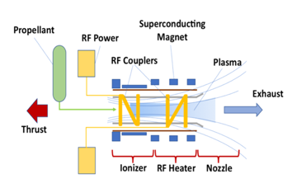
Schematic of the VASIMR® engine. Source: Ad Astra Rocket Company.

Variable Specific Impulse
A unique feature of the VASIMR® engine is its capability to vary or “modulate” the plasma exhaust velocity and total output while maintaining maximum power. This technique, called “Constant Power Throttling,” is similar to the function of the transmission in an automobile in adapting to the conditions of the road. Two parameters are varied during a typical operation: the total mass flow rate leaving the rocket and the velocity of the particles leaving at the rocket exhaust. The two modalities are similar to the low and high gears of an automobile transmission, which are used, judiciously, depending on the need for torque or speed on the vehicle’s route. With VASIMR®, as the ship moves away from a planet’s gravity, the thrust can be reduced and the specific impulse increased to reduce the fuel consumption. The reverse is true as the ship slows down to enter and orbit about its destination planet. This variability results in optimum performance and does not exist in present-day rockets.
Near Earth, powered by solar energy, the VASIMR® engine is designed to be able to propel robotic cargo missions with very large payloads to the Moon, Lagrange points and geo-stationary space. Ad Astra plans to pursue commercial opportunities in these markets through the development of a solar-powered space tug. A conceptual design of this multipurpose space tug is shown below.
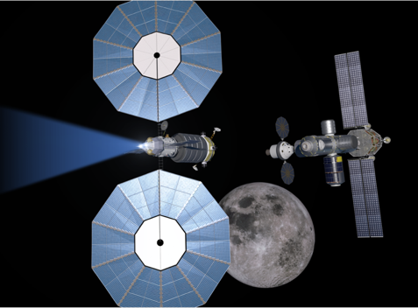
A conceptual VASIMR® space tug. Source: Ad Astra Rocket Company
For missions in deep space, nuclear generated electricity coupled with high power VASIMR® propulsion could dramatically shorten human transit times between planets. VASIMR® could reduce the long trip times and small payload-to-propellant ratios imposed by the use of conventional rockets.
Efficient plasma generation, heating and controlled exhaust from the magnetic nozzle are key features in the engineering of VASIMR®. Powerful, yet compact and lightweight, superconducting electromagnets create a strong magnetic field (similar to an MRI medical scanner) necessary to control the hot plasma and isolate it from nearby structure. Electromagnetic waves (radio waves) are used to produce the plasma in the “ionizer” and also to heat it to the desired conditions in the “RF heater.”
  - The critical components that comprise the VASIMR® system include:
- High-temperature superconducting magnets,
- High-power, efficient and compact RF technology; and
- Space-qualified cryocoolers for the required temperature range.
These technologies have been developed by Ad Astra’s team or by other private companies with whom Ad Astra has established contact.

VASIMR® at a power of 200 kW
The VF-150TM model, operating at a power level of 150-200 kW, was chosen by Ad Astra as its first commercial engine. The VF-150TM is intended to supply primary propulsion for applications such as maintenance of orbital space stations, satellite refueling/servicing, payload transport to the moon, de-orbiting dead satellites and robotic planetary missions. With the growing power capability of space solar arrays (and the increasing interest in space nuclear power), these applications are expected to take advantage of the higher specific impulse and power capability of the VASIMR® system as compared to existing electric propulsion technologies.
The VASIMR® engine provides several advantages over competing technologies, including:
  - Much higher specific impulse (I_{sp}) than chemical rockets or other plasma rockets.
Technology | Chemical (measured | Hall Thruster (Xenon, measured) | VASIMR® (Argon, measured) | VASIMR® (Hydrogen, estimated)
Specific Impulse (sec) | 300-500 | 2800 | 5000 | 10000
Typical specific impulse (I_{sp}) values for various propulsion technologies. Source: Ad Astra Rocket Company
  - Capability to vary or “modulate” the specific impulse and thrust to optimally match the mission requirements.
This feature enables unprecedented flexibility to deliver payloads with the least amount of propellant. The variability of the specific impulse is achieved by two principal techniques: a) variation of the power ratio delivered to the first and second stages of the engine and b) variation of the propellant atomic mass (i.e., using a lighter propellant such as Argon increases the I_{sp} and reduces the thrust while a heavier gas such as Krypton increases the thrust at the expense of I_{sp}) Engine operational efficiency as a function of I_{sp} for various propellants is shown below.
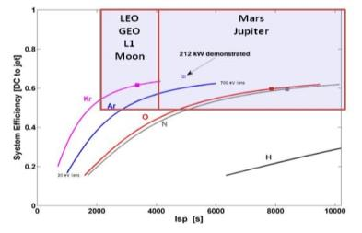
Engine efficiency for various propellants. Source: Ad Astra Rocket Company
  - High power density
VASIMR® operates at higher power density than competing plasma rockets. This important feature of the basic physics of the engine implies a more compact design at high power as compared with other electric thrusters. This is shown schematically below as a comparison of the power density characteristic of two other competing technologies: the ion engine and the Hall effect thruster. As seen in the diagram, the ion engine, having no magnetization has a power density of the order of 40kW/m²; the Hall thruster exhibits weak electron magnetization and can achieve a 5-fold increase in power density to 200 kW/m²; finally, the VASIMR® with both electron and ion magnetization further increases the power density another order of magnitude to 4000 kW/m².
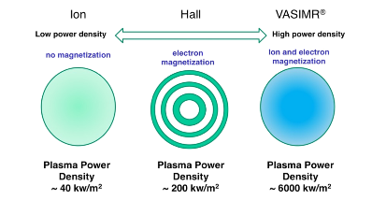
Engine power density comparison with two other technologies. Source: Ad Astra Rocket Company
  - Uses a variety of naturally abundant fuels.
This important feature implies lower propellant costs. Presently, virtually all competing electric propulsion systems in use or under development use Xenon as the propellant. However, this gas is extremely scarce in nature and expensive to produce. VASIMR® experiments have shown the feasibility of operation with a variety of readily abundant propellants such as Argon, Krypton, Neon, Nitrogen, Deuterium and Hydrogen. Furthermore, propellants such as Nitrogen, Deuterium and Hydrogen can be delivered to space as stable and easily storable chemical compounds such as ammonia and water. The use of water could also provide a means for delivering oxygen for the human crew of a space station or a lunar habitat.
  - Electrodeless.
The absence of electrodes or grids in VASIMR® greatly reduces component erosion issues. VASIMR® relies on electromagnetic waves (radio waves) to deliver the power to the working fluid (the plasma). In contrast to other electric rockets where physical electrodes or grids come in contact with the plasma, VASIMR®’s electromagnetic antennas (also called “couplers”) are outside and protected from the plasma by the magnetic field. The figure below shows a comparison between a VASIMR®–generated plasma and that generated by a similar power competitor, the MPD device.
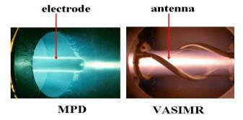
The VASIMR® is an electrodeless device (right), eliminating internal electrodes (left) that are eroded by the plasma flow. Source: Ad Astra Rocket Company
  - Scalable
The VASIMR® engine is scalable, allowing it to be used for near Earth or cislunar applications with solar electric power and deep space applications with nuclear electric power. This scalability is not present in competing electric rocket systems where high-power operation implies increasingly larger engines or clusters of engines. This limitation for competing designs is caused mainly by exposed electrodes and grids where material erosion is the limiting factor.
  - Fuel-efficient
The VASIMR® engine is expected to be capable of maintaining large platforms, such as the International Space Station, in orbit at a fraction of the cost of the conventional rockets that are currently used for this purpose. This is a direct consequence of VASIMR®’s higher specific impulse. The figure below is an estimate of the fuel delivery cost differential for providing annual atmospheric drag compensation services to the International Space Station with VASIMR® vis-à-vis conventional chemical propulsion.
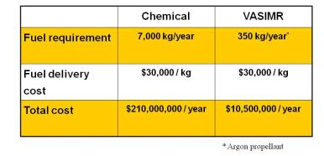
Estimated annual fuel delivery costs for drag compensation of the International Space Station. Source: Ad Astra Rocket Company

Technology Readiness Level (TRL)
NASA uses TRLs to measure the maturity of a technology. The TRL ratings provide a metric for determining risk associated with the insertion of new technology. A copy of the official document explaining TRLs can be found at the following link:
http://www.hq.nasa.gov/office/codeq/trl/trl.pdf
  - The TRL ratings can be summarized as follows:
TRL1: Basic principles observed and reported
TRL2: Technology concept and/or application formulated
TRL3: Analytical and experimental critical function and/or characteristic proof-of concept
TRL4: Component and/or breadboard validation in laboratory environment
TRL5: Component and/or breadboard validation in relevant environment
TRL6: System/subsystem model or prototype demonstration in a relevant environment (ground or space)
TRL7: System prototype demonstration in a space environment
TRL8: Actual system completed and “flight qualified” through test and demonstration (ground or space)
TRL9: Actual system “flight proven” through successful mission operations
NASA does not issue opinions regarding the TRL achieved by private companies. Ad Astra has not obtained an independent assessment of the TRL of the VASIMR® technology.

Present Status and Near-term Plans
Ad Astra has completed more than 10,000 successful high-power firings of its most advanced VASIMR® prototype, the VX-200™ in the company’s Houston vacuum chamber facility. These tests demonstrated the engine’s excellent firing repeatability and performance (6 N thrust, 5000 sec I_{sp} and a thruster efficiency greater than 70%) with no measurable signs of engine wear.
To optimize company resources, however, the above tests were all of short duration (less than 1 minute) sufficient to reliably establish the rocket’s performance and measure thermal loads. Long duration (several hours) operations are now being conducted to demonstrate the engine’s new proprietary core design and thermal control subsystem and better estimate component lifetime.
These technological advances were incorporated, under the NextSTEP NASA contract, in a fully integrated test article called the VX-200SS™ (SS= Steady State). In July of 2021, Ad Astra successfuly completed an 88-hour, high power (80 kW) endurance test of the VX-200SS™ demonstrating the operation of the rocket core’s thermal management system.
Following these tests, Ad Astra is now focusing on demonstrating thermal steady state operation of the VX-200SS™ at a power level of 100 kW. These activities are expected to be completed in 2025.

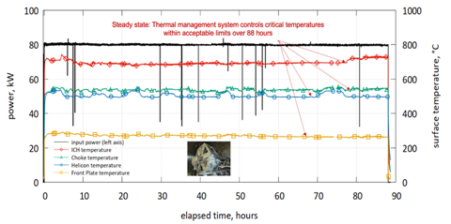
VX-200SS™ 80 kW, 88-h, high-power endurance test results; Source Ad Astra Rocket Company
Anticipating the completion of >100 kW operation in thermal steady state, Ad Astra is now developing plans for the next logical step in the VASIMR® technology maturation: the development of the VF-150TM flight demonstration engine, shown in the figure below.
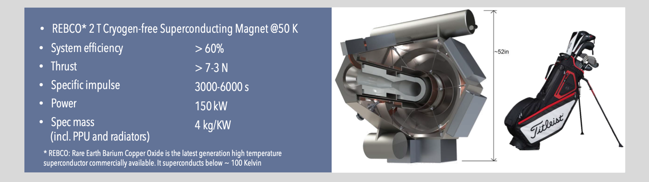
Ad Astra envisions the VF-150TM as its first commercial engine. Its 2 Tesla, Rare Earth Barium Copper Oxide (REBCO) cryogen-free high temperature superconducting magnet would operate at 50 K, using the latest generation of superconducting tape commercially available. Source: Ad Astra Rocket Company
Funding requirements to develop the first flight engine are estimated to be approximately $100 M over a period of approximately 4 years. When completed, the VF-150TM would bring the VASIMR® technology to TRL-6.
To bring the VASIMR® engine to flight readiness, Ad Astra is developing a 4-year plan for the construction of two TRL-6 engines, the VF-150TM-1 and VF-150TM-2 in a staggered parallel schedule (see the figure below). The development of VF-150TM-1 will precede that of VF-150TM-2 by approximately 6 months. This period is designed to allow lessons learned in the manufacturing of (-1) to be incorporated in the manufacturing of (-2). The development of (-2) is expected to be slightly shorter and both engines are planned to be completed by Q1 of 2028.
Learning from the development process is expected to lead to VF-150TM-2 being ready for flight integration first, leaving VF-150TM-1 as a ground engineering model, which could be upgradable to flight with minor effort in the event of a failure in the first mission, not attributable to the engine hardware. By the same token, given a successful first flight, VF-150TM-1 could also be readied for flight in a semi-commercial discounted mission with a potential payload customer on board.
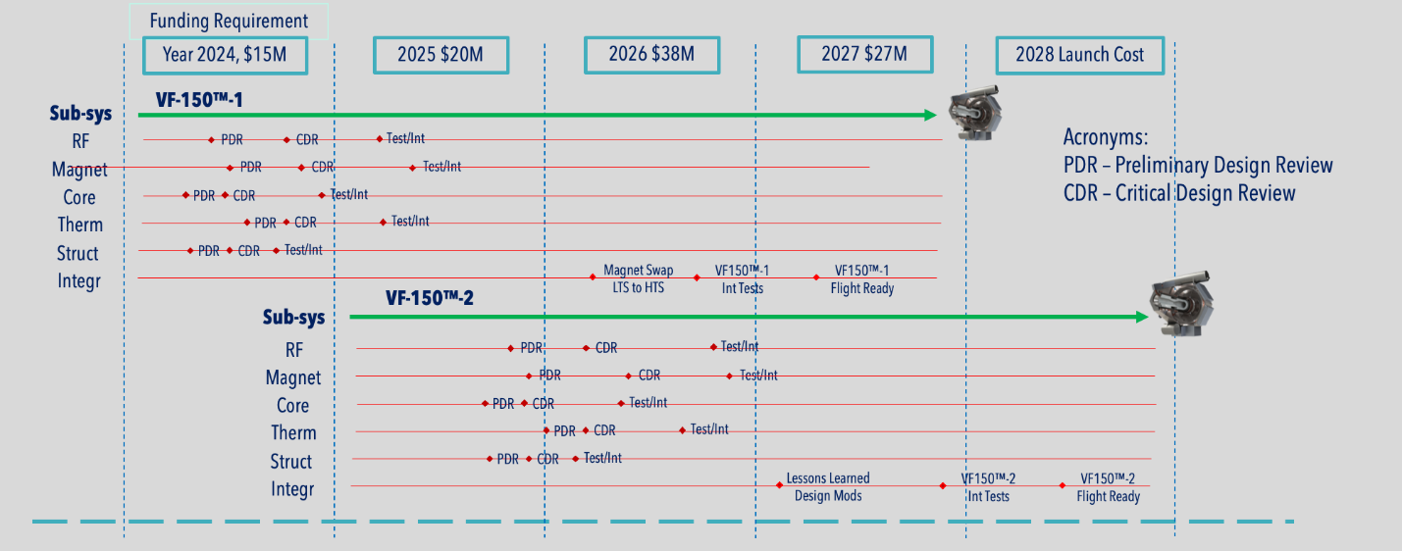
4-year staggered schedule for the development of the VF-150TM-1 and VF-150TM-2 engines. Source: Ad Astra Rocket Company
Upon Authority to Proceed (ATP) for the next phase of development, Ad Astra would initiate a number of major parallel projects in system design and manufacturing, including a new rocket core, a high temperature superconducting magnet, a new TRL-6 RF PPU system frm from Aethera, among others. These major elements are shown in the figure below.
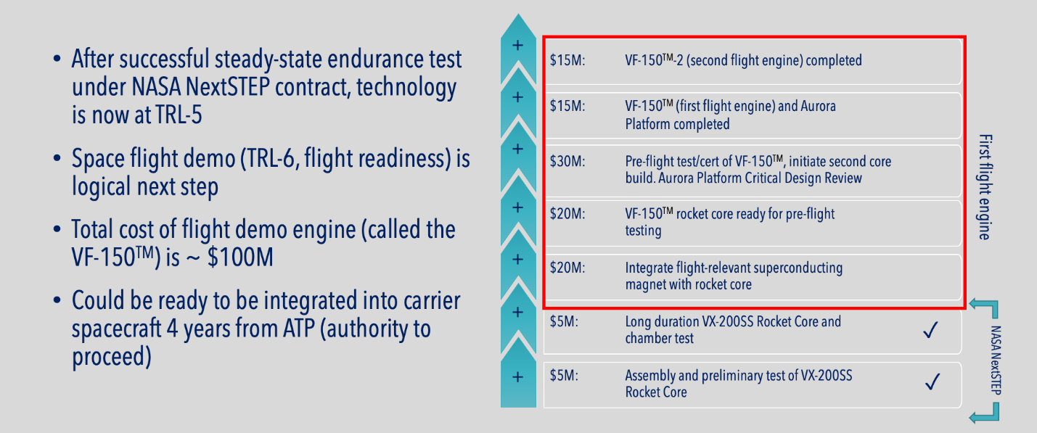
Major development elements and funding requirements for the VF-150TM technology maturation. Source: Ad Astra Rocket Company

Chronology of major development elements for the VF-150TM flight demonstration
Beyond these demonstrations, Ad Astra plans to fill a developing high power transportation niche in the Earth-Moon environment, including drag compensation of large orbiting space stations in low Earth orbit (LEO), the delivery of large payloads to the lunar surface and Lagrange points, recovery and repositioning of dead satellites to graveyard orbits, or to disposal trajectories to the sun or elsewhere, access to potential space resources existing in Near Earth Objects (NEOs), such as asteroids and comets and propelling cargo and human missions to Mars and beyond. A VASIMR® lunar cargo tug could deliver more than twice the payload to the surface of the Moon, as compared to a conventional chemical stage.

Chronology of Technical Accomplishments
Since its inception in 2005, Ad Astra has endeavored to mature the technology base of the VASIMR® engine with focused experiments and technology development programs. Over the years, these programs have yielded valuable results and enabled the company to bring the TRL of the engine from 2 to approaching 6. The completion of the current NextSTEP program with NASA has reached TRL-5 and positions the company for achieving TRL-6 in a space flight demonstration test. The figure below shows a brief chronology of major accomplishments in the technology maturation program since the company’s inception in 2005 with a combination of private investment and NASA-funded contracts.
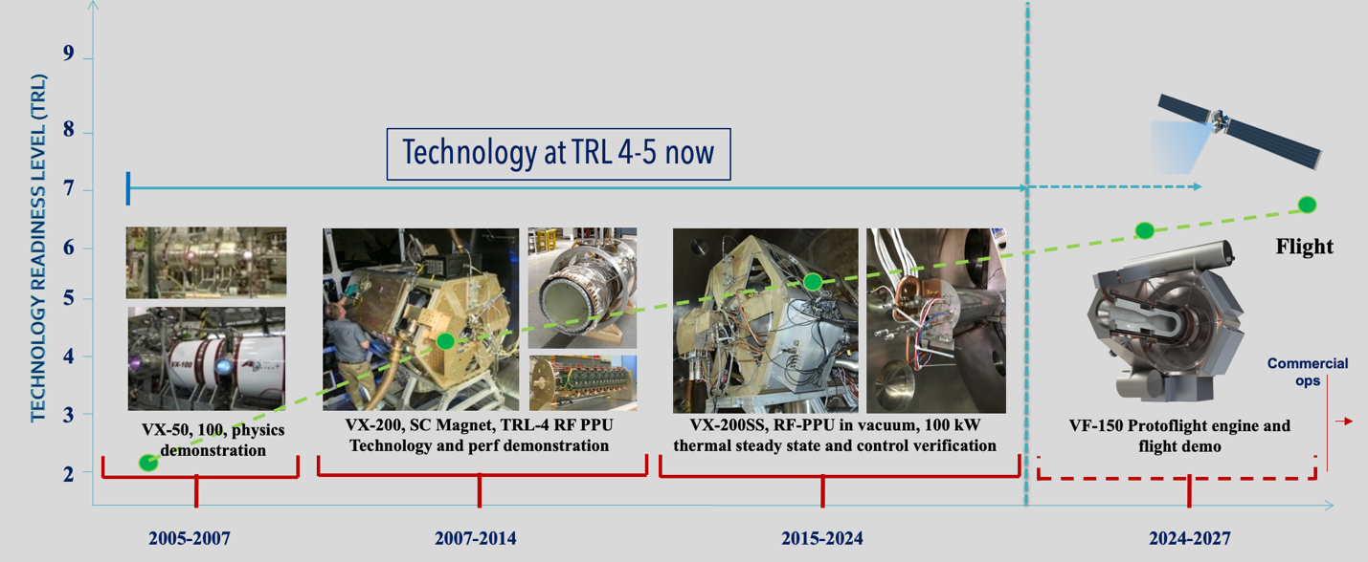
Technology Maturation Milestones. Source: Ad Astra Rocket Company
  - Highlights in the TRL development:
2006 successful demonstration of efficient operation with Neon and Argon, propellants
2009 Ad Astra demonstrates high power operation in the VX-200 ground prototype.
2010 VX-200 experiment achieves excellent thruster efficiency at full 200 kW rated power (see figure below).
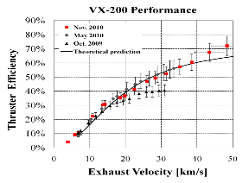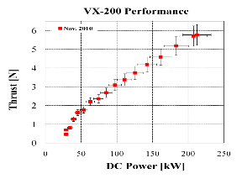

Thruster efficiency vs exhaust velocity (~specific impulse x 10) and thrust vs input DC power. Results are shown for three separate experimental campaigns in October 2009, May of 2010 and November of 2010. Hardware refinements to the second stage led to significant performance improvement. Source: Ad Astra Rocket Company

2011 VX-200 Experiments measured the krypton ionization cost, another propellant of interest.
2012 Full characterization and optimization of VX-200 performance
2013 Initial design of the VX-200SSTM (SS=Steady State)
2014 Negotiations with NASA on VASIMR® funded program, proposal submission
2015 Proposal evaluation and NexSTEP, 3-year contract award for the VX-200SSTM
2016 New rocket core demonstrated, 1st year contract successfully completed, 2nd year approved
2017 Third year approved by NASA, 100 hour cumulative high-power operation completed
2018 Canadian Space Agency support for VASIMR® RF Power Processing Unit (PPU)
2020 High power RF PPU full power operation demonstrated in vacuum.
2021 VASIMR® VX-200SSTM high power endurance test (88 hrs at 80 kW) completed
2023 Improved thermo-mechanical design of RF coupler assembly and second stage RF transmission line

Major Technical and Business Goals
  - Demonstrate VASIMR® in space
This is the most important near-term goal of the Ad Astra team. Laboratory experiments have demonstrated the solid physics foundations on which the VASIMR® technology is based. At the same time, systems engineering studies show the general characteristics and performance of a flight system. Present activities combine the physics and the engineering into a demonstration prototype denoted as the VX-200 (for VASIMR® experimental prototype at 200 kW), which has been extensively tested in the laboratory vacuum chamber, along with its steady state derivative, the VX-200SSTM. The test of the VF-150TM is the logical next step.

  - Develop a commercial arm to market the technology
Several profitable business ventures will be possible, some immediate, others later. VASIMR® technology can also be used to support national and international space transport operations, including in-space resource recovery from near-earth asteroids and comets and orbital operations of commercial facilities being proposed for space tourism and research. A VASIMR® driven space tug could be used to access the constellation of satellites orbiting geostationary space for re-supply, maintenance and repair, and to provide a mechanism for disposal and cleanup of orbiting debris.
Ad Astra’s primary mission is to develop the VASIMR® engine and associated technologies, and to provide high performance electric propulsion services to meet the needs of an emerging market as shown in the figure below. Ad Astra plans to develop infrastructure to test new electric propulsion technologies in space, including future test facilities on the surface of the Moon.
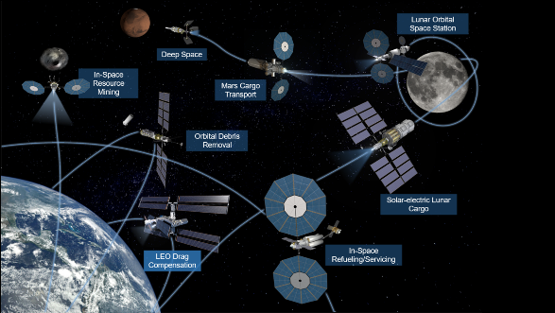
Emerging in-space logistics services market where propulsion is the common denominator. Source: Ad Astra Rocket Company

CHAPTER 6: VASIMR® ECONOMICS and Business Opportunities
The cost of launching rocket fuel into space is a major driver in the cost of space operations. Plasma rockets require much less fuel to operate. For example, the propellant required by a VASIMR® engine to maintain the International Space Station in a stable orbit for one year is 1/20 of that required by a conventional chemical rocket, leading to major cost savings. Such savings would also enable a number of commercial missions to Earth’s satellite constellation, including servicing, refueling, repositioning and end-of-life disposal. A similar analysis applies to supply missions to the Moon and a number of other applications in Earth orbit and beyond.
VASIMR® also exhibits advantages over other competing plasma rockets due to its electrode-less design and its use of inexpensive and abundant propellants such as argon, neon and hydrogen. Other systems tend to suffer from wear and erosion of electrodes immersed in the hot plasma, and the use of Xenon propellant in these systems tends to make them much more expensive to operate. The current price of commercial Xenon is about $1000/kg, compared to Argon at about $5/kg.

The Market
In recent years, private investment in non-government commercial spaceflight projects has grown. Major industry participants, such as SpaceX, Bigelow Aerospace, Virgin Galactic, and Blue Origin are continuing to develop suborbital and orbital transport vehicles and modular space stations. VASIMR® is expected to perform the following functions in this emerging economic arena at a fraction of the cost of competing technologies:
- Satellite repositioning
- Satellite decommissioning/disposal
- Satellite refueling, maintenance and repair
- Drag compensation for space stations
- Lunar cargo delivery
- Ultra-fast deep space robotic missions
- In space resource recovery

Business Strategies and Technology Implementation Elements
The fundamental benefit of electric/plasma propulsion comes from a drastic reduction in propellant requirement as compared with conventional chemical propulsion. However, historically, the application of these technologies has been limited by the low power characteristic of present-day spacecraft. These boundary conditions are rapidly changing, however. The growing availability of abundant solar electrical power (for applications in the Earth-Moon environment) and the potential of nuclear electric power (for deep space missions) has created a high-power electric propulsion niche, which is currently unfilled. Ad Astra aims to further develop and fill this market opportunity through a number of technical activities as described below.

  - The “Aurora” Power and Propulsion Test Platform
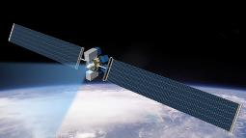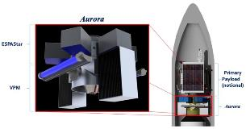
A conceptual rendering of the fully deployed Aurora System (left) and in its stowed configuration within the shroud of a notional orbital delivery vehicle (right). Source: Ad Astra Rocket Company
The first planned space tests of the VASIMR® engine are expected to be supported by Ad Astra’s “Aurora,” a commercial electric power and propulsion testbed designed to operate in space. A major objective of the Aurora System is to test the performance of Ad Astra’s 150-200 kW VF-150TM VASIMR® engine in the space environment. The Aurora System could be delivered to space by a commercial launcher and robotic orbit transfer vehicle (OTV), such as Northrop Grumman’s Cygnus Vehicle or other commercial delivery vehicles still under development. A conceptual design of the Aurora System has been proposed for installation on the starboard side of the Z1 truss on the International Space Station. Along with the appropriate electrical and mechanical interfaces, the Aurora System comprises two main elements:
  - The Propulsion module (PRM): Consists of the VF-150TM VASIMR® engine and associated components
  - The Platform module (PLM): Consists of the structural assembly supporting all elements of the Aurora system. It includes the PLM thermal subsystem, electrical (batteries and PMAD), command/data routing and carrier structural interfaces
The VF-150TM VASIMR® engine, which constitutes the main element of the Aurora System, is an advanced 150-200 kW electric thruster that uses radio waves to ionize argon propellant and magnetic fields to accelerate the resulting plasma, producing useful thrust. The space test is part of Ad Astra Rocket Company’s comprehensive business plan to field the technology in space in support of future commercial human and robotic transportation missions in cislunar and interplanetary space. The VF-150TM is expected to generate a total thrust of approximately 5 N at a specific impulse of approximately 5000 seconds. The VASIMR® technology is intended to combine the advantages of both, high and low thrust/I_{sp} propulsion systems. The Aurora System will feature an energy storage module that will enable pulses of up to 150-200 kW for periods of several minutes.

Business concepts post initial space test
The successful flight of VF-150TM -1 will validate the VASIMR® engine design, which will be offered to US and approved international customers in a variety of venues. The flight validation of the VASIMR® engine design should enable a variety of applications for this class of engines as primary propulsion for robotic solar-electric spacecraft, all of which exhibit more capability and operational economy than conventional chemical rockets. Some examples of these applications are:
- Integration of VF-150TM-1 in a free flyer mission, as described earlier, could be initiated immediately upon successful achievement of the space test of its twin, VF-150TM-2. High power solar electric propulsion (SEP) is widely considered a priority requirement for a robust space transport infrastructure.
- A commercial Low Earth Orbit (LEO), high power solar-electric space-tug could be used for orbital debris mitigation. The VASIMR® engine can enable these missions at a fraction of the cost of its closest competitor. Please see:
https://www.adastrarocket.com/our-engine/applications/space-debris-removal/
and https://www.adastrarocket.com/pdf/VASIMR-Orbital-Cleaner.pdf
- Service and Support to Satellites and Cislunar Cargo Transport, such as refuel, repair and reposition could be enabled by a high power VASIMR® solar-electric tug. Such services to government and commercial customers could provide significant cost savings to the industry. Please see:
https://www.adastrarocket.com/our-engine/applications/cargo-transfer-to-the-moon/
and https://www.adastrarocket.com/pdf/Cargo-Delivery-to-L1.pdf
- Re-boost/orbit maintenance services for orbiting space stations could be provided by Ad Astra’s autonomous commercial solar electric power and propulsion module at a fraction of the cost of present day chemical rockets.
https://www.adastrarocket.com/our-engine/applications/space-station-reboost/
- Ad Astra’s re-usable high power commercial deep-space catapult could field robotic packages to the outer reaches of the solar system faster and more economically than conventional rockets. Transit time would be cut down to a fraction of current times. Please see:
https://www.adastrarocket.com/our-engine/applications/fast-robotic-missions-in-deep-space/
and
https://www.adastrarocket.com/pdf/Ad-Astra-Deep-Space-Catapult-06-27-2014.pdf
- Ad Astra’s “Viento” Asteroid Deflection Vehicle concept could intercept and deflect an asteroid threat to our planet, such as the meteor that fell over Chelyabinsk, Russia in 2013. Please see:
https://www.adastrarocket.com/our-engine/applications/asteroid-mining-deflection-and-in-space-resource-recovery/
and
https://www.adastrarocket.com/pdf/VASIMR-Asteroid-Deflection.pdf
- A VASIMR® Propelled Resource Recovery Tug could provide ample performance to efficiently capture and reposition asteroids for mining and resource recovery. NASA and other private companies are currently considering such missions. Please see:
https://www.adastrarocket.com/our-engine/applications/asteroid-mining-deflection-and-in-space-resource-recovery/
For a more detailed graphical, technical and financial information of these missions, please visit our website.
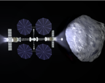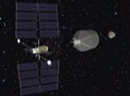

Competition
NASA and some private enterprises are investing limited resources in the development of advanced propulsion systems designed to overcome the shortcomings of conventional chemical rockets. Some of these systems may in the future compete for market share with the VASIMR® engine. Of these, the most likely competitor is the Hall Effect Thruster (HET).
Unlike the VASIMR® engine, Hall thrusters rely on application of an electric field to accelerate the propellant directly. These systems are well suited for low power (approximately 5 kW) applications for satellite station-keeping maneuvers, as their controlling physics does not scale well at high power density. One shortcoming of these engines is their reliance on the propellant Xenon, a rare and expensive gas.
In the high-power niche, the VASIMR® competes with the high-power Hall thruster and the less mature Magnetoplasma Dynamic Thruster (MPD). In 2015, NASA established a controlled competition of three high-power propulsion technologies: the ELF Thruster from Mathematical Sciences Northwest (MSNW), The Nested Hall Thruster from Aerojet Rocketdyne and the VASIMR® VX-200SSTM engine from Ad Astra. The competition required for each technology to demonstrate 100 hours in thermal steady state at 100 kW. Of the three, the VASIMR® VX-200SSTM surpassed its competitors in power and duration by two orders of magnitude, completing an endurance test of 88 hours at 80 kW in the vacuum environment. The competitive landscape is likely to move to even higher power with the inception of nuclear electric space power. In this area, the scaling of the VASIMR® engine is even more favorable. The figure below shows the results of the NASA high-power endurance test competition.
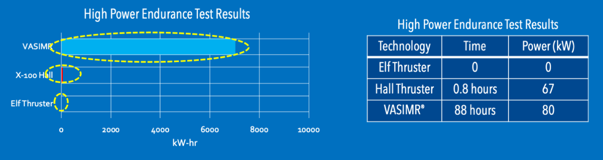
Results of the NASA high-power endurance test competition. Source: Ad Astra Rocket Company

Company Strengths
Ad Astra’s management team believes that the following strengths provide it with a competitive advantage:
- The Ad Astra team contains a well-balanced mix of business, technical and operational experience. Ad Astra builds on a solid scientific foundation. The VASIMR® early development took place over 25 years of research by a highly qualified multidisciplinary team from NASA, the national laboratories and academic and research centers worldwide. These studies laid the foundation for the present technology and demonstrated the controlling physics of the engine.
The Houston and Costa Rica teams comprise a strong skill mix of young talent of engineers, scientists and technicians in the Costa Rica facility combined with the more seasoned US research team.
- Ad Astra’s Costa Rica and Houston teams have reached a high degree of operational maturity and work together to enable the timely accomplishment of Ad Astra’s technical milestones.
In the course of developing the VASIMR®, Ad Astra has developed a number of unique skills and capabilities that are, in and of themselves, marketable. A complete list is given below with some illustrative examples:
  - Mission design and analysis
  - Space environmental testing
  - Engineering design
  - Computer modeling
  - Electrical and RF power
  - Manufacturing
  - Thermal engineering
  - Plasma materials testing
  - Intense plasma sources
  - Plasma measurements
  - Optical systems
  - High temperature radiators
  - Cryogenics
  - Magnetic fields and superconductivity
  - Advanced graphics and animation capability
  - High power plasma sources
The Ad Astra team has decades of aggregate experience in the development and testing of intense high-power plasma sources with ion and electron heating. Ad Astra has developed this expertise working with helicon RF sources and other inductive and capacitive plasma discharges on a wide variety of gases, including hydrogen, deuterium, helium, nitrogen, argon and xenon.
  - Plasma diagnostics
Alongside the development of plasma sources, Ad Astra has also acquired unique expertise in plasma diagnostics, including infrared sensors, optical and mass spectrometers, residual gas analyzers, ion flux, double, triple and guarded Langmuir probes, plasma force and momentum sensors, microwave interferometers, EMI sensors, three-axis magnetometers, retarding potential energy analyzers. These skills enable Ad Astra to compete in a set of highly specialized fields in energy, environmental sciences, medicine, plasma processing and materials science, among others.
  - High vacuum technology
Ad Astra also operates five vacuum chambers at its Houston and Costa Rica facilities ranging in size from the largest at 150 m³ to the smallest at .25 m³. Driven by large cryopanels, the largest chamber can reach hard vacuum conditions at pressures as low as 10⁻⁸ Torr with pumping speeds of 360,000 liters/sec.
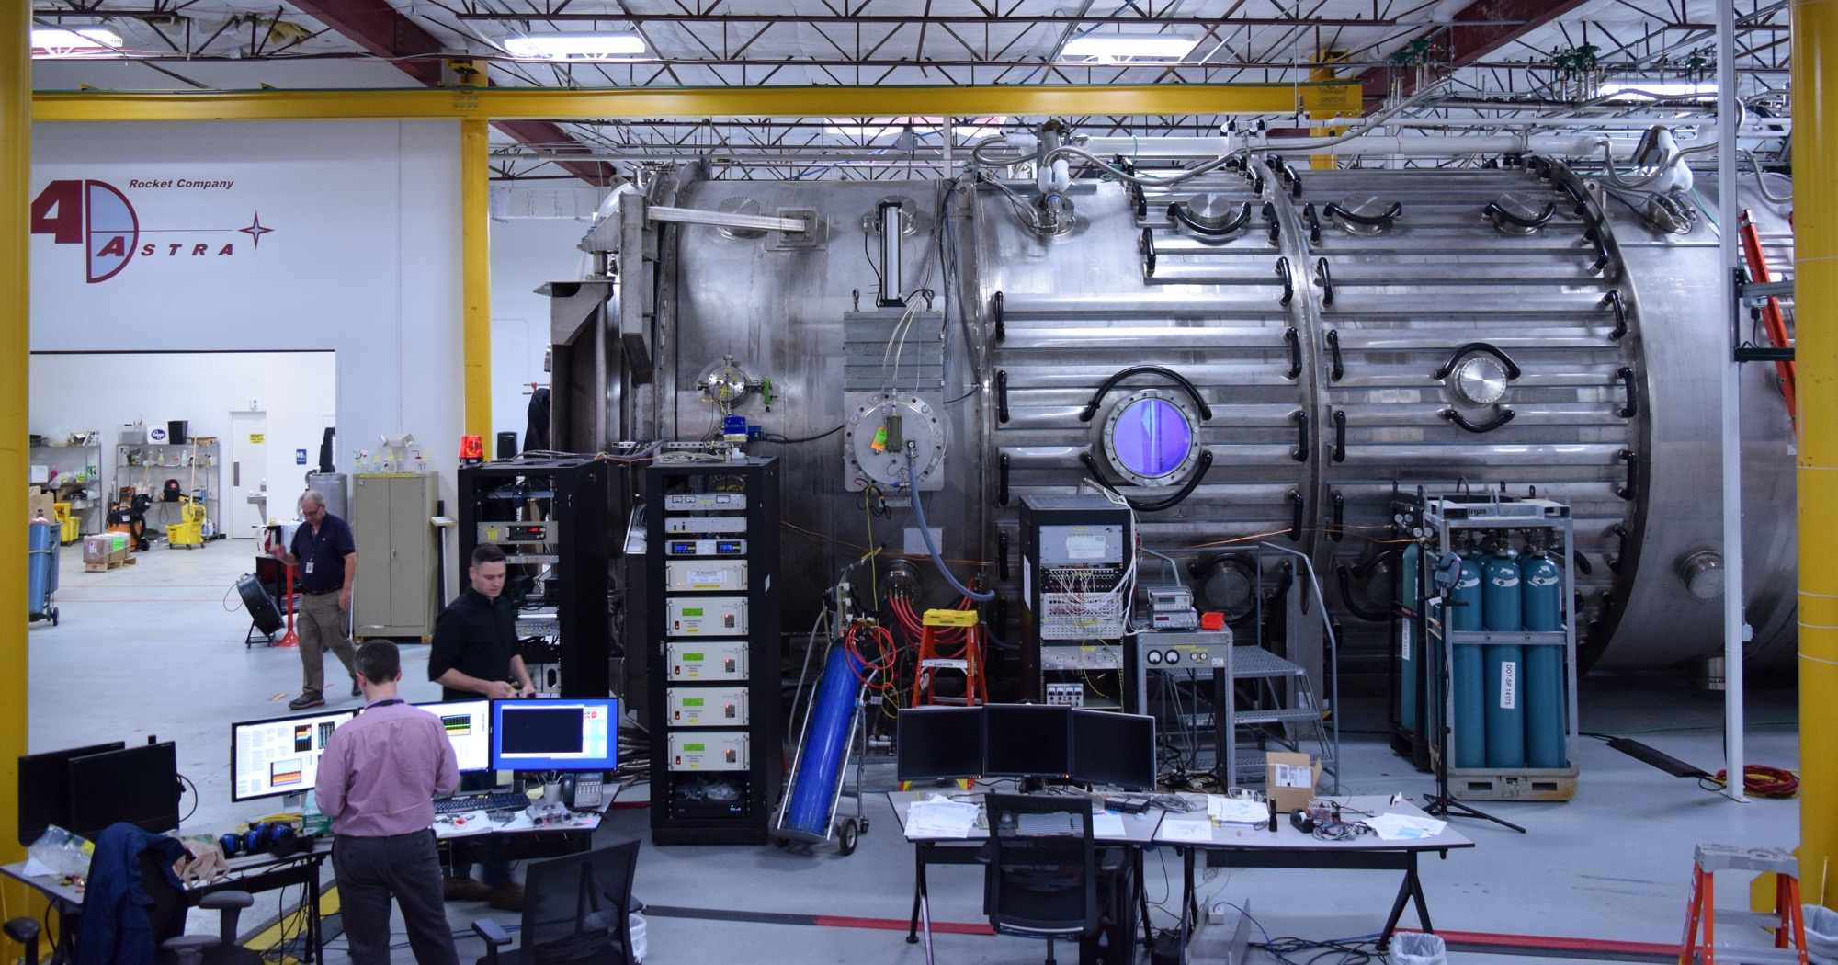
150 m³, < 10⁻⁸ torr base pressure Large Space Simulation Chamber. Source: Ad Astra Rocket Company
  - Flight certified manufacturing
Ad Astra also has a significant manufacturing capability at both locations, including a state-of-the-art flight certified machine shop, capable of manufacturing exotic, one-of-a-kind complicated parts in a variety of materials and with full traceability and in close collaboration with the engineering team.
  - Computerized design and numerical simulation
Ad Astra has also developed a strong capability in computerized design and numerical simulation and analysis, including thermal and structural modeling, as well as advanced simulations of magnetized plasma and RF wave propagation. In addition, Ad Astra’s computer codes can now optimize interplanetary trajectories and mission architectures with high power electric propulsion. These codes are being used to map new approaches in space transportation using the VASIMR® engine.
Ad Astra continues to explore these capabilities as potential generators of early revenue for the company in Earth-bound applications and services.

Alliances, Collaborations and Partnerships
In developing the VASIMR®, Ad Astra benefits from a number of key technologies and capabilities that have evolved elsewhere and are pursued by other companies. For example, the VASIMR® magnetic field is produced by superconducting magnets specially designed to operate in space. The superconducting magnet required for the first VASIMR® prototype was manufactured by Scientific Magnetics Ltd. of Culham, England. New collaborations in superconducting technologies and space systems are being explored with companies and institutions such as Commonwealth Energy of Cambridge Massachusetts, General Atomics of San Diego, California, Raytheon Research of East Hartford Connecticut, D-Orbit Space of Como Italy, among others.
As part of the hydrogen ecosystem project in Costa Rica, Ad Astra has developed collaborations with Air Liquide, a French company and world leader in industrial gases, Cummins Inc. a global power company based in Columbus Indiana; US Hybrid, a US manufacturer of fuel cell transport vehicles based in Los Angeles, California; Relaxury S.A., a Costa Rican transportation company and operator based in the City of Liberia and serving transportation routes in northwestern Costa Rica. In pursuing its business plan, Ad Astra continues to develop appropriate relationships with strategic partners worldwide, which are covered under non-disclosure clauses.

Collaboration with NAUTEL and Aethera, Ltd, Canada.
Ad Astra has maintained a strong research collaboration with NAUTEL, Ltd., of Nova Scotia, Canada and the newly founded Canadian company, Aethera Ltd. also of Nova Scotia. These teams have developed reliable solid state RF technology for the plasma generation and heating in the VASIMR® engine. NAUTEL Ltd., is an industry leader in the design, manufacture and operation of high-power solid-state radio frequency (HPSSRF) systems for communications and other industrial applications and Aethera has been formed as an R&D company by the original team of scientists that developed the existing RF generators. The new company is now improving the design of the system to approach TRL 5 and beyond. Ad Astra has signed a manufacturing contract with Aethera to provide the TRL-5 RF technology needed to support the VX-200SSTM testing activities in vacuum. Aethera, in turn, has also secured a contract with the Canadian Space Agency to support the continuing maturation of the RF system to TRL-6 in support of the commercialization of the VASIMR® engine.

Solar array technology development
Independent of Ad Astra, the U.S. Defense Advanced Research Projects Administration (DARPA) has been developing advanced high-power solar array technology for future applications in high power space propulsion. The company remains interested in these potential developments and continues discussions with potential solar array developers, such as Northrup Grumman Corp and Deployable Space Systems to consider all options for future flight. While NASA and DARPA may be the primary funding agencies for space solar power systems, Ad Astra intends to pursue discussions with other international partners.

Other Potential Applications of Ad Astra’s Electric Propulsion Technology
  - Electrodeless Plasma Sources
Electric/plasma rockets comprise a large and growing family, which includes ion engines, resistojets, Hall thrusters, magnetoplasmadynamic (MPD) thrusters, pulsed plasma thrusters (PPT), pulsed inductive thrusters (PIT) and other derivatives of these systems still in the conceptual stage. Many electric thrusters pose very similar technical challenges as VASIMR®, with consequently similar solutions. While there is already a well-developed market supply for these technologies and hence competition, the demand is both expanding and diversifying, and Ad Astra could bring significant innovation. For example, all plasma thrusters require a reliable plasma generator. The efficiency of this component, measured as the number of ions produced per watt of input electrical power, plays a critical role in the overall efficiency of the rocket. Present-day plasma sources for ion engines and Hall thrusters require physical electrodes, such as hollow cathode discharges in direct contact with the plasma. These components suffer from material erosion and sputtering, which limit their reliability and life. Instead, the VASIMR® team has opted for electrode-less plasma sources, such as the RF-driven helicon discharge. Major advances in this technology have been achieved by Ad Astra, through unique refinements to the basic helicon. Therefore, the VASIMR® helicon could be successfully incorporated in a number of existing electric propulsion systems, such as high-power ion engines and two-stage Hall thrusters potentially enhancing their performance and reliability.
  - Electric/Plasma propulsion testing services in the space environment
Steady state testing of high-power electric propulsion technologies will pose stringent and expensive demands on existing Earth-based facilities. For power levels in the megawatt range, pumping speeds in excess of 10⁶ liters per second will be required in order to maintain acceptable conditions in the exhaust region. For example, a thruster using Xenon propellant operating in full steady state at Isp of 5000 seconds or less and power levels of 100 kW or above, could only be marginally tested in a handful of existing Earth facilities, which are also large and expensive to operate. Thrusters using lighter gases are more severely limited even at modest power levels. In addition, the presence of chamber walls modifies the open boundary conditions of plasma rockets, affecting the measurements and hence the assessment of the true system performance. These considerations and the growing ease of human access to near-Earth space, as compared to two decades ago, have led to a renewed interest in space testing.
Ad Astra envisions capturing an emerging market in space testing of high-power electric rockets and other key space exploration technologies with the development of a power and propulsion test platform to be attached to the International Space Station or an equivalent human rated orbital facility. Operation of this platform in space will enable the side-by-side testing of multiple high-power electric/plasma propulsion technologies and a number of additional technologies as described above. Ad Astra Rocket Company could provide these services to the rapidly growing global electric propulsion community.
  - New applications of plasma technology
In the early days, plasma technology spawned the field of gaseous electronics, which produced the vacuum tube, radio and television, but more recently, plasma physics has exploded into many other areas, including high power lasers, plasma etching of microelectronic circuits, plasma deposition and coatings, materials technologies, energy production, as well as thermonuclear fusion and rocket propulsion.
Two new applications have also been considered: plasma disintegration of highly toxic waste (including medical and biological) and plasma filtering of radioactive waste. In the former, the complex but highly stable biological toxins and toxic hydrocarbon byproducts of chemical refineries and chemical processes, which represent a major public hazard, could be effectively “disassembled” by a plasma device into their harmless elemental components (hydrogen, nitrogen, carbon, etc.)
In the latter, the highly radioactive material (typically only 15% of the existing radioactive waste) could be separated from the remaining (very low radioactivity) 85% by a magnetized plasma filter. In both of these applications, the high-power helicon RF discharge is a potential candidate, and Ad Astra can be an effective contender in this emerging business.
  - Electric Propulsion diagnostics development
The complex physics of plasmas and the need for repeatability and process control has also generated a market for reliable and accurate plasma diagnostics. The Ad Astra team has developed expertise in this area and could produce turn-key diagnostics for a variety of experimental devices and industrial processes. These include: multi band microwave interferometers, total flux, Langmuir, B-dot and Mach probes, retarding potential analyzers, as well as a variety of RF instrumentation and control techniques for helicon and wave driven plasma discharges.
Other areas of Ad Astra involvement include: superconducting systems design and development, cryo and thermal management, spacecraft engineering and integration, CAD and advanced graphics and animation capabilities, system design and general consulting services. The company will also engage in international collaboration (subject to export control).

CHAPTER 7: Costa Rica Operations and company diversification

Operations in Costa Rica
Ad Astra operates two wholly owned subsidiaries in Costa Rica to support technology development for the VASIMR® and other commercial applications, as well as Ad Astra’s growing activities in renewable energy. The subsidiaries operate on a budget of approximately $600,000 per year in a 700 square meter laboratory located on EARTH University, La Flor Campus, in northwest Costa Rica. An aerial view of the Ad Astra’s Costa Rica facility is shown below.
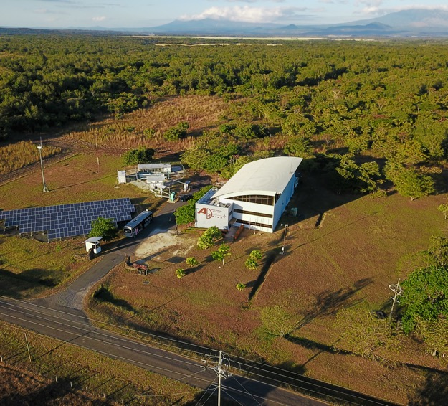
Aerial view in 2022 of Ad Astra Costa Rica laboratory and the company’s renewable energy installations in Costa Rica. Source: Ad Astra Rocket Company

Plasma Research in Costa Rica
A steady-state helicon plasma generator, called the VX-CR, and associated vacuum infrastructure along with the required diagnostics are fully operational and can support life cycle studies of typical VASIMR® materials. An experimental thermal jacket for the VX-CR was designed, modeled, fabricated and successfully tested in the device. The Ad Astra Costa Rica and Houston teams also participated in zero-g investigations of the Sunpower Cryocooler, an important component of the VF-150TM low temperature sub-system. These experiments were conducted as part of NASA’s zero-g flight program. The flights, conducted over the Gulf of Mexico, provided the first opportunity for Costa Rican employees of Ad Astra to experience weightlessness.
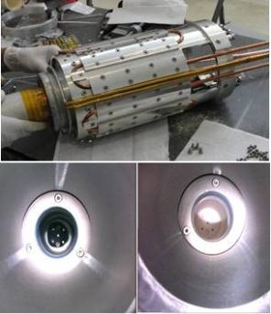
An experimental thermal jacket (top) was developed for the VX-CR experiment that tests a proposed thermal solution for the VF-150TM first stage. Carbon deposits (bottom left) from organic sources, which would degrade long-term operation, have been virtually eliminated (bottom right) with careful engineering. Source: Ad Astra Rocket Company

Company Diversificartion
Through the broad technology portfolio that has resulted from VASIMR® research, the company has also been able to diversify into other areas of business, such as renewable energy, green hydrogen technology, plasma diagnostics, vacuum and cryogenic technology, thermal management, advanced manufacturing, computer simulation and modeling, among others. This diversification has generated revenue for Ad Astra without detracting from the company’s primary space propulsion focus.
A major diversification project completed in 2021 is the construction of the Costa Rica Space Radar, a large electronically steered space radar designed to track objects in low Earth orbit (LEO) as small as two centimeters in diameter. The high precision structure was built by Ad Astra Costa Rica, under contract with the US Company LeoLabs. The Costa Rica Space radar is part of a growing global network of space radars operated by LeoLabs and currently the most advanced and the only such instrument in the equatorial band. Ad Astra Costa Rica built the high-presicion structure and supported LeoLabs in project management, oversight and permitting. The figure below shows the completed and fully operational facility located in a 3 Ha land lease from the Costa Rican sugar mill “El Viejo” near the town of Filadelfia in the province of Guanacaste.

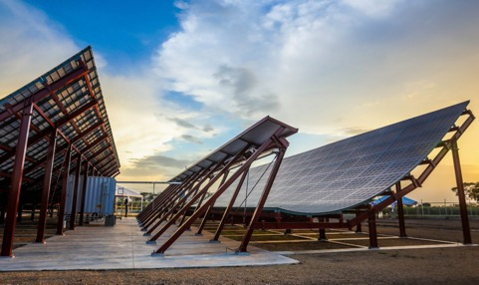
A section of the Costa Rica Space Radar, located in “El Viejo” Sugar Mill, near the town of Filadelfia in the Province of Guanacaste. Source: Ad Astra Rocket Company.
The high precision structure was built by Ad Astra, Costa Rica in an off-site temporary manufacturing facility set at nearby “Solarium” industrial complex, about 15 km west of Liberia. The figure below shows the “A” frame design and their construction and assembly prior to shipment to the construction site.
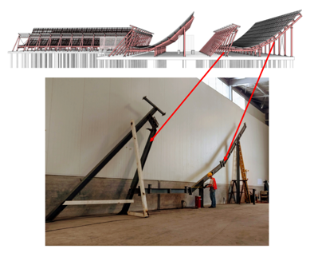
High presicion steel “A” frames were built at a temporary manufacturing facility set by Ad Astra at the “Solarium” industrial complex 15 km west of the City of Liberia

Ad Astra’s Renewable Energy Journey
Through its wholly owned Costa Rican subsidiary, Ad Astra Servicios Energéticos y Ambientales AASEA, S.R.L., the company began developing an integrated program in renewable energy from wind and solar power.
  - Development of mid-scale wind turbines
A wind turbine program was initiated at Ad Astra Costa Rica in 2009 to grow this capability in-house. Three generations of wind turbines have been developed. The initial activity focused on the testing of a Gen III 5 kW turbine with 3.5 m blades. Initial testing of this system was completed in April of 2014. The system is installed outside the laboratory on a deployable tower. The figures below show the stages of development and present status.
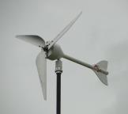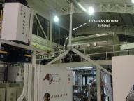
Three generations of Ad Astra wind turbines: (From L to R) Fenhyx-A 0.125kW, Fenhyx-B 0.250kW and Fenhyx-C 5.0 kW. Preliminary 5 kW wind generator tests are conducted in the high bay of Ad Astra’s Costa Rica Laboratory. Source: Ad Astra Rocket Company
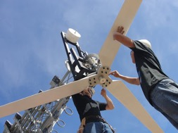
5 kW Wind turbine blades undergo field testing at Ad Astra, Costa Rica. Source: Ad Astra Rocket Company
  - Ad Astra’s 76 kW Solar Power Plant
In April of 2016, Ad Astra Costa Rica completed the installation of a 76-kW solar farm to supply 100% of the company’s electrical needs. The project was completed under contract with SIBO Energy, a small Costa Rican company specializing in solar power generation. The Ad Astra installation falls under the pilot project regulation of Costa Rica’s government owned power utility where the excess energy generated by the solar plant can be “stored” in the country’s electrical grid for future use on an annual basis. The solar plant is fully operational and supplies the full electrical needs of the laboratory since May of 2016.

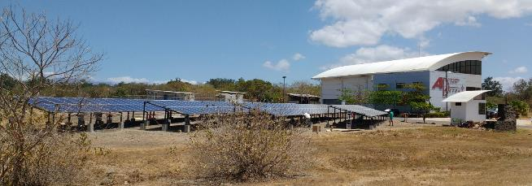
Ad Astra, Costa Rica completed a 76-kW solar installation designed to supply 100% of its electrical power needs. Source: Ad Astra Rocket Company

Green Hydrogen
Costa Rica consumes approximately 170,000 TJ of energy annually, of which more than 70% is provided by the combustion of petroleum-based hydrocarbons, mainly used in transportation. Yet, Costa Rica has no domestic petroleum or natural gas reserves and its significant wind and solar potential are still largely untapped; therefore, the capacity to transition to a hydrogen economy could be a viable option to supply the totality of the nation’s energy needs.

Hydrogen – Biogas Power Generation
In September of 2011, the company initiated joint investigations with Cummins Inc. (NYSE, CMI) to transform an internal combustion motor-generator from gasoline to hydrogen and mixtures of that gas with other hydrocarbons. For example, hydrogen accelerates the speed of combustion of biogas, transforming it into an attractive fuel for internal combustion motor-generators. The Project seeks a potential niche of commercial application in agricultural regions such as Costa Rica’s Guanacaste province and in regions and countries with similar conditions. The hydrogen would be generated by solar and/or wind energy. The 7.3 kW hydrogen-biogas electric generator was successfully tested and remains operational at the Ad Astra facility. The project demonstrated the potential for clean energy production in small farming communities and rural areas in Central America and other parts of the developing world where access to conventional petro-fuels (gasoline, diesel, etc) may be difficult and/or expensive.

The 7 kW Cummins Hydrogen/Methane power generators undergoes optimization tests at Ad Astra’s Costa Rica Laboratory. Source: Ad Astra Rocket Company.

Hydrogen Storage Technology with Costa Rica’s RECOPE
On October 12, 2011, Ad Astra Costa Rica, SRL signed a $300,000 contract with Costa Rica’s state-owned oil refinery (RECOPE) to define a conceptual advanced hydrogen storage system, as part of Ad Astra’s exploratory hydrogen-based power generation initiative. The six-month (phase A) project delivered, on April 12, 2012, a conceptual system design as well as construction costs and schedule estimates for RECOPE’s evaluation and potential execution (phase B) by Ad Astra. The 1.4 M$ phase B was approved by RECOPE and successfully completed by Ad Astra on December 12, 2013. On February 24, 2014 a $400,000 subsequent expansion of the project (phase C1) was also approved and completed in August of 2014. Phase C1 provided operational experience with the new system and delivered a conceptual design and budget for a hydrogen dispenser station.
In 2014, a change in the country’s leadership prevented RECOPE from continuing the transition to green hydrogen. However, Ad Astra continued with infrastructure development, independent of RECOPE, through a private-public partnership, led by Ad Astra, which included Costa Rica’s Sistema de Banca para el Desarrollo (SBD) and four other companies, including Air Liquide, a world leader in gases, technologies, and services for industry and health; US Hybrid Corporation, specializing in hydrogen fuel-cell electric vehicles, Cummins Inc. a US global power leader in diesel and alternative fuel engines, and Relaxury S.A., a subsidiary of Costa Rica’s Purdy Motor S.A.
The image below shows Ad Astra’s initial vision for Costa Rica, a public transport pilot demonstration ecosystem, based on hydrogen generated from carbon-free renewable energy that could also allow the partnership to measure its financial sustainability, business potential and its relevance to Costa Rica and the region. Ad Astra provided the coordination and leadership to this public-private partnership. The integration of the electric generation and hydrogen dispensing elements were accomplished in March of 2017 and complemented the existing hydrogen production infrastructure. A regional mass transit demonstration, featuring a hydrogen fuel cell electric bus entered initial operations in November of 2017.
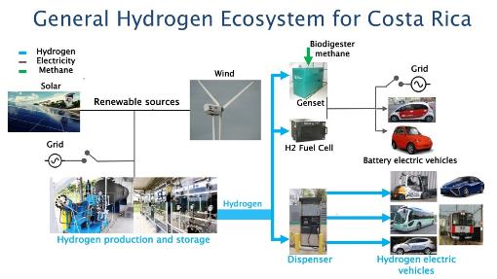
Ad Astra’s Hydrogen Ecosystem for Costa Rica. Source: Ad Astra Rocket Company

First Hydrogen Fuel Cell Electric Bus
Costa Rica’s first fuel-cell electric bus was manufactured by Belgium’s Van Hool for US Hybrid Corp, who integrates the fuel-cell electric power train. It has a seating capacity for 35 passengers and an approximate range of 338 km on 38 kg of compressed hydrogen.
Other vehicle applications are being considered as the ecosystem expands. Hydrogen-electric transportation could help free Costa Rica from its dependence on imported oil, retaining a sizable portion of its GDP currently used to import fossil fuels. About 70% of Costa Rica’s energy is consumed by highly polluting transportation. With the Liberia installation, Costa Rica joins Brazil and Argentina as the third Latin American country to adopt hydrogen technology for transportation and becomes the first to integrate a fully renewable system.

Ad Astra’s fuel cell bus was inaugurated on November 27, 2017 at the company’s Liberia facility. Source: Ad Astra Rocket Company
Ad Astra has become a regional leader in “green hydrogen” technology. The Costa Rica hydrogen plant operates on water electrolysis with electricity generated from Ad Astra’s own solar and wind infrastructure. The hydrogen bus, “Nyuti,” launched in November of 2017, became the first such mass transport operating in Central America and in May of 2018 was given the honor of transporting Costa Rica’s newly elected president Carlos Alvarado Quesada and his cabinet to their inauguration ceremony in San José. In 2018, Ad Astra’s Costa Rica Green Hydrogen Transportation Ecosystem became the first of its kind operating in Latin America.
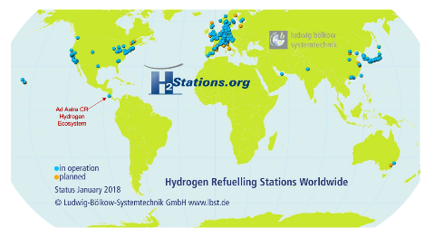
In 2018, Ad Astra’s Costa Rica hydrogen ecosystem became the first of its kind in Latin America. Source as shown

Latin America’s First Hydrogen Fuel Cell Electric Sedans
In 2019 Ad Astra and Costa Rica’s Purdy Motor SA enabled the deployment of the first hydrogen fuel cell electric sedans in Latin America, the Toyota Mirai, with four units introduced to the nation in January of that year. These vehicles are in operation in Costa Rica’s northwest province of Guanacaste and fueled with “green hydrogen” produced at Ad Astra.
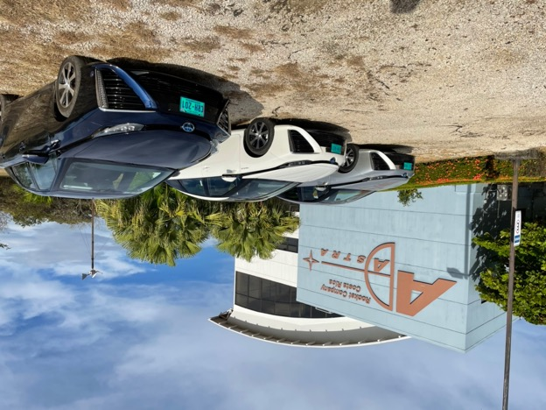
Three units of the Toyota MIrai fleet of hydrogen fuel cell electric sedans operating in Guanacaste. Fueled at the Ad Astra hydrogen facility, these units are the first of their kind in Latin America.

Latin America’s First H70 Fast Hydrogen Refueling Station
In 2020, Ad Astra, in collaboration with the Interamerican Development Bank (IDB) and the Toyota Mobility Foundation (TMF), moved forward with an expansion of the Costa Rica hydrogen infrastructure with a 50% increase in the plant’s hydrogen capacity and upgrading the hydrogen dispenser to state-of-the-art H70 fast refueling at 700 atmospheres with gas precooling. This upgrade is now fully operational and enables the fast refueling (~10 minutes) of fuel cell electric sedans, such as the Toyota Mirai, the Hyundai Nexo and the Honda Clarity to full capacity, giving them a range of 500-600 km. The H70 infrastructure is the first of its kind in Latin America.
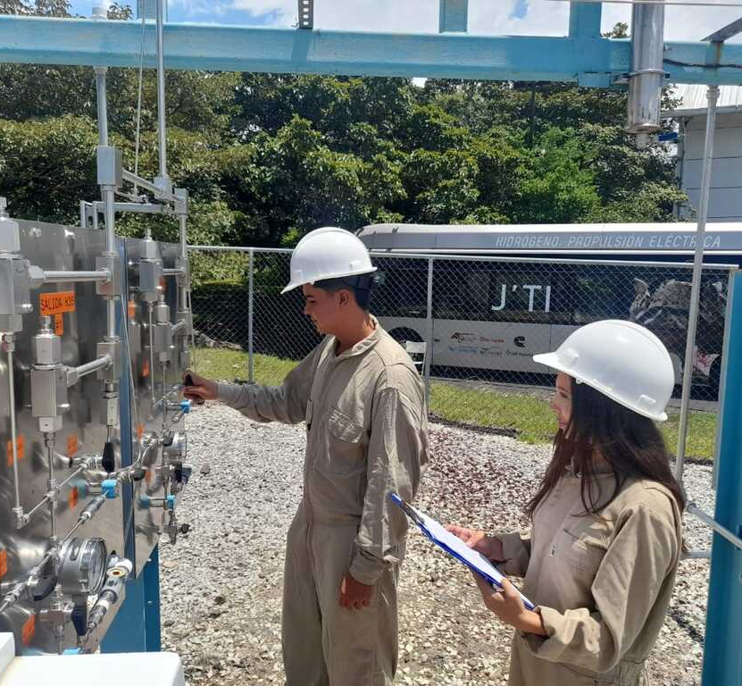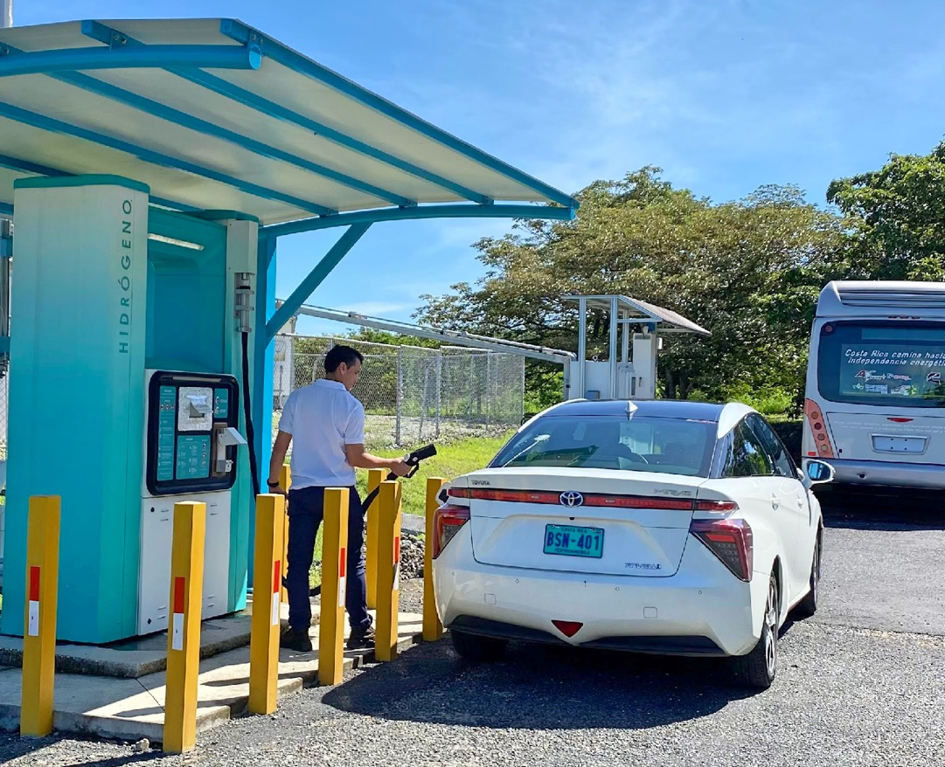
Ad Astra’s hydrogen infrastructure expansion and upgrade for H-70, 700 atm, fast refueling (~10 minutes) capability with gas precooling. Source: Ad Astra Rocket Company
These diversification efforts capitalize on the growing sophistication of Ad Astra’s skill set and are taking the company on a path to day-to-day operational financial self-sufficiency.

ProNova Energy, a Joint Venture with Mesoamérica
Ad Astra initially intended to pursue its activities in renewable energy through its subsidiaries: Ad Astra Energy and Environmental Services, Inc., a Delaware corporation and Ad Astra Servicios Energéticos y Ambientales (AASEA), S.R.L., a Costa Rican corporation. However, more recently Ad Astra has opted to pursue these business opportunities through a joint venture with Mesoamérica, a private equity and advisory firm with offices in Costa Rica and Colombia.
An initial meeting between Ad Astra and Mesoamérica took place in September of 2021. The meeting explored the synergies of the two companies and the potential to combine their skill sets to jointly pursue projects in green hydrogen throughout Latin America. The two teams developed a plan to assess this opportunity and, after several months of study, concluded that a joint venture would be mutually beneficial. In March of 2022, the two companies announced the creation of ProNova Energy, a 50/50 Joint Venture between Ad Astra, Costa Rica and Mesoamérica. On October 28, 2022, Cavendish S.A. signed Memorandum of Understanding to become part of the joint venture; each entity now owns 33.33% of ProNova Energy.
The strategic partnership seeks to take green hydrogen to a new level of large-scale deployment and transform Latin America’s energy matrix. Green hydrogen is evolving as a key energy storage alternative for a decarbonized world economy. ProNova Energy will initially function as a developer of green hydrogen solutions for customers in Costa Rica.

Chapter 8: Company Structure AND ORGANIZATON
Ad Astra’s is organized as follows:
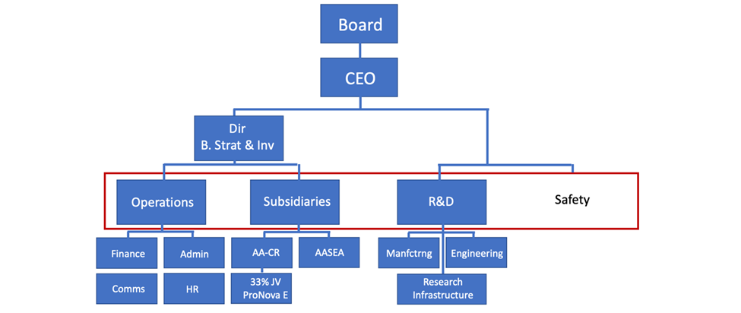
Company organization. Source, Ad Astra Rocket Company

Subsidiaries
Ad Astra’s subsidiary structure includes Ad Astra Rocket Company (Costa Rica) S.R.L., to support technology development for the VASIMR® and other commercial applications. The subsidiary operates on the La Flor Campus of EARTH University, in northwest Costa Rica.
The company supports its developing business in the renewable energy space through two wholly owned subsidiaries: 1) Ad Astra Servicios Energeticos y Ambientales, Inc., a Delaware corporation, and 2) Ad Astra Servicios Energeticos y Ambientales AASEA, S.R.L., a limited liability company organized in Costa Rica. The figure below describes this structure.
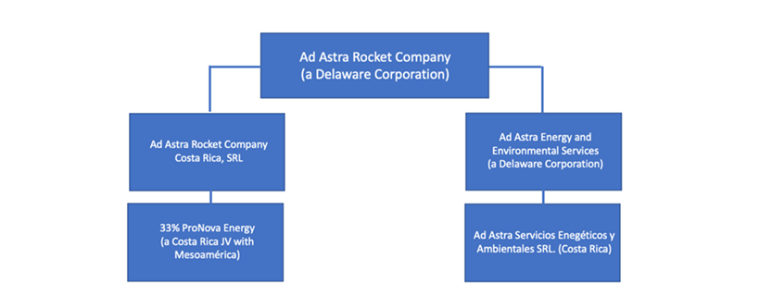
Subsidiary structure. Source: Ad Astra Rocket Company
Ad Astra Rocket Company, the parent company organized in Delaware, United States, is the issuer of the Common Stock sold in this public offering.

Property, plant and equipment
Ad Astra’s main property and equipment at December 31, 2023 consists of the following: computer and software, laboratory equipment, machine shop equipment and solar power equipment, an experimental wind turbine, as well as some elements of the hydrogen ecosystem infrastructure at the Liberia facility.
The company operates from a leased facility in Houston, Texas and has purchased the property at the Liberia, Costa Rica facility. The two installations are located at the following addresses:
Ad Astra Rocket Company
141 W. Bay Area Blvd
Webster, Texas 77598 USA
Ad Astra Rocket Company, Costa Rica
8 Km Oeste de Plaza Santa Rosa
Finca La Flor
Liberia, Guanacaste
Costa Rica

Chapter 9: Operating results and financial forecasting and reporting (management view)

Results of Operations
Ad Astra is a development stage enterprise and does not expect to generate significant revenue from sale of VASIMR® engines during its development stage. However, Ad Astra has and expects to continue to generate some revenue from government contracts, such as NextSTEP, designed to help mature the VASIMR® engine technology. Similarly, Ad Astra has been able to generate some revenue from its hydrogen ecosystem development and services in energy projects. Ad Astra devotes significant efforts to raising additional capital to help develop its products to bring to market. Ad Astra generated small amounts of revenue in the years ended December 31, 2020, 2021, 2022, and 2023 through NASA contracts associated with the VASIMR® engine technology development, as well as service contracts in the areas of precision manufacturing, plasma research, energy research, engineering projects, superconducting technology, speaking engagements and sponsorships. Ad Astra generated total revenue of $1,007,895 in 2020, $1,990,506 in 2021 and $497,037 in 2022, and 963,143 in 2023.
Ad Astra’s expenses for the years ended December 31, 2022 and 2023 included payroll expense, professional fees and other general and administrative expenses. Total general and administrative expenses decreased from 2022 to 2023 by $1,776,115.
Ad Astra Rocket Company (Costa Rica) S.R.L, generated the following percentages of Ad Astra Rocket Company’s consolidated revenue and expenses for the years ended December 31, 2021 and 2022.
 | Year Ended December 31, 2021 | Year Ended December 31, 2022 | Year Ended December 31, 2023
Revenue | 24% | 35% | 21%
Expenses | 26% | 14% | 36%

Ad Astra’s development can be separated into two periods:

- Pre-operating period, that covers years from 2005 through 2028 and includes the development of the laboratory prototype (VX-200 or VASIMR® experimental), and the first flight engine, the VF-150TM.
- Operating period that covers years from 2028 and beyond, and includes the completion of the in-space tests of the plasma engine (VF-150TM) and the initiation of other commercial applications.

During the operating period, there is a wide range of opportunities for Ad Astra to generate revenue as well as other opportunities to develop applications for derivative technology. The planned Aurora Electric Power and Propulsion Test Platform is expected to also serve as a commercial test bed for other technologies requiring space testing. Astra intends to market the services of this facility worldwide. The VASIMR® engine is also expected to perform the following functions in an emerging international public and private market at a fraction of the cost of competing technologies:
- Drag compensation for space stations
- Lunar cargo delivery
- Satellite repositioning, including end-of-life disposal
- Satellite refueling, maintenance and repair
- In space resource recovery
- Ultra-fast deep space robotic missions

Accounts Payable and Accrued Liabilities
As of December 31, 2023, the Accounts Payable and Accrued Liabilities balance consisted primarily of trade payables and deferred salaries. Ad Astra’s Accounts Payable and Accrued Liabilities balance decreased $213,537 from $1,475,781 as of December 31, 2022 to $1,262,244 as of December 31, 2023. The decrease was the result of vendor debt conversion to stock.
Liquidity and Capital Resources
Ad Astra’s revenue from government contracts and other services has been sufficient to support basic company operations. However, to timely accomplish its plan of pre-operative milestones, Ad Astra needs to sell additional capital stock or incur in debt-financing to complement ongoing government contracts. Ad Astra has also met short-term working capital needs through two notes payable, one from a commercial bank, and one from one of its stockholders. Ad Astra estimates that it will need a total of approximately US $100.0 million between 2024 and 2028 to bring the VASIMR technology to flight readiness. Please refer to the table entitled “Projected Cash Expenditures” below for a summary of the intended uses of these funds. Ad Astra will incur fees and pay commissions to underwriters and others in connection with raising this capital, and thus the total amount of capital that may need to be raised to complete the space demonstration is likely to be close to US $110.0 million.
In addition to the anticipated proceeds of this offering, Ad Astra will also pursue raising capital through offerings of capital stock in other markets and through long-term loan agreements from banks or multilateral agencies that promote development in Central America. Ad Astra will incur fees and pay commissions to investment bankers in connection with its capital raising efforts. There can be no assurance that Ad Astra will be successful in these efforts to raise additional capital.

Perceived Impact of Covid-19 on Ad Astra’s Operations

Both in its operation in the United States as well as Costa Rica, Ad Astra Rocket Company observed the stay-home and work-safe orders and guidelines implemented in both nations, and at the local level in Harris County, Texas, which comprises the Houston metropolitan area and surrounding communities, including the city of Webster where Ad Astra is located. While the company continues to make progress on its programs, these requirements slowed down the accomplishments of planned milestones at both facilities and prompted the management to refocus the workload so as to maximize productivity in the virtual environment. As of December 31, 2022, all company personnel at both facilities have been fully vaccinated agains Covid-19 and operations are back to normal.

Projected Cash Expenditures
The following table summarizes Ad Astra's actual expenditures in 2023 and projected expenditures from 2024 through 2027 for the construction of the VF-150TM-1and the VF-150TM-2.
These projections are based on a number of assumptions and information that is currently available to Ad Astra's management. While management believes that these assumptions are reasonable, various factors could cause these assumptions to be incorrect and could cause Ad Astra's actual expenditures to be materially different than those projected.
These projected expenditures are wholly dependent on Ad Astra’s ability to sell capital stock or obtain financing (for example, through government contracts) to fund these expenditures. Ad Astra will delay or modify the development schedule for the VF-150TM and the components of the VASIMR® if it does not have the funds necessary to follow the projected schedule outlined below.

 | year
Element | 2023 | 2024 | 2025 | 2026 | 2027
 | (actual)
lab/ground ops | 1,754,076 | 6,385,000 | 6,335,340 | 6,649,607 | 6,970,842
VF150 development | - | 8,612,900 | 12,443,528 | 17,850,000 | 6,360,000
VF150-2 development | - | - | 1,275,000 | 12,497,500 | 8,990,000
Propulsion Test Platform | - | - | - | 1,000,000 | 2,850,000
System integration | - | - | - | - | 2,900,000
Solar array | - | - | - | - | -
Space tug | - | - | - | - | -
Space tug launch | - | - | - | - | -
TOTAL PER YEAR | 1,754,076 | 14,997,900 | 20,053,868 | 37,997,107 | 28,070,842
cumulative cost | 1,754,076 | 16,751,976 | 36,805,844 | 74,802,951 | 102,873,793
Projected Cash Expenditures. Source: Ad Astra Rocket Company

Chapter 10: Directors, management personnel and employees
The Ad Astra Board of Directors approves all major decisions affecting the company. The officers of the corporation are responsible for the day-to-day operations of the company. The company conducts weekly general meetings and division meetings to review its business plan and monitor progress. The company’s technical advances are reviewed weekly with the management team.
Ad Astra is controlled by an eight-member Board of Directors elected annually by company shareholders. The composition of the Board is as follows:
 | Franklin R. Chang Díaz– Chairman of the Board & Chief Executive Officer: An astronaut with NASA for 25 years, Dr. Chang Díaz holds a PhD. in plasma physics from MIT. He is the inventor of the VASIMR® engine and led the initial experiments at MIT and NASA. With over 30 years of experience in R&D programs and space operations, he also served on the board of Cummins Inc. (CMI, NYSE) a major US publicly traded company.
 | Robert E. Singer – Outside Director & Board Secretary: A distinguished Houston attorney, Mr. Singer supported the initial incorporation of Ad Astra on behalf of Dr. Chang Díaz and represented the firm during the NASA negotiations for the privatization of the VASIMR®. From 1996 to the present, Mr. Singer has been in private practice, providing general legal representation to privately held companies. A former partner in the law firm of Lipstet, Singer & Hirsch (1979 to 1996), he holds a J.D. degree from the University of Texas and a Bachelor of Arts degree from the University of Pennsylvania.
 | Theodore “Tim” Solso – Outside Director: An internationally-renowned technology and business leader, Mr. Solso is the former Chairman and CEO of Cummins Inc, (CMI, NYSE). Under his 11-year leadership the company became a global technology leader with a diversified portfolio of diesel and gas engine technology, power generation and related components, topping $18 billion in annual sales. He was Chairman of the Board of General Motors and served on President Obama’s President Management Advisory Board. Mr. Solso earned his bachelor’s degree at DePauw University in 1969 and his MBA from Harvard University in 1971
 | José A. Zaglul – Outside Director: A consumate manager and recognized figure in sustainable development, Dr. Zaglul was the President of EARTH University in Costa Rica, an institution, which has risen to worldwide prominence under his 15-year leadership. The recipient of many international honors in environmental sustainability and public service, Dr. Zaglul holds a Masters degree from the American University of Beirut and both Masters and PhD degrees from the University of Florida.
 | Charles “Chuck” Schue – Outside Director. Mr. Schue’s other directorships include Aethera Technologies Limited, FirstGuard Technologies, ONN Specialties, Parable Broadcasting Company, SourceRecycle, Tagence, and Ursa Navigation Solutions. Before starting his private sector career, Chuck served in the U.S. Coast Guard, where he was a “mustang”. He holds an MSEE from the Naval Postgraduate School, MSEM from WNEU, and an EMBA from GMU. He is a Senior Member of the IEEE and the American Society for Quality; a Fellow of the Royal Institute of Navigation, and a founding member of two RTCM and eight SAE international standards committees. Chuck owns, or is named on, nine patents.
 | Steven Chapman- Outside Director. Mr. Chapman was Cummins Group Vice President – China and Russia from 1990 until his retirement in 2020, after 35 years of service. He holds a BA in Asian Studies and Political Science from St. Olaf College in Northfield, Minnesota, and an MS in public and private management from the Yale University School of Management. In addition to his native English, he is fluent in both spoken and written Mandarin.
 | John C. Wall – Outside Director: With more than 40 years of industry experience in engine technology, and global engineering, John is a recognized leader in research and product engineering. He was Cummins longest-serving Chief of Technology Oficer from 2000 to his retirement in 2015. He was elected to the National Academy of Engineering in 2010. John studied at MIT, where he received bachelor’s and master’s from the Mechanical Engineering Honors Program in 1975 and ScD in 1978.
 | Christian Wedell – Outside Director. Former director of Microsoft’s European business based in Munich, Germany. A 20 y Venture Capital investor, he served on the board of the Kauffman Fellowship program and was president of the Munich Network. He holds an MS in Mathematics and Information Science from the University of Kiel, and BA Humanities Open Univ of England

The Management Team
While each of Ad Astra’s team members is very important to the success of Ad Astra’s business plan, The VASIMR® technology is by now sufficiently mature and responsibility for further development is held by Dr. Chang Díaz and the rest of the technical team. The financial team includes Isabel Sánchez who serves as Ad Astra’s Director of Business Strategy and Investment and Ms. Enriqueta Martínez who serves as Corporate Controller. The Houston operation is also supported by a strong commercial banking team at JP Morgan Chase and legal counsel provided by Robert Shearer JD, a partner with the firm Akin Gump Strauss Hauer & Feld LLP.
The management team in Costa Rica includes Dr. Juan Ignacio del Valle Gamboa, Director of Operations, Costa Rica and Manager of Ad Astra Servicios Energéticos y Ambientales (AASEA), a Mechanical Engineer with Ad Astra for over 8 years with specialization in control systems and with a brilliant track record in major project development. Ms. Grethel Berrocal serves as Administration, Finances and Human Resources Director and Ing. Norberto Arce, a highly experienced electrical engineer who serves as Director of Engineering and Program Manager overseeing all technical projects in Costa Rica’s portfolio. The technical team is complemented by a strong financial group, which includes Alex González Murillo, a financial analyst who leads Ad Astra Costa Rica’s business development function in green hydrogen and renewable energy, and Mr. Mariano Alvarez Cañas, an economist with over 45 years of experience in investment and banking and serves as the company’s international business advisor and principal liaison for Ad Astra in Europe. Legal counsel in Costa Rica is provided by Luis Diego Castro JD, a partner with Arias Abogados.
Ad Astra’s Board of Directors has eight members. The current members of the Board of Directors were elected by the stockholders at the annual meeting of stockholders held in November 2023. All directors are elected annually to serve until the next annual meeting of stockholders or until their successors are duly elected and qualified. The company is not party to any services or similar contract or company policy with the members of the Board of Directors with respect to their service as directors. The officers of the company are elected by the Board of Directors and serve annual terms.
Ad Astra’s Board of Directors has granted a general power of attorney to Franklin Chang Díaz, Chief Executive Officer and President to represent Ad Astra in connection with the registration of Ad Astra’s common stock for a public offering with the Sugeval and with the Costa Rican Bolsa Nacional de Valores and has authorized, directed and empowered Dr. Chang Díaz to negotiate, finalize and sign each and every document, instrument and agreement that is necessary or advisable to effect a public offering of Ad Astra’s common stock. The Board has also ratified all such actions previously taken by Dr. Chang Díaz that are consistent with the powers granted to him.
Set forth below are, the names, year of birth and positions of Ad Astra’s officers and directors:
All directors and officers, except for Dr. José A. Zaglul and Mr. Christian Wedell, are citizens of the United States, and Dr. Chang Díaz is a dual citizen of the US and Costa Rica. None of the directors or officers are related by blood or marriage.
Name | Birth year | Board Position | Officer
Franklin R. Chang Díaz | 1950 | Board Chairman | President and CEO
Robert E. Singer | 1948 | Director | Board Secretary
Theodore “Tim” Solso | 1948 | Director | None
José A. Zaglul | 1948 | Director | None
Charles “Chuck” Schue | 1960 | Director | None
Steven Chapman | 1954 | Director | None
John C. Wall | 1951 | Director | None
Christian Wedell | 1950 | Director | None
Under Delaware law, any transaction between Ad Astra and a member of Ad Astra’s Board of Directors or any company affiliated with a director must be approved by a majority of the Board of Directors. Ad Astra’s Board of Directors would require that the director with an interest in the transaction abstain from voting to approve the transaction. None of Ad Astra’s directors or officers are contractually entitled to severance or other compensation upon termination of their employment or service to Ad Astra. Officers and directors do not have any preferential right to purchase shares of capital stock offered for sale by Ad Astra. The officers and directors hold stock options, which enable them to purchase shares of Ad Astra common stock at fixed prices upon the vesting of the stock options. None of the directors or officers have filed bankruptcy or been subject to any regulatory or administrative action related to violations of securities laws.

Executive Compensation
Presently, Ad Astra’s officers are paid an annual salary approved for each individual by the Chief Executive Officer in consultation with key members of top management at both laboratories. A Compensation Committee within the Board of Directors was formed and approved by the Board of Directors in November of 2016 to recommend executive compensation for approval by the Board of Directors. Ad Astra also expects its Board of Directors to compensate officers, directors and consultants through appropriate stock incentives granted under Ad Astra’s 2016 Stock Incentive Plan. The purpose of the stock incentive plan is to enable Ad Astra to attract and retain highly qualified personnel who will contribute to Ad Astra’s success and to provide incentives to such individuals who are linked directly to increases in stockholder value.
Ad Astra’s stock incentive plan authorizes the issuance of 2,000,000 shares of Ad Astra’s common stock pursuant to grants of restricted stock, stock options or other equity incentives. The terms of each grant will be determined by the Board or a committee of the Board and set forth in a separate grant agreement between Ad Astra and the individual. The exercise price for all stock options will be at least equal to 100% of the fair market value of the common stock on the date of grant. Options may be exercisable for up to ten years, and the exercise thereof may be subject to time or other vesting conditions. The Board of Directors currently administers Ad Astra’s Stock Incentive Plan on the recommendation of the Board’s Compensation Committee.
Ad Astra has granted stock options to purchase an aggregate of 239,000 shares of its common stock to selected employees, directors and consultants as of December 31, 2023, at $8.00 per share. This includes a program under which each member of its Board of Directors can receive an annual grant of an option to purchase 3,000 shares of common stock with an exercise price equal to the fair market value of the common stock on the date of grant. This program was on hold since 2010 but was approved to resume by the Board of Directors on March 12, 2019. Prior to this resolution, the members of the Board of Directors did not receive compensation for their services as directors. The Board of Directors has the ability by majority vote to approve the compensation payable to each of the members of the Board, including the compensation of the members of the Board that vote in favor thereof.

Personnel
Ad Astra believes that one of its biggest strengths is its people. Over 40 years of research on the VASIMR® engine have gathered a most qualified multidisciplinary team from NASA, the national laboratories and academic and research centers worldwide. Moreover, over 10 years of operations at Johnson Space Center’s Advanced Space Propulsion Laboratory saw virtually no turnover of personnel, a fact that underscores the enthusiasm and commitment of all of the team members. Ad Astra intends to continue to build on this achievement.
Ad Astra currently employs a total of 16 individuals on a full-time basis in its Houston and Costa Rica operations. Other individuals are indirectly funded by the company through research contracts to support specific tasks as needed. Ad Astra also hires advisors and consultants as needed. None of Ad Astra’s employees are members of a union or subject to a collective bargaining agreement.
Stockholder | Shares of Common Stock Outstanding | Percentage Ownership | Fully-Diluted Shares | Fully-Diluted Percentage Ownership
Franklin Chang Díaz, Chairman and CEO | 14,060,750 | 66.89% | 14,072,150 (1) | 60.80%
Robert Singer, Director and Secretary | 266,500 | 1.27 | 280,500 (3) | 1.19
Theodore M. Solso  Director | 15,208 | 0.07 | 143,508 (4) | 0.62
Charles Schue | - | - | 49,700 | 0.21
Steven Chapman | - | - | 43,700 | 0.19
John C. Wall | - | - | 31,200 | 0.13
Christian Wedell | - | - | 187,300 | 0.81
Others | 6,679,505 | 31.77% | 8,341,205 (5) | 36.04
Total | 21,021,963 | 100.00% | 23,144,263 | 100.00%
Directors and Officers (7 individuals) | 14,627,458 | 69.58% | 15,088,058 | 65.19%

Chapter 11: Significant stockholders and transactions with related parties

Stock Ownership
Dr. Chang Díaz, Ad Astra’s founder, Chairman and Chief Executive Officer holds 66.89% of Ad Astra’s outstanding shares of common stock. Dr. Chang Díaz received the common stock in exchange for his many contributions to Ad Astra, including a cash investment of over $6,000,000. Other common stockholders include some of the founding directors and key individuals who made contributions to Ad Astra during its formative stages. The following table sets forth the ownership of Ad Astra's common stock, as of December 31, 2023, by its officers and directors and by each stockholder that owns at least 5% of the common stock, and the ownership of Ad Astra’s common stock by such individuals or entities on a fully diluted basis assuming the conversion of all outstanding shares of Series A, C and D and E Preferred stock into common stock.
In December 2008, the Board of Directors approved a stock split by way of dividend of 3,000 shares of common stock for each outstanding share of common stock, and all share amounts in this prospectus reflect this dividend.

(1) Includes 75 shares of Series D Preferred Stock held by a family member which are convertible into shares of Common Stock on a 100 for one basis.
(3) Includes 3 shares of Series C Preferred Stock.
(4) Includes 1,033 shares of Series D and 250 Series E Preferred Stock which are convertible into shares of Common Stock on a 100 for one basis.
(5) Includes 369 shares of Series A Preferred Stock and 25 shares of Series C Preferred Stock which are convertible into shares of Common Stock on a 3,000 for one basis and 3,736 shares of Series D Preferred Stock and 5,637 shares of Series E Preferred Stock which are convertible into Common Stock on a 100 for one basis.

Transactions with related parties
  - Preferential of Similar Rights
None of Ad Astra’s stockholders have preferential or similar rights to purchase shares of Ad Astra’s capital stock.
  - Transactions with Directors and Stockholders
During the year ended December 31, 2009, the Company entered into an uncollateralized line of credit with a vendor who is owned by a stockholder who was also a member of the Board of Directors in the amount of $1,200,000. In May 2011, the Company entered into a note modification agreement which reduced the available line of credit to $408,000 and extended the maturity date to May 31, 2012. During the year ended December 31, 2011, the vendor converted $792,000 of the outstanding balance into 22 shares of Series C Preferred stock at $36,000 per share based on market prices of preferred stock sold to investors through private placements. During the year ended December 31, 2010, this vendor converted $510,000 of the outstanding balance into 17 shares of Series A Preferred Stock at $30,000 per share based on market prices of preferred stock sold to investors through private placements. Following these conversions, the Company’s outstanding balance at December 31, 2023 on the line of credit was $408,000, plus accrued interest of $276,110. All principal and accrued unpaid interest is due and payable on demand. The interest rate on this line of credit is equal to the current Chase “prime” interest rate, 8.50% (as reported by Bloomberg, L.P.) at December 31, 2023.
As of December 31, 2023, the Company had demand notes payable to an officer of the Company with a balance of $2,178,275, plus accrued interest balance of $29,205. Also as of December 31, 2023, the Company had two short-term loans from independent Directors in the amount of $55,000. These loans were made to the Company on an interest-free basis.

Chapter 12: Financial Information
The following financial information is included in or annexed to this prospectus:
- Audited financial statements with notes as of and for the twelve-month periods ended December 31, 2020, 2021, 2022.

Frequency of information to investors
Dear investor, the following information about Ad Astra and its financial condition will be available from Ad Astra and at the SUGEVAL for review.
Report | Frequency | Place of reference
Material Fact Announcements (**) (1) | Immediately after its knowledge | In SUGEVAL and Ad Astra’s office at Finca La Flor, Liberia, Guanacaste. Reports marked with (*) or (**) are also available on the website  www.sugeval.fi.cr; those marked with (*) are also available on the website www.adastrarocket.cr
Updated prospectus (**) | Annually
Financial statements (*) | Quarterly
Audited financial statements (**) | Annually
Corporate Governance Report | Annually
Projected Cash Flow | Annually

- Ad Astra will notify investors of information that is considered relevant through a Material Fact Announcement. Under Costa Rican law, Ad Astra is responsible for making Material Fact Announcements of all material decisions made by its Board of Directors within the period of time established by SUGEVAL.

Chapter 13: Additional information
The following agreement is available for review at Sugeval’s website: www.sugeval.fi.cr
Nonreimbursable Space Act Agreement. The privatization of the Variable Specific Impulse Magnetoplasma Rocket

Chapter 14: Annexes
Annex 01 | Annual un-audited financial statements with notes as of and for the twelve months ended December 31, 2023.
Annex 02 | Deleted
Annex 03 | Opinion of Baker & Hostetler LLP regarding certain U.S. tax matters
Annex 04 | Opinion of AFC, S.A. regarding certain Costa Rican tax matters
Annex 05 | Opinion of John Mowell regarding Ad Astra VASIMR® expert opinion
Annex 06 | Letter from Ham Langston and Brezina regarding the capitalization policy.
Annex | Issuer’s sworn declaration

Power density is defined here as power flowing through the cross-section of the plasma plume; therefore, it has the units of kW/m².
Green hydrogen is obtained by decomposing water into its constituents – hydrogen and oxygen – using renewable energy sources such as hydroelectric, wind and solar. The process, called electrolysis, is carbon-free and does not contribute to global warming.

